

Operators Manual (v2.21)

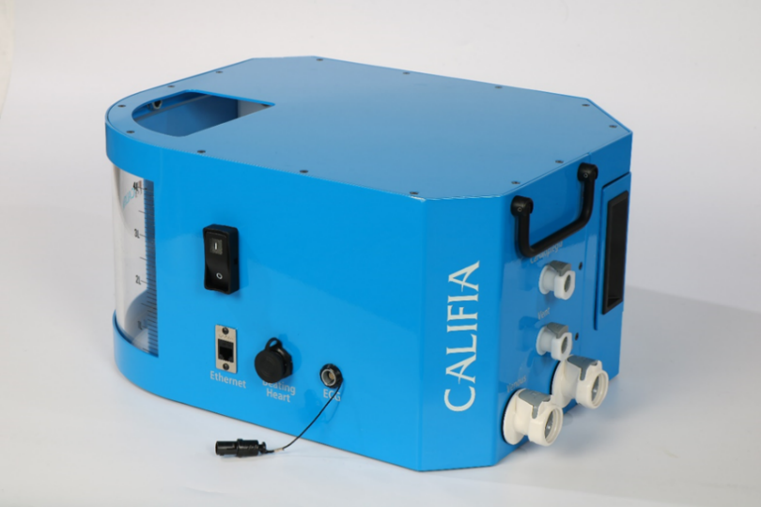

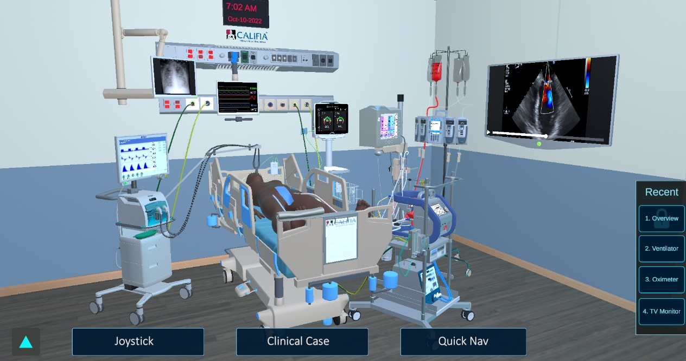



www.biomedsimulation.com
No part of this work may be reproduced in any form or by any means - graphic, electronic, or mechanical, including photocopying, recording, taping, or information storage and retrieval systems - without the written permission of Biomed Simulation Inc.

Products that are referred to in this document may be either trademarks and/or registered trademarks of the respective owners. The publisher and the author make no claim to these trademarks.

While every precaution has been taken in the preparation of this document, the publisher and the author assume no responsibility for errors or omissions, or for damages resulting from the use of information contained in this document or from the use of programs and source code that may accompany it. In no event shall the publisher and the author be liable for any loss of profit or any other commercial damage caused or alleged to have been caused directly or indirectly by this document.

Under no circumstances should this simulator system be used to guide the management of any living patient.

CALIFIA® is a registered trademark of Biomed Simulation Inc.

US Patent No. 14051442
European Patent No. 2906107
Canadian Patent No. 2887344
Singapore Patent No. 11201502855X
Chinese Patent No. ZL 201380062871X
US Patent Pending PCT/US2018/012009

CALIFIA® is in conformity with the following standards

EVS-EN 61326-1:2013 Electrical equipment for measurement, control and laboratory use – EMC requirements – Part 1: General requirements.

EVS-EN 61010-1:2010 Safety requirements for electrical equipment for measurement, control and laboratory use – Part 1: General Requirements



All rights reserved.
© Biomed Simulation Inc. 2011-2025

Table of Contents

1. Overview 1-1
1.1. Simulator Components 1-1
1.2. Computer Requirements 1-2
1.2.1. OR Monitor Display Requirements 1-3
1.2.2. Upgrading Software 1-3

2. Installation and Setup 2-1
2.1. Program Installation 2-1
2.2. External Connections 2-2
2.2.1. Data and Power Connections 2-2
2.2.2. ECG Connector 2-3
2.2.3. Beating Heart Connector 2-3
2.2.4. Hydraulic Connections 2-4
3.3. Blood Pressure Pump 2-5
3.3.1 Pressure Pump and Arterial Pressure Control 2-6

3. Modes of Operation 3-1

4. Menu 4-1
4.1. Configure 4-1
4.1.1. Lab Reports 4-2
4.1.2. Pump Record 4-3
4.1.3. Units 4-4
4.1.4. Characters 4-5
4.1.5. Printer 4-5
4.1.6. Work Directory 4-6
4.2. Scenario Editor 4-8

5. Clinical Scenario Files 5-1

6. 3D Intensive Care Unit 6-1
6.1 ECMO Circuit Configurations 6-3
6.1.1 Cannula Selection 6-5
6.1.2 Clamps 6-7
6.1.3 Call Button 6-8
6.1.4 Cerebral Oxymeter 6-9
6.1.5 Patient’s Chart 6-11
6.1.6 Fluid Infusion 6-12
6.1.7 Mosaic Mode 6-13

7 Instructor’s Panel Tabs 7-1
7.1 Patient Variables Tab 7-2
7.2 Blood Chemistry Tab 7-3
7.2.1 Bicarbonate ion ( HCO₃⁻ ) 7-3
7.2.2 Calculate Desired Gases 7-4
7.2.3 Heparin Dose Response 7-5
7.3 Fluid Management 7-6
7.3.1. Defining the I-O Characteristics of Fluids in the Master List 7-6
7.3.2. Initiating the Fluid Panel 7-7
7.3.3. Preparation of Priming Fluids (Pre-CPB or Pre-ECMO) 7.8
7.3.4. Fluid Management on ECC Support 7-11
7.3.5 Urine Output Management 7-12
7.3.6 Fluids Balance 7-13
7.3.7. Adding and Editing Fluids in the Master Fluid List 7-14
7.3.8 Fluid Management Module Data Captured in the Pump Record 7-15
7.4 Electronic Gas Blender (EGB) 7-16
7.5. Cardiovascular Variables Tab 7-17
7.6 Pulmonary Variables Tab 7-18
7.7 Ventilator Tab 7-19
7.7.1 Ventilator .ini File 7-19
7.8 Cardioplegia Delivery Tab 7-20
7.9 Monitors / Labs Tab 7-21
7.9.1 ACT Plus 7-24
7.9.2 Spectrum Medical 7-24
7.9.3 NIRS 7-25
7.9.4 GEM 3000 7-26
7.9.5 Media Files 7-27
7.9.6 ECG Tone Volume 7-28
7.9.7 Waveform Show/Hide 7-28
7.10 CALIFIA Controls Tab￼7-29
7.11 Cannula Editor 7-31
7.12 Calibration Panel 7-32
7.12.1 CVP Calibration 7-32
7.12.2 Flow Calibration 7-34
7.12.3 Two Pont Calibration (Level, Pressure, Temp) 7-34

8 Instructor’s Panel Common Elements 8-1
8.1 Blood Gas Calculation (CPB Only) 8-1
8.2 Temperature Source 8-2
8.3 Evaluation Controls 8-3
8.3.1 Text to Speech 8-3
8.3.2 Surgical Events 8-3
8.4 OR Clock 8-4
8.5 Virtual Pressure Displays (ECMO Only) 8-5
9. CPB (Sim) Legacy Screen 9-1

10 Clinical Scenarios 10-1
10.1. Scenario Controls 10-1
10.2. Scenario Files 10-3

11. Switching Modes of Operation in CALIFIA Simulator Software 11-1

12 Technical Assistance / Service 12-1

Appendix A Beating Heart Attachment A-1
A.1. Beating Heart Tabs A-2
A.2. Beating Heart “Sync” Mode A-3
A.3. Beating Heart “Rate/Volume” Mode A-4
A.4. Beating Heart “Interactive” Mode A-5

Appendix B CALIFIA’s Lung B-1

Appendix C HMS+ Option (Legacy Screen) C-1

Appendix D INVOS Option D-1

Appendix E Data Streaming E-1

Appendix F Display Settings for OR Monitor F-1
F.1. Display Settings F-1
F.2. Touch Screen Settings F-2

Appendix G Equations G-1
G.1. Body Surface Area Calculations G-1
G.2. Base Excess G-1
G.3. Temperature Correction G-1

Appendix H Licensing Activation I-1

Overview

The CALIFIA® Perfusion Simulator system can simulate a patient before, during and after cardiopulmonary bypass for open heart surgery or for long-term support with extracorporeal membrane oxygenation (ECMO). It is a programmable, high fidelity simulator system designed to attach to any heart-lung or ECMO machine and circuit. It is intended both as a teaching tool, and as a tool for evaluating the performance of a clinician in the conduct of a simulated clinical case. Among the more significant features of the CALIFIA simulator is its wide range of automatic physiological responses. Another important capability is the ability to script and load unique clinical scenarios which allow any patient parameter, or machine setting, to be pre-established and set automatically. Each scenario step includes the patients’ physiological parameters, controls for which of the ancillary monitors are displayed, and even text to speech entries for requests or other communication during the case. These individual scenario “steps” can be started and automatically advanced at predetermined intervals. In addition, progression through the scenario steps can be stopped and started at the operator’’sdiscretion. The operator can modify scenario parameters and manually trigger the next step in the scenario program. Alternatively, steps can be set to advance automatically at predetermined intervals.

  - Simulator Components

CALIFIA® is made up of four components shown in blue in Figure 1
Patient
Module
Heart Lung/ECMO Machine
Clinician
Instructor
Instructor’s Panel
Laptop
OR/ICU Monitor
Figure 1 Simulator Components

CALIFIA® Patient Module - The “Patient Module” consists of a reservoir and valve system with multiple transducers and controllers, all connected to a Windows-based laptop computer via an Ethernet cable (Cat 5) connection. The Patient Module transmits data-such as extracorporeal blood flow, cardioplegia flow and circulating blood volume-back to the laptop, which uses this information to simulate patient responses during cardiopulmonary bypass or ECMO. The laptop then drives a separate display, referred to as the “OR (or ICU) Monitor,” which mimics typical surgical or ICU monitors by displaying a broad range of patient data.

OR Monitor” – In addition to standard cardiovascular parameters, the OR Monitor can display various ancillary devices such as cerebral oximetry, in-line blood gas monitors, the ACT machine, and printouts from POC devices like blood gas analyzers, the Heparin Management System (HMS), and thromboelastograms (TEG). The visibility and timing of these monitors during a case can be controlled via the Controller Display or Instructor Panel—either manually or through a preset Clinical Scenario. The monitor can also show multiple ECG patterns, including transitions to an arrest rhythm following application of the cross-clamp and detection of adequate cardioplegia delivery.
T

Instructor’s Panel – The laptop screen functions as the Instructor’s Panel, used by the instructor or simulation operator (see Figure 37). It enables control over patient physiological parameters, selection and display of monitor types on the OR Monitor, and management of scenario progression.

  - Computer Requirements

The list below gives the optimum specifications for running the simulation system.

Specifications

LAPTOP COMPUTER  (instructor’s panel) |  | External touchScreen  (learner screen) |  | CALIFIA ® patient module
Operating System: | MS Windows® 11 (64-bit) | Screen Resolution: | 1920 1080 pixels | Hydraulic quick disconnects: | (CPC PN)  2x ½” plugs  (65GP-PF2-08)  3x ¼” plugs  (50AC-PB2-04)
Processor (CPU): | Intel® Core™ i7 or higher | Screen size: | 24” | Hydraulic quick disconnects:
Minimum Processor Speed: | 2.5 GH multicore | Touchscreen interface: | USB-B | Hydraulic quick disconnects:
RAM: | 16 GB DDR4 or better | HDMI Port: | YES | Dimensions: | 18 x 13.5 x 8 inches
Disk Space: | 10 GB or larger | Dimensions: | 22 x 16 x 5 inches | Weight: | 32 pounds
Screen Resolution: | Support for 1920 x 1080 | Weight: | 13 pounds | Power consumption: | < 180 Watts
®Video ports: | HDMI | Power consumption: | 35 Watts | Operating Voltage: | 24 V DC
Graphics Card: | 3D-rendering such as NVIDIA GeForce RTX2060 | Operating Voltage: | 100-240 V AC  50/60 Hz | Operating Temperature: | 0° to +40° C
Network ports: | 1 Ethernet  1 Wi-Fi | Operating Temperature: | 0° to +40° C | Certifications: | EN 61326-1:2013, EN 61010-1:2010
Touchscreen: | YES |  |  | Warranty
Screen size: | 15.6 inches |  |  | Term: | CALIFIA ® Patient Module: 2 years parts and labor.
Weight (typical): | 5 pounds |  |  |  | Everything else: 1 year.
Power consumption (typical): | Less than 65 Watts
Operating Voltage: | 100-240 V AC  50/60 Hz
Sample Laptop: | MSI Creator Z16 A11UET

    - OR Monitor Display Requirements

The OR Monitor display is designed to be run as an extension of the laptop main display. It should be a touch screen monitor and support a minimum resolution of 1920 x 1080 pixels.

Instructions for setting up the OR Monitor and activating the touchscreen capabilities under Windows 8.1 or newer are given in Appendix F.

    - Upgrading Software

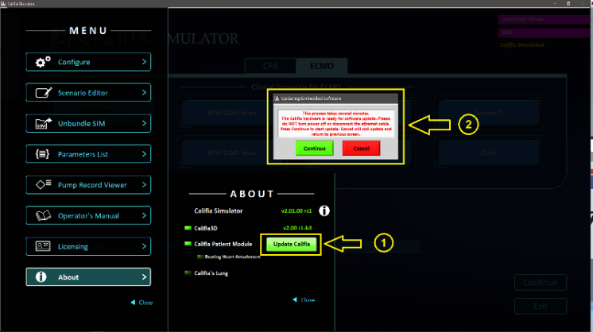
Occasionally, a CALIFIA® Simulator software upgrade requires an update to the embedded firmware in the CALIFIA® Patient Module. When this is necessary, a green Update Firmware button will appear in the Menu > About section (see Figure 2). Clicking this button will open a warning message. To proceed, press Continue to begin the firmware update. The update process may take several minutes to complete.

Figure 2 Update CALIFIA Firmware

- Installation and Setup®

  - Program Installation

To install the CALIFIA® Simulator Program, follow these steps:
- Log in as an administrator or a user with administrative privileges.
- For the best installation experience, temporarily disable any antivirus software.
- If a previous version is installed, go to Settings > Apps, locate CALIFIA® Simulator, and uninstall it.
- Locate and run the Setup.exe file for the new installation.
- Follow the on-screen instructions to complete the installation. Using the default settings is strongly recommended.
- Once installation is complete, re-enable any antivirus software that was previously disabled.

- disabled.
  - External Connections

    - Data and Power Connections

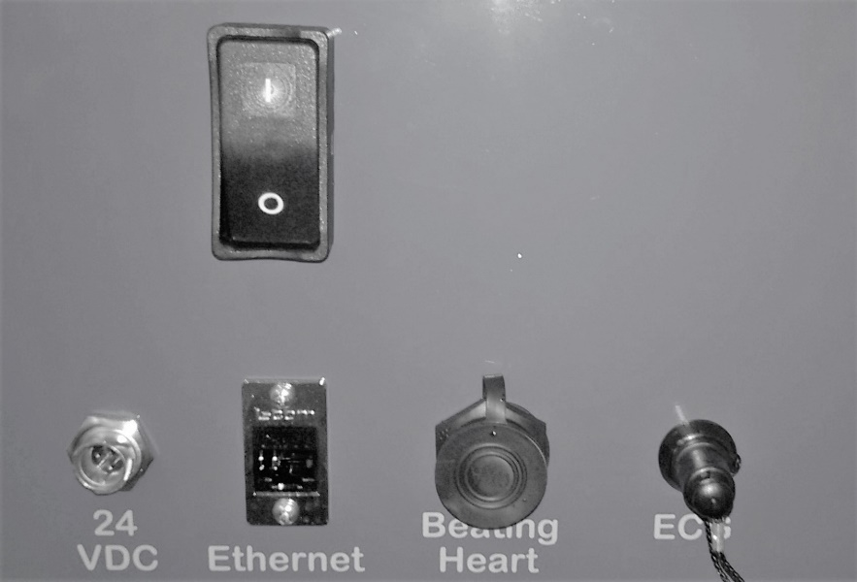
⑤
④
③
②

①

Figure 3. CALIFIA Side Panel

The electrical switch (On-Off) ①, electrical power adapter (24 V DC) ②, Ethernet ③, Beating Heart ④, and ECG connectors ⑤ can all be found on the side panel as shown in Figure 3.

The electrical power adapter connects to the port labeled “24 VDC” on the side of the CALIFIA® Patient Module (see Figure 3).
For best results, ensure the following steps are completed before turning on the laptop and launching the CALIFIA® Simulator software:
- Connect the electrical power adapter.
- Connect the Ethernet cable from the Patient Module to the laptop.
- Power on the Patient Module.
Verify that the OR Monitor is powered on and connected to the laptop. This monitor should be set as an extended display with a recommended resolution of 1920 x 1080 pixels. A USB cable must also be connected to enable touchscreen functionality.
Instructions for adjusting screen resolution and calibrating the touch screen using the Windows Control Panel are provided in Appendix F.

    - ECG Connector
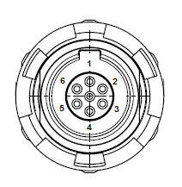
Figure 4. ECG Connector

For the ECG connector, 4 pins are used: 1, 2, 3, and the center pin (ground). All three pins (1-3) put out the same signal which corresponds to the ECG signal displayed on the OR Screen. All channels use pin 7 – “Ground”, as reference. The default output voltage amplitude is 1V. This output voltage can be manipulated from zero to five volts

    - Beating Heart Connector

The Beating Heart connector is meant to attach to an external (optional) add-on component which is designed to be used with a rubber or tissue heart. Details for operating the beating heart can be found in Appendix A Beating Heart Attachment.

Contact Biomed Simulation for additional information:
marketing@biomedsimulation.com
    - Hydraulic Connections

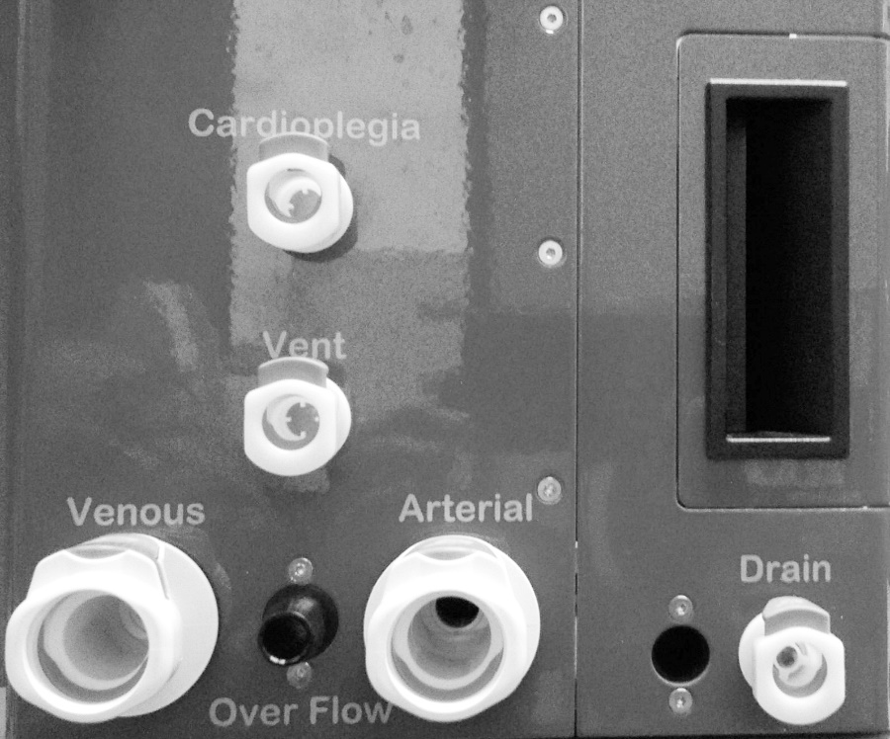

Figure 5. Hydraulic Connections

Hydraulic connections for attaching the Patient Module to the Heart-Lung or ECMO machine or VAD are all found together on the back panel and labeled “Cardioplegia”, “Vent”, “Venous” and “Arterial” (see Figure 5). These are meant to be connected to the associated tubing lines as indicated. Note that for VV ECMO, the venous return to the patient should be attached to the “Arterial” connector. The “Cardioplegia” and “Vent” connections are only meant to be used during simulation of cardiopulmonary bypass. These quick-disconnects fittings do not have valves and water will leak out of them if water is poured into the front reservoir. During ECMO simulations it is recommended that the “Cardioplegia” and “Vent” ports be connected using a shunt to prevent blood (water) loss from the reservoir. What about VAV
There are two additional connections labeled “Overflow” and “Drain”. The “Drain” port, unlike the “Cardioplegia” and “Vent” ports includes a valve and will not open until the male side of the connector is inserted. The “Overflow” port is a ½” barbed connector that provides runoff should the reservoir become overfilled.

  - Blood Pressure Pump

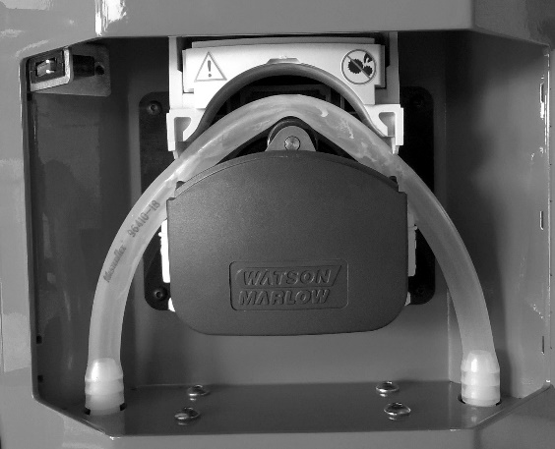
Pressure Pump

Figure 6A. Pressure Pump-Lid Open
The pressure pump can be found in the rear compartment. It is recommended that when the CALIFIA Patient Module is not in use, the lid on the pressure pump should be raised, relieving stress on the silicone tubing as shown in Figure 6A. The lid must be down in the locked position while using the simulator as seen below in Figure 6B.

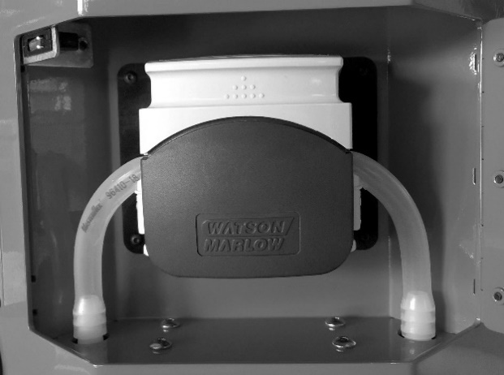

Figure 6B. Pressure Pump-Lid Closed

It is important to periodically lubricate the tubing and rollers in the pressure pump. This can be done by removing the tubing from the pump raceway and applying silicone lubricant. Extreme care should be used in replacing the tubing; assuring that it is pushed all the way to the back along the raceway. Otherwise, the tubing can get pinched and possibly punctured, especially at the edges where the tubing enters or leaves the pump.
    - Pressure Pump and Arterial Pressure Control

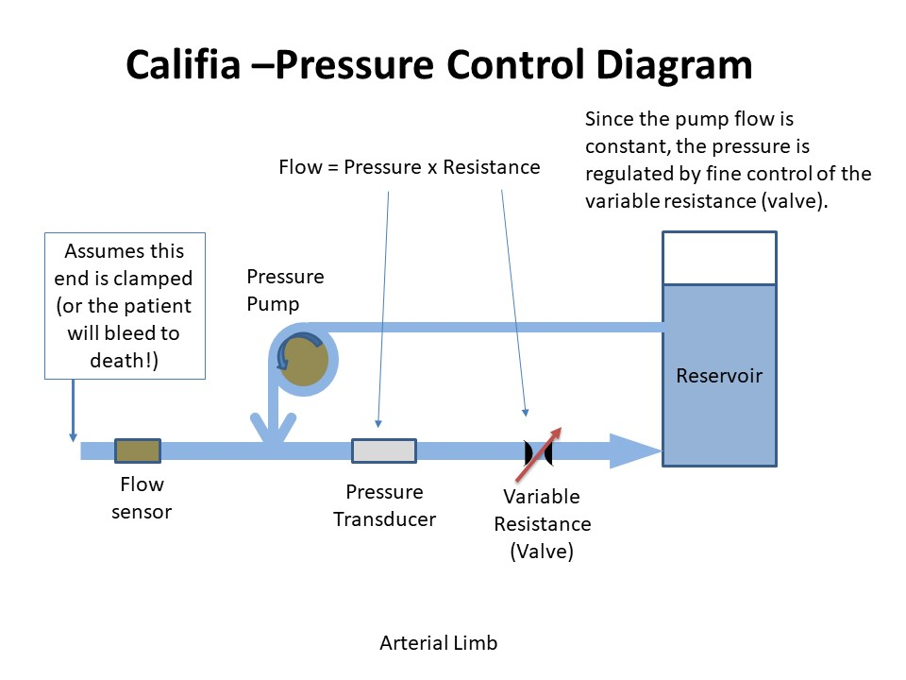

Figure 7. Arterial Pressure Control System

The pressure pump is designed to deliver a pulse into the arterial line depending on the stroke volume of the left ventricle and the heart rate. Assuming that the distal end of the arterial limb is clamped, the pressure in the line will be determined by the arterial valve which will vary by the resistance to the flow back to the reservoir (see Figure 7). If “Pressure Control” is activated, (see 7.10. CALIFIA Controls Tab) the resistance of the arterial valve will be regulated to maintain the pressure in this arterial limb equal to the systolic and diastolic arterial blood pressure as displayed on the OR Monitor.

- Modes of Operation

The program opens to a start screen with two main simulation categories, accessible via the top two tabs labeled “CPB” and “ECMO” (Figure 8).
).

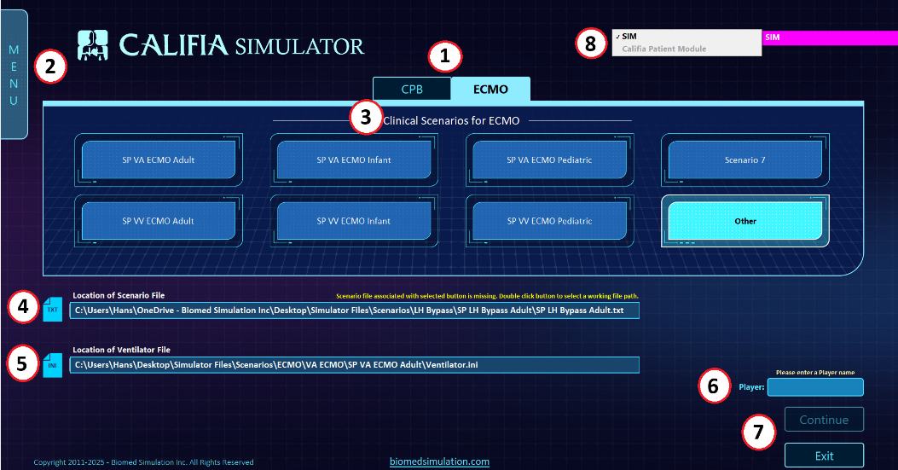

Figure 8. Opening Screen showing ECMO Tab Options

The layout and design of the Opening Screen are identical for both CPB and ECMO modes.
Key components of the Opening Screen include:
① Simulator Tabs – Select between the CPB or ECMO simulator modes..
② Menu Access – Opens options for Configuration, Licensing, User Manual, and more (see Section 4: Menu).
③ Clinical Scenarios – Displays up to seven preprogrammed scenarios for each simulator. Custom scenarios can be loaded using the “Other” button.
④ Scenario File Location – This field appears when the “Other” button is selected, allowing manual selection of a scenario file (*.txt) (see Figure 8).
⑤ Ventilator File Location – Displays the path to the required ventilator configuration file (*.ini). Details provided in Section 7.7.1: Ventilator.ini File.
⑥ Player Field – Appears only when the Pump Record feature is enabled. The name entered here becomes the filename for the generated pump record (see Section 4.1.2: Pump Record)
.⑦ Continue and Exit Buttons –
Click “Continue” to launch the selected simulator or “Exit” to close the program.
Note: The “Continue” button remains inactive (greyed out) until both a scenario file and a ventilator.ini file have been selected.
⑧ Mode Indicator Tab –
Displays whether the active mode is “SIM” (software-only simulation) or “CalifiaCALIFIA Patient Module” (if the hardware is connected).

- Menu

Press the 'MENU' tab (② in Figure 8) to open a series of additional options.

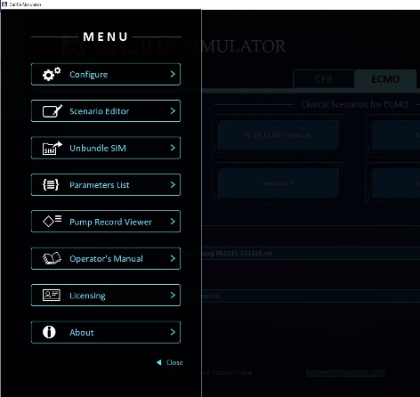

Figure 9. Tab Options Under “Menu”

A detailed explanation of each tab option follows.

  - Configure

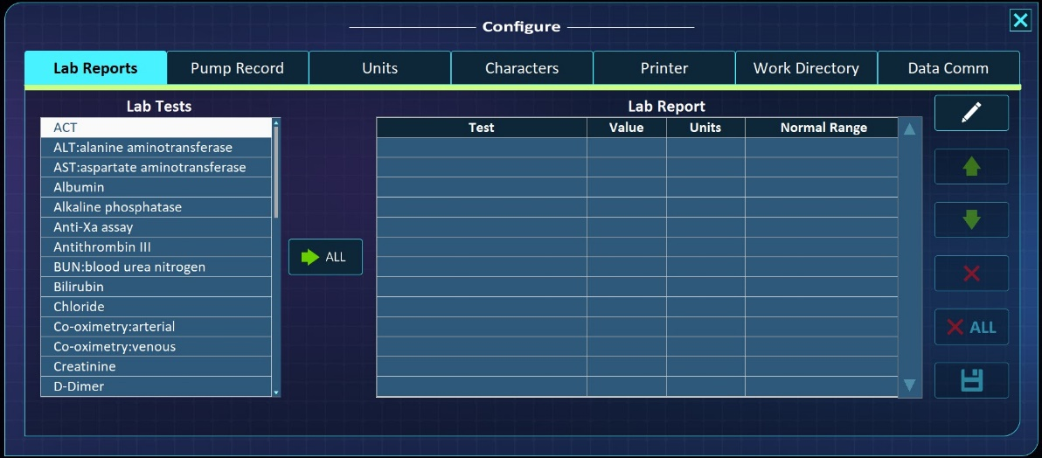

Figure 10. Tab Optionsunder Configure

Selecting the “Configure” button brings up several choices of configurable elements, each of which will be described below.

    - Lab Reports

Customized Lab Reports can be generated by left clicking and dragging choices from the “Lab Tests” column and dropping them into the “Test” column to the right in the Lab Report table
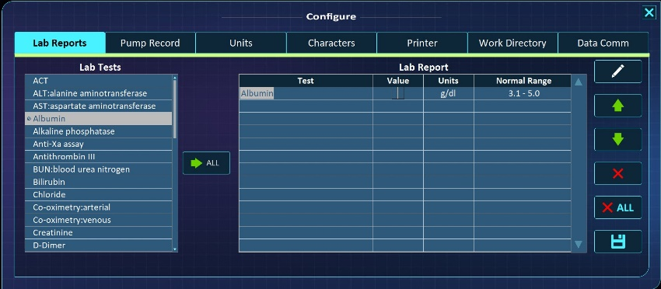

Figure 11. Selecting Tests and Adding Values

Dropping a test into the “Lab Report” table will automatically fill in the Units and Normal range values as seen in Figure 11. Results can be added into the “Value” column by clicking on the space, activating the cursor and entering the value.

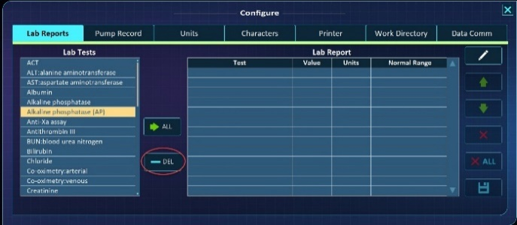
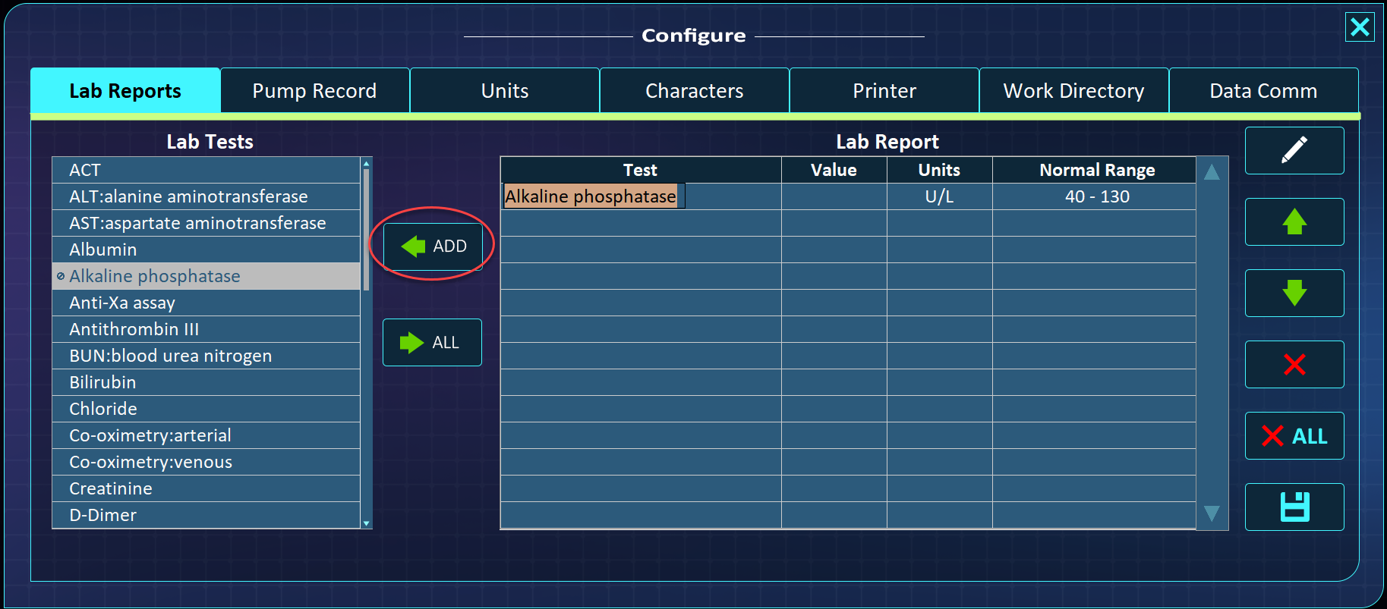

Figure 12. Customizing Tests, Units or Normal Range

It is also possible to modify the “Test”, “Units” or “Normal Range” entries by double clicking on the entry and activating the cursor as shown in (Fig. 12 Left). When this is done, a new “Add” button appears which allows the modified entry to be added to the Test Selection table. Note that this overwrite the original Test Selection if the name of the test is the same but will add a new test if the Lab Test name is unique. Double clicking on an element in the Lab Tests column brings up a delete button (Fig. 120 Right) allowing the entry to be removed from the list.

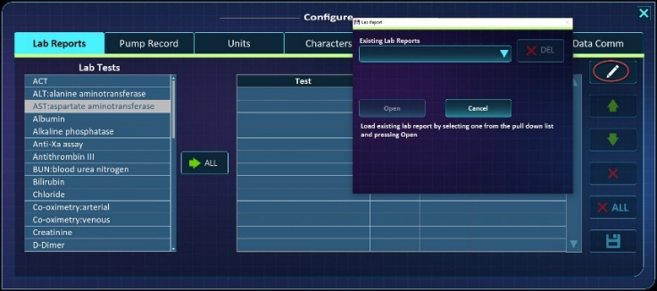

Figure 13. Editing Existing Lab Reports

An existing lab report can also be loaded into the “Lab Report” window by pushing the “Pencil” button as seen in the upper right of Figure 13.

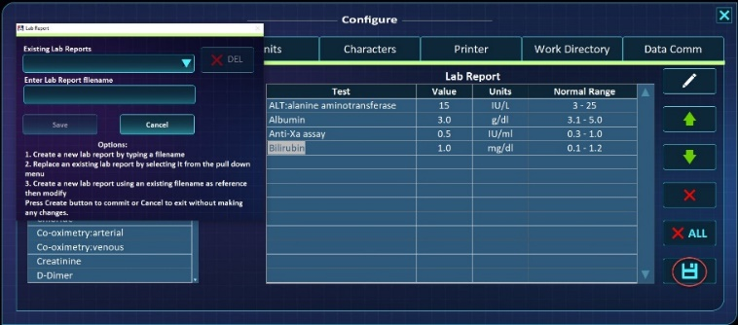

Figure 14. Saving Lab Reports

Once a lab report has been generated, it can be saved by pushing the Save button shown in the lower right in Figure 14. Pushing the Save button opens a dialog window which allows a new filename or an existing lab report to be modified. These reports are saved as .png files in the sub folder …Simulator Files\Lab Reports (see )

    - Pump Record

The second tab enables a continuous digital recording of a variety of selected parameters during the simulated case, thus generating an electronic Pump Record. To activate this charting capability, first push the button labeled “Create Pump ***Record” (see Figure 15A). This will bring up the pump record set-up screen (see Figure 15B)

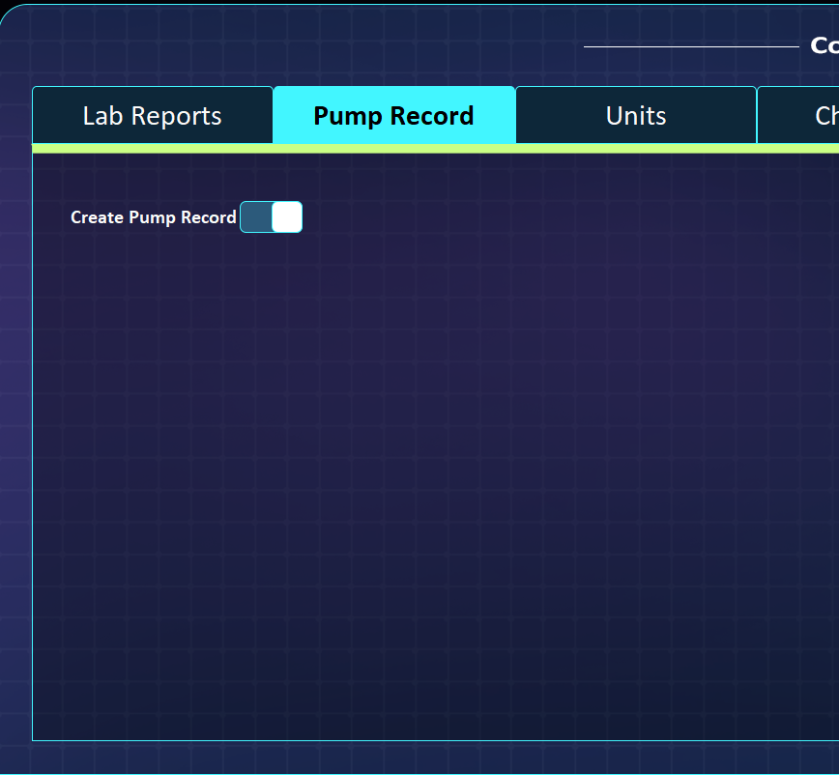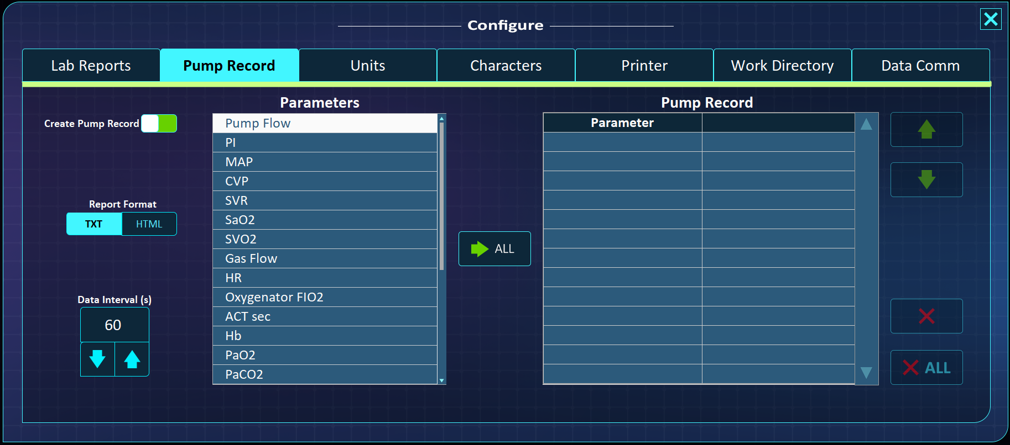
A. B.

Figure 15. Pump Record Set Up Screen

Parameters available for charting can be found in the “Parameters” table on the left. Individual parameters can be dragged and dropped into the “Pump Record” table in the Parameter column as shown below in Figure 16.

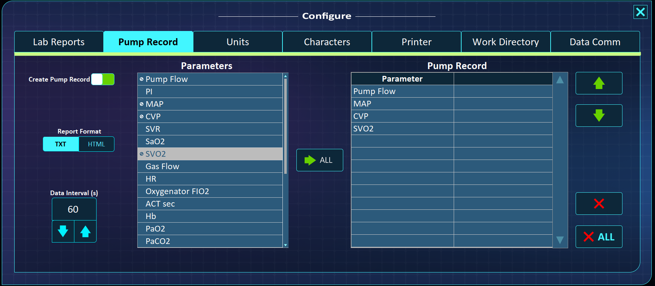

Figure 16. Adding Parameters to be Charted

The format of the final Pump Record can also be chosen allowing between Tab-delimited text “TXT” or “HTML” formats. Also, the interval for data recording can be set on this page with the “Data Interval (s)” control. It should be noted that the parameters chosen to be charted and their order will be retained after the simulator is shut down so there is no need to reconfigure the pump chart each time the simulator is run.

If a pump record is to be generated, an additional field will appear near the bottom of the opening page titled “Player” (see Figure 7, ⑥). The name placed in this field will be used as the name of the file created during the simulated case. This file will be placed in a folder named “Pump Records” created at the same location as the scenario file being used.

    - Units

Units used for reporting various parameters are made in this tab (Figure 17). Note that these selections are retained after the simulator is shut down.

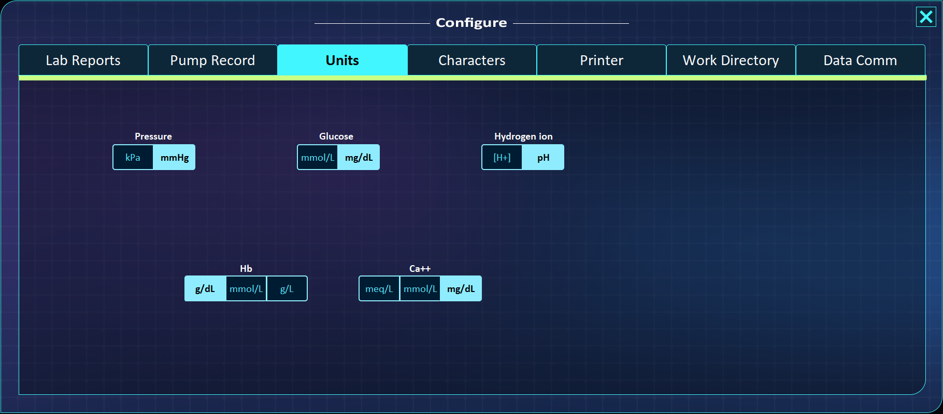

Figure 17. Units Tab

    - Characters

This tab establishes which voices are assigned to the various avatars in the scenario. The list of selectable voices is queried from the Operating System. Any text to speech voice packages installed in the computer will automatically appear in the drop-down lists
(see Figure 16). Note that these choices are retained after the simulator is shut down.

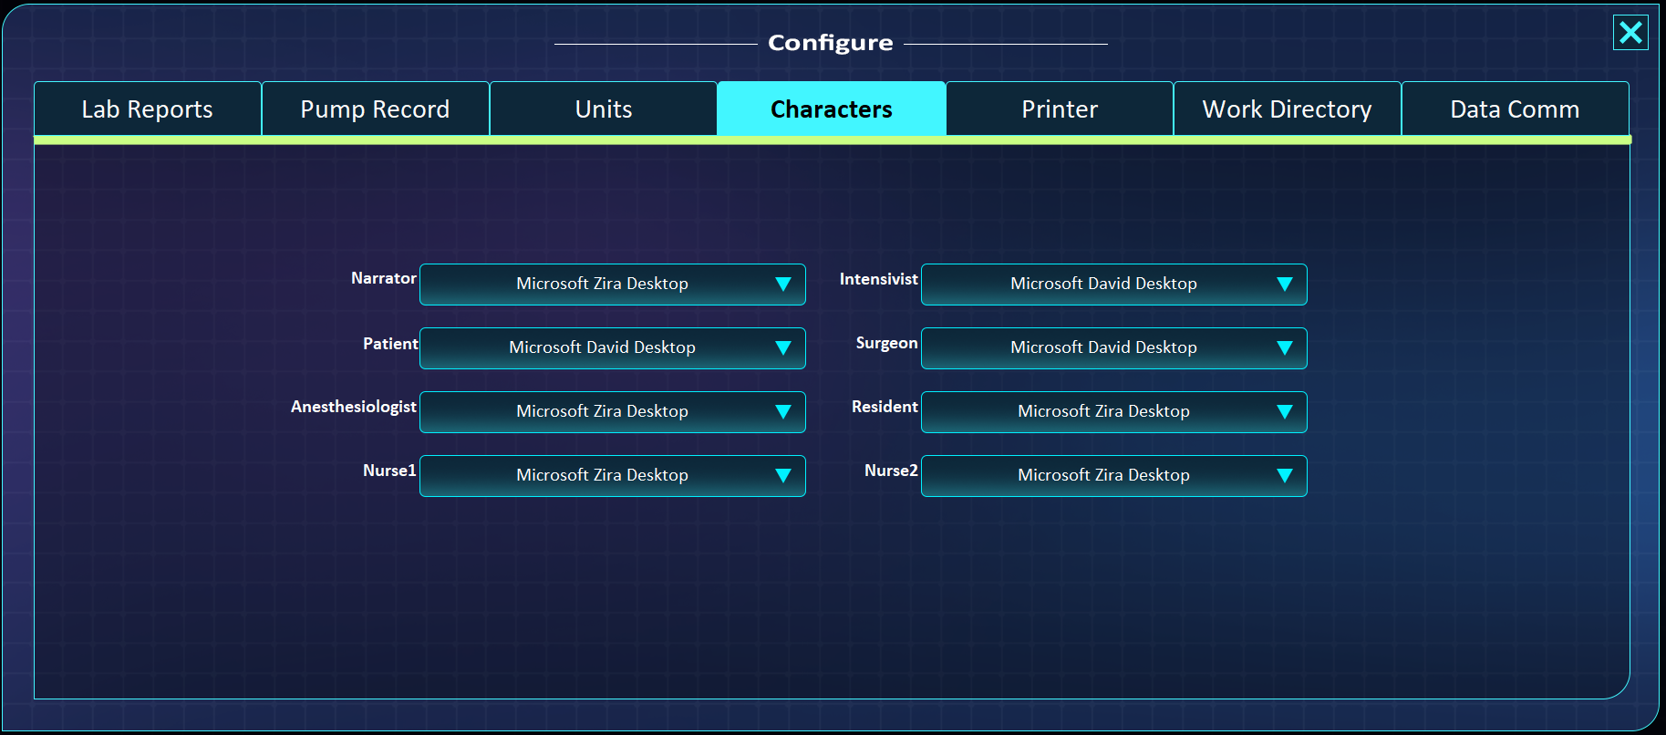

Figure 16. Characters Tab

    - Printer

The “Printer” tab allows the selection of a printer to be used for the various selectable printouts (Gem 3000 or HMS, or Lab Report or TEGs). For the printer to be available on this drop-down list it must be installed, connected and recognized by the Operating System. Note that this printer choice will be retained after the simulator is shut down.

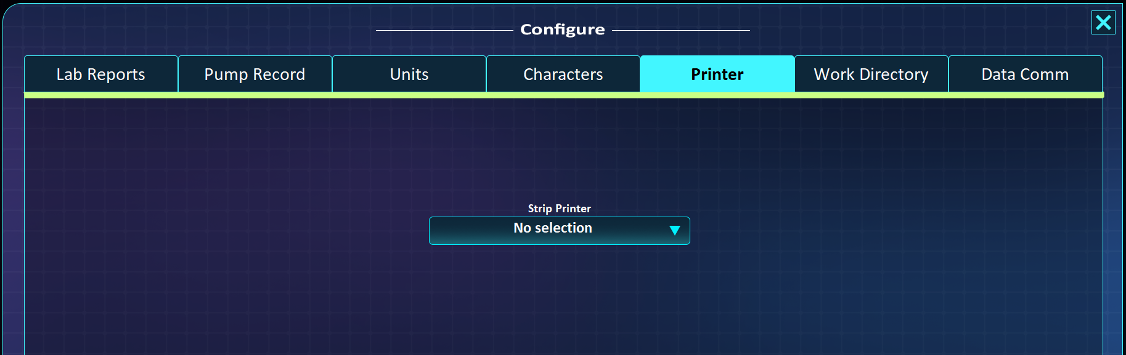

Figure 17. Printer Tab

    - Work Directory

A Master Work Directory organizes all relevant User files necessary to run the simulator. The Master Work Directory structure by pressing the “Open Work Directory” button shown in Figure 18. The initial location for this directory is the Desktop. If this location is acceptable then there is no need to do anything in this tab.

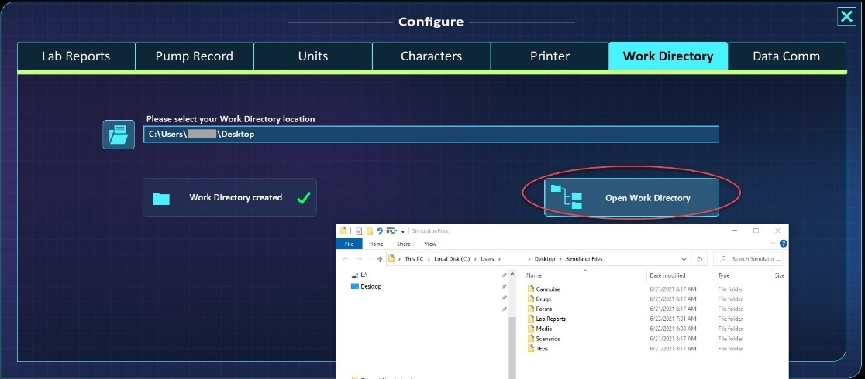

Figure 18. Work Directory Structure

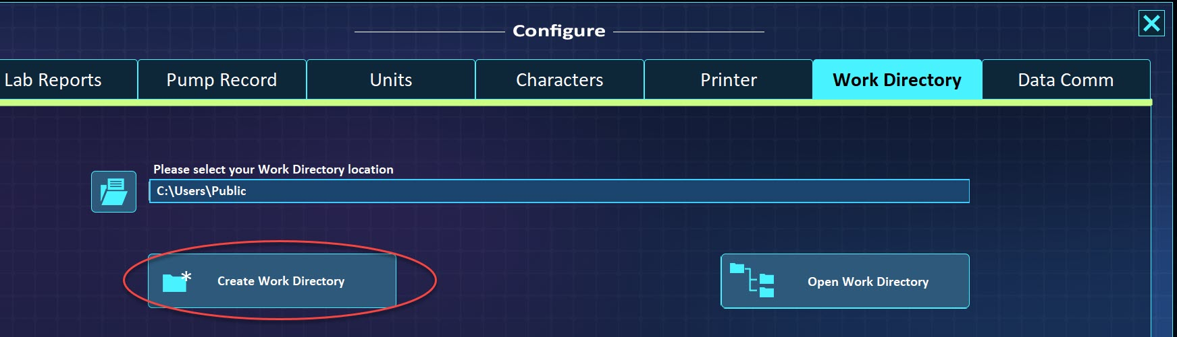

Figure 19. Creating a New Work Directory

To create a Work Directory in a different location, follow the steps below (see Figure 19):
- Select an existing location where the Work Directory is to be created.
  - This step enables the “Create Work Directory” shown in Figure 19.
- Press the Create Work Directory button
  - Once the work directory is created, this button is greyed out and labeled “Work Directory created”
- Open the new Work Directory location by pressing “Open Folder” button

Work Directory folders

Simulator Files – the top-level folder in the Work Directory; created by the simulator and used to organize all user files.
Cannulae – includes a single file (Cannulae.ini) used to store information relevant when loading arterial or venous cannula profiles. Please refer to
7.11 Cannula Editor for more details.
Drugs – includes subfolders with drugs available in the simulators. If new drug files are created, these can be added to this subfolder. [Currently this feature isn’t functional]
Lab Reports – storage location for lab reports generated using the Lab Reports tab. Please refer to 4.1.1. Lab Reports for more details.
Media – location for all media files available to simulators. Popular formats for video files (wmv, mpg, avi) and images (gif, png, jpg) are supported.
Scenarios – contains two subfolders: CPB & ECMO. The user can store scenario files inside subfolders. A new simulator ships with sample scenario files for both ECMO & CPB. It should be noted that scenario files can be loaded from any computer location.
TEGs – TEG profiles can be added to this folder in the form of image files (supported formats are PNG, BMP, JPG, GIF).

NOTE: Do not change the names of any of these folders: Simulator Files, Cannulae, Drugs, Lab Reports, Media, Scenarios, CPB, ECMO & TEGs.

  - Scenario Editor

The Scenario Editor is activated by pressing the “Scenario Editor” button under Menu in the Opening Screen as shown in Figure 9.

Although scenario files are tab-delimited text files and can be viewed and modified with many text editors like Notepad, WordPad, MS Word or Excel, a dedicated Scenario Editor offers convenient and time-saving tools to work with scenario files and ensure they remain compatible with the simulator. Scenario files can include over 60 physiological and monitoring variables along table columns and can have an unlimited number of steps represented by rows. the Scenario Editor is a useful tool to help manage these files. Figure 29 shows the Scenario Editor with labels for its key parts.

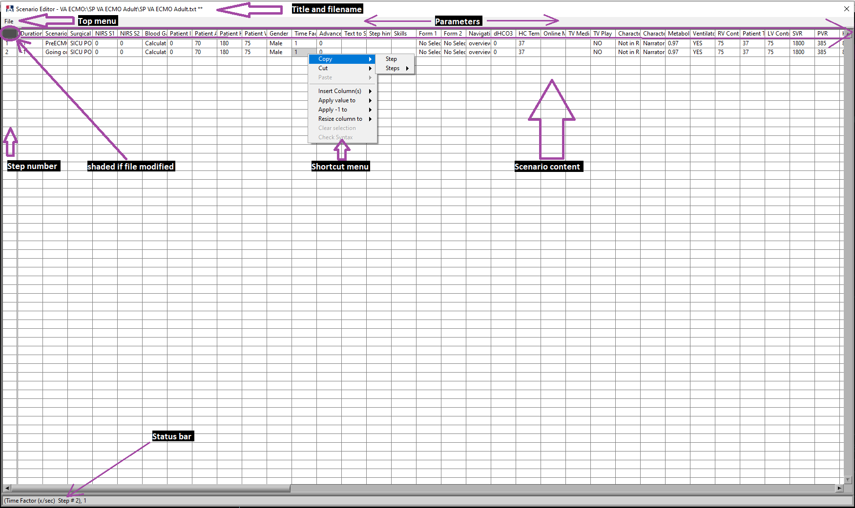

Figure 20. Scenario Editor

Most functionality of the Scenario Editor is available through the “File” top menu and shortcut menu (accessible by right-mouse clicking anywhere inside the populated table area). When a scenario file has been modified and not yet saved, the top left cell is shaded in grey color; for a file with no modifications this cell is white. The status bar at the bottom of the table provides information based on the location of the mouse cursor, the status bar offers the user relevant & timely information.

Following is the File top menu selection list, Figure 21.

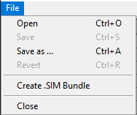

Figure 21. Scenario Editor’s File Top Menu List

Open – ( shortcut keys: <CTRL>+O) – Prompts the user to load a new scenario file.
Save – ( shortcut keys: <CTRL>+S) - Saves any modifications to a new file. The new filename includes the original name plus a timestamp. To illustrate, if the original file is demo.txt; then the new filename can be: demo 032421-145040.txt (the timestamp format is mmddyy-hhmmss) – the filename and its path is shown in the Scenario Editor’s Title bar. If the original filename already includes a timestamp, then it will be updated. If no modifications have been made yet, then this functionality is disabled.
Save as … - ( shortcut keys: <CTRL>+A) - It brings up a new panel, Figure 22, used to save currently opened scenario file with a new filename in a new work folder.
Enter new scenario filename, ①.
The ventilator.ini file from the original location is copied to the new work folder unless Default box is unchecked, ②. In this case, use the file browse button to point to a different ventilator.ini file.
The new scenario file can be linked to any of the Opening Screen buttons, ③, for quick access. Give the selected button a label, ④. If “Other” button is selected, then no label is needed.
The new Scenarios sub-folder is created under CPB or ECMO, ⑤, depending on the Opening Screen CPB-ECMO selector.
Press the Create button, ⑥, to create the new scenario file; notice the Scenario Editor’s title bar reflects the new filename and location.

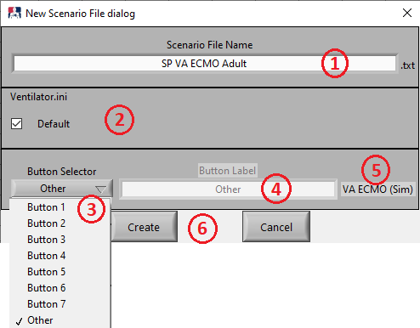
Figure 22
Revert – ( shortcut keys: <CTRL>+R) - Reload the original scenario file and NOT save any modifications. In other words, any changes will be lost.
Create .SIM Bundle – It brings up panel used to create a SIM bundle file.
By default the SIM filename matches the scenario filename and the desktop folder as destination. Either of these can be edited as shown in ①, Figure 23.
A SIM file is a special bundle of files that can include files associated with a scenario file such as Media files, Forms and Lab Reports, ②. Associated files are checked under the “Used in Scenario” column, ③.
The last column, “Include in sim”, ④, is used to add files to the SIM bundle. These selections do not have to be associated with the scenario file.
The size, in bytes, of all selected files is shown in ⑤.
Press Create button to complete the SIM file creation, ⑥.
If any files are added, removed or renamed in the Work Directory, press the Refresh button, ⑦, to make sure it shows in the corresponding list.

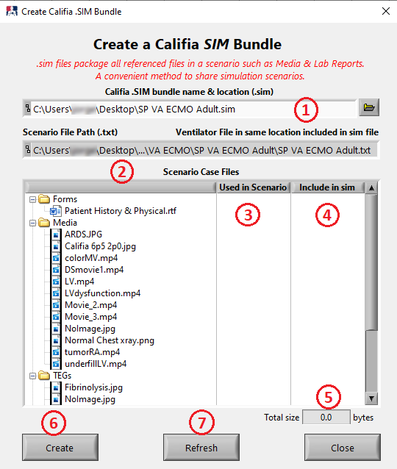
Figure 23
Close – Close file. If a modification has been made, a prompt will ask user to confirm this action or save before closing.

Following is a list of features available by way of the shortcut menu (right click).

Copy >> Step – copies the content of an entire step and enables the ability to paste it elsewhere in the table. Step copied is highlighted as shown in Figure 24

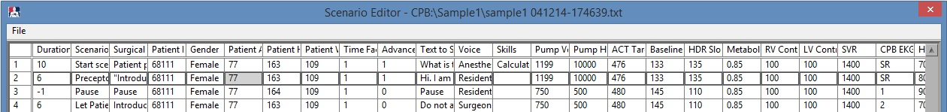

Figure 24. Contents in Step 2 selected (the result of either a copy or a cut)

Copy >> Steps >> Start AND End – Copying multiple steps is a two-step process. First select the Start step and then select the End step. These can then be pasted elsewhere in the table. Copied steps are highlighted as shown in Figure 25.

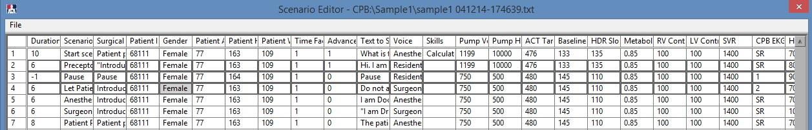

Figure 25. Contents in Scenario Steps 2 to 4 are selected
(the result of either copying or cutting multiple steps)

Cut >> Step - Cuts the content of an entire step allowing it to be pasted elsewhere in the table.
Cut >> Steps >> Start AND End – Cutting multiple steps is a two-step process. First select the Start step and then select the End step. These can then be pasted elsewhere in the table. Cut steps are highlighted as shown in Figure 25.
Cut >> Column – Cuts an entire column from its current location. Note this function immediately removes the cut column and enables the Paste >> Column function. The Status bar can prove useful indicating the cut column.
Paste >> Step(s) >> Above Selection or Below Selection or Replace Selection – Selecting one of these options pastes a copied or cut step or group of steps in new location.
Paste >> Column >> to right of Selection or to left of Selection or replace Selection – Selecting one of these options pastes a cut column in new location.
Insert Column >> to right of Selection or to left of Selection or replace Selection – Selecting one of these options inserts a new column. This function is only available if there are parameters not yet used in the scenario file. Figure 26 shows the parameter selection dialog box listing missing parameters in a scenario file. Note: if a parameter shown in this list is already part of the scenario file, check its spelling; it may be in this list because the Scenario Editor does not recognize it as a valid parameter, hence the Simulator would not recognize it either and behave unexpectedly.

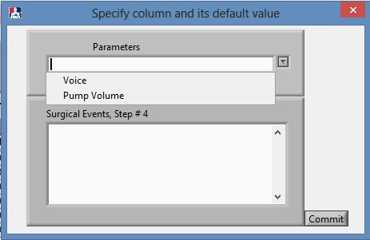

Figure 26. Select Parameter and Its Default Value for New Column

Apply value to >> entire column or rest of column – The value in the selected cell is copied to either all cells in the column or only to cells below the selected one.
Apply -1 to >> this element or entire column or rest of column – The value of -1 has special significance; the simulators ignore parameters whose value is -1 when reading the scenario file values. During a write action, a dialog message prompts the user to choose how to treat parameters with -1 as a value – Refer to SECTION 12.1 for more details; either maintain its value as -1 or write the actual parameters value. To illustrate, if Heart Rate is set to -1 in the scenario file but its slider value is 85, then selecting the Heart Rate will change the value in the scenario file from -1 to 85.
Resize column to >> default size or this element or largest element – This selection is useful to enlarge the viewing area to match the content of the selected cell or the largest value for that column. Selecting default size returns the cell to the original size.
Clear Selection >> – Clears any commands to copy or cut row(s).
Check Syntax >> – This functionality is currently not implemented.

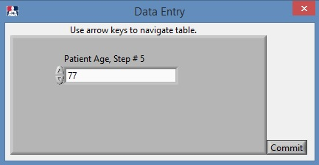
To modify any cell content, left-click once in the cell. This action brings up a Data Entry box as shown in Figure 27. This box is sensitive to the type of data compatible with that particular parameter. To illustrate, figure 27 shows a numerical field for Patient Age in Step #5. Other parameters like Skills or Text to Speech would allow the user to type in text for that particular objective. Pressing the Commit button makes the change in the table. The box can be closed using the X button on the top right corner. Note that while the box is active, using the arrow keys (up, down, left, right) allow you to navigate through the table and make multiple changes quickly. Don’t forget to press Commit for every change.

Figure 27. Data Entry Box for Patient Age, Step #5

- Clinical Scenario Files

In order to start the simulator, it is first necessary to specify a clinical scenario file. A scenario file is a text file which provides the simulator with instructions to establish physiological parameters or carry out a series of events. Scenario files will be described in more detail in section 10. Clinical Scenarios.

The 8 large rectangular buttons in the “Clinical Scenarios” section of the Opening Screen can be used to select and load a specific scenario file. Three scenario files come preloaded.
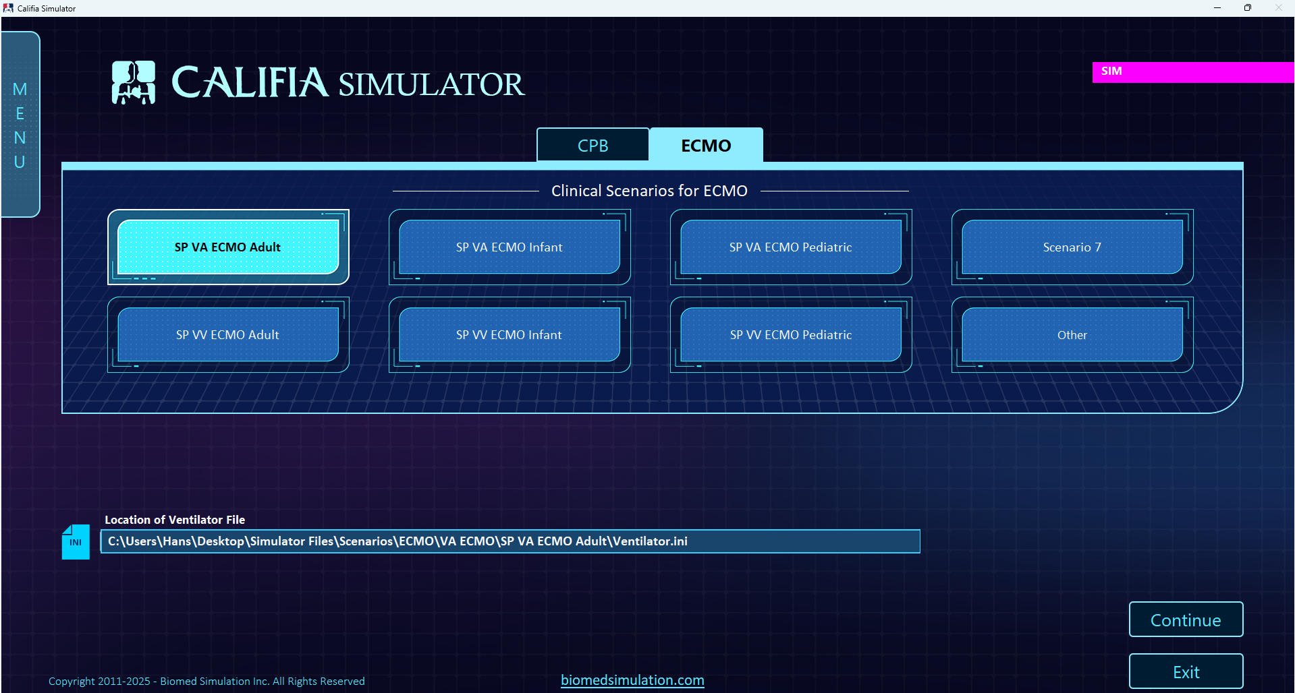

Figure 28 Clinical Scenario Buttons

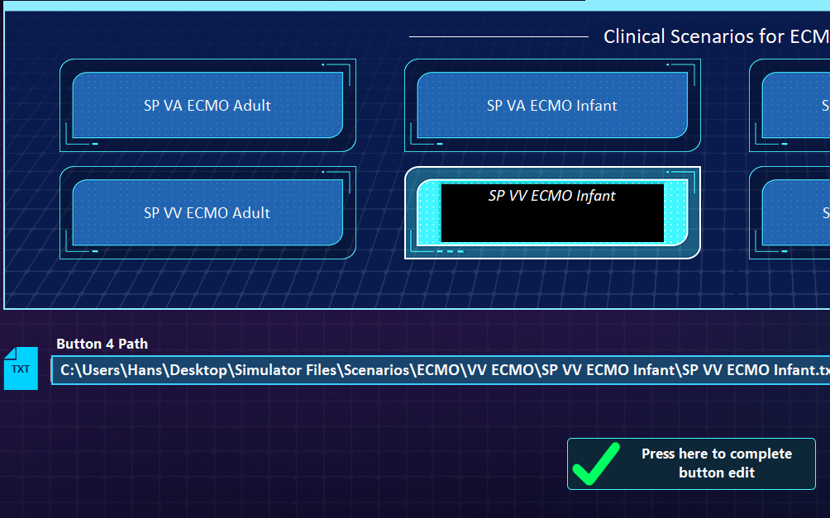

Figure 29 Editing Scenario Buttons

These buttons can be “programmed” to automatically point to specific scenarios.by first double clicking and activating the button itself (turning it dark), allowing the label to be changed (Figure 29)

The bottom field is used to designate which scenario file is to be associated with that button Otherwise, the entire file path of the txt file to be used must be entered in the file dialog box. Finally, select the “Press Here to Complete Button Edit”.

When the bottom right button labeled “Other” is pushed, a separate file dialog field will open under the scenario buttons (see Figure 28 ). Once the scenario file has been chosen (*.txt extension), click the “Continue” button to start the simulator. It should be noted that the simulator program will not start without the designation of a valid scenario file

- 3D Intensive Care Unit

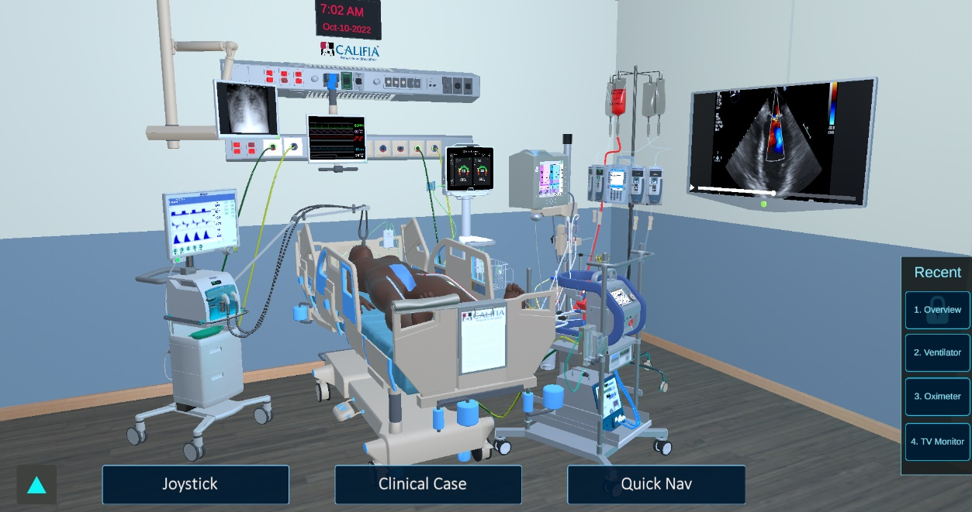

Figure 30 3D ICU Environment

The 3D ICU is an interactive environment allowing the player to move around the room and interact with the various monitors, equipment, etc. Navigating can be accomplished in several ways. The “Q-W-E-A-S-D” keys allow three-dimensional movement within the environment typical of most video games. The arrow keys also allow movement in two dimensions. A joystick can be also accessed with the “Joystick” button at the lower left corner.
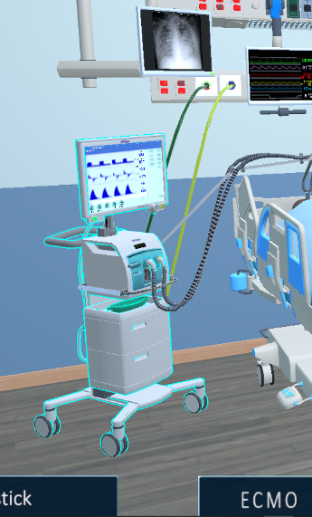
Many of the items in the room are targets. Hovering over a target with the mouse will highlight the device (Figure 31). Clicking on the target will bring the user directly in front of the device as shown in this example with the ventilator.
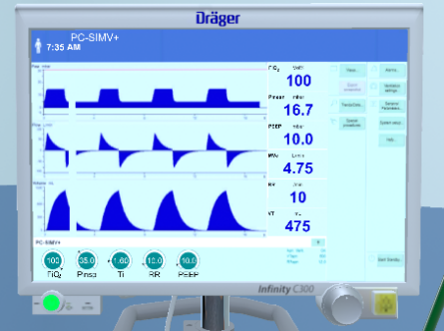

It should be noted that the 3 most recently visited navigation locations can be seen in the small ribbon at the lower right corner of the environment labeled “Recent” (Figure 30).
Figure 31 Highlighted Target

A comprehensive list of navigation spots can be found under the “Quick Nav” button at the far lower right corner of the environment (see figure 30). This button brings up a list of available navigation spots.

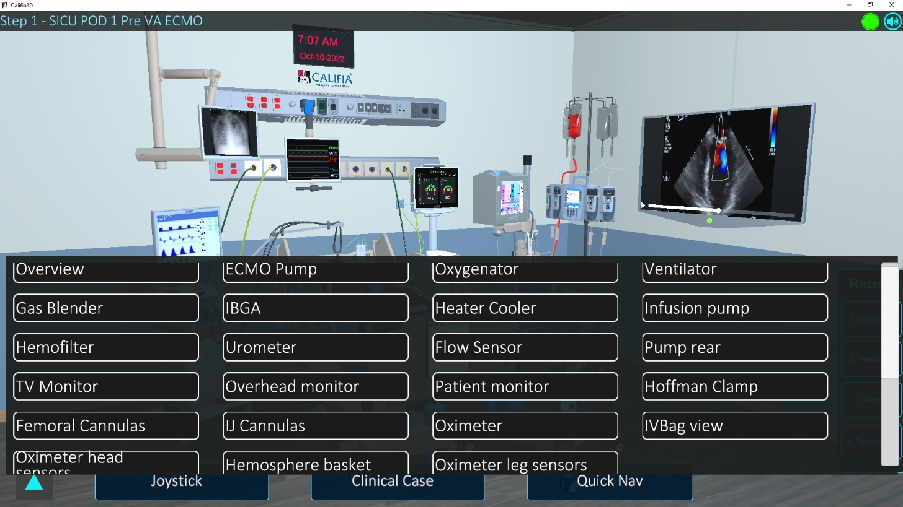

Figure 32a Navigation Spots

To create a custom navigation target, scroll to the bottom of the Navigation list. Position the user’s eye at the new desired location and press the “+” button (Figure 32b lower left) and name the new location.

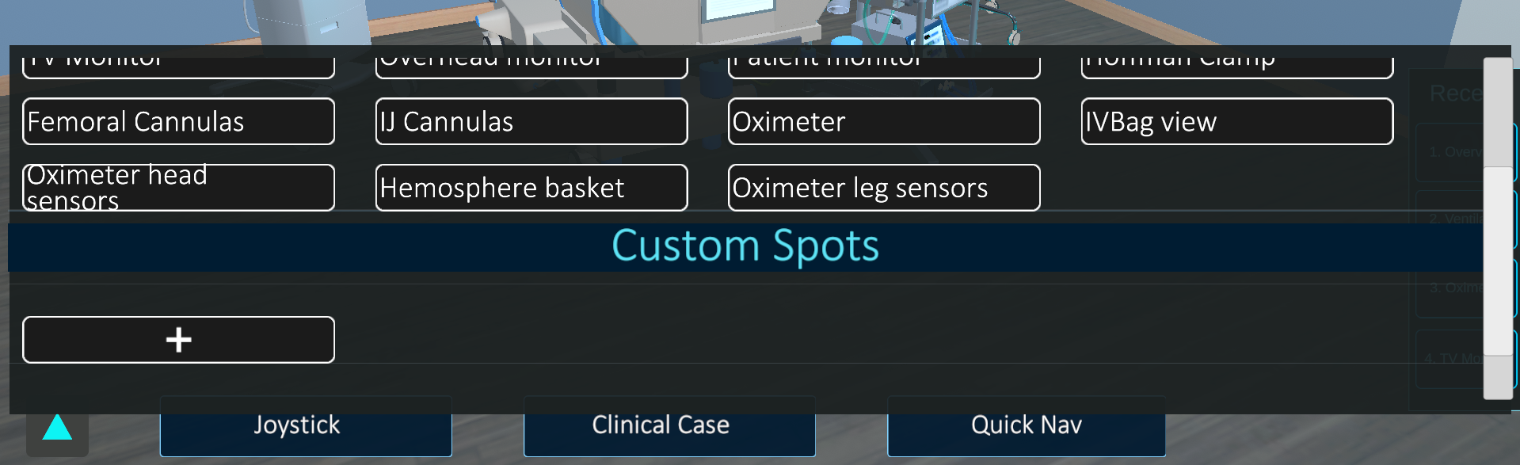

Figure 32b Navigation Spots (cont.)

  - ECMO Circuit Configurations

Clicking the “ECMO” button (second from the left Figure 30) brings up a selection of available ECMO circuit configurations.

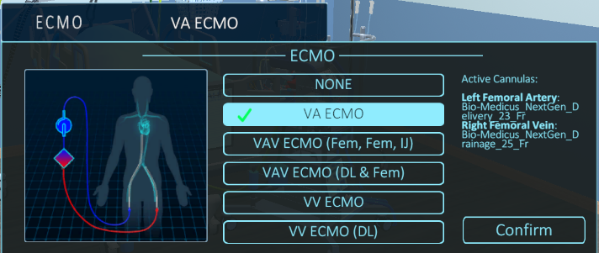

VA ECMO (Fem-Fem)

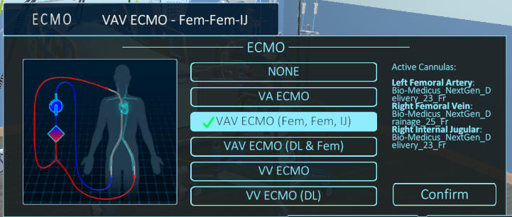

VAV ECMO (Fem-Fem-IJ)

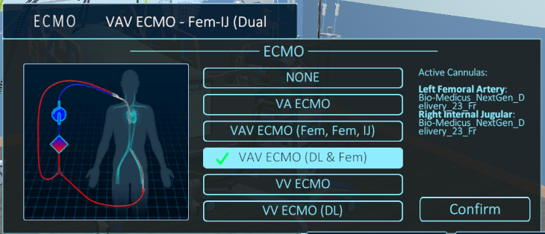

VAV ECMO (DL & Fem)

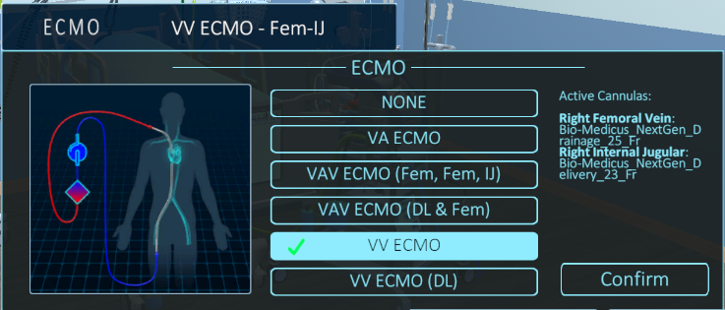

VV ECMO (Fem-IJ)

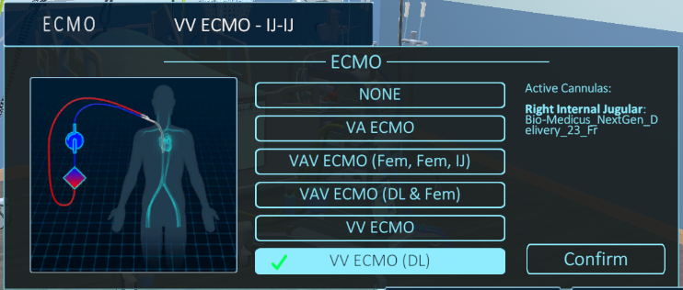

VV ECMO (DL)

Figure 33 Available ECMO Circuit Configurations
Once a cannulation configuration has been selected and confirmed, the appropriate circuit will automatically be introduced into the environment. In the case of the two ECMO circuits utilizing an augmented limb (VAV), a Hoffman Clamp and a flow sensor are placed on the extra branch. The flow probe can be moved to various locations on the circuit. The Hoffman Clamp is a “target” and clicking on it will position the user directly above the clamp and open a small window showing the degree of opening (see Figure 34). The clamp can be opened by turning counter-clockwise.

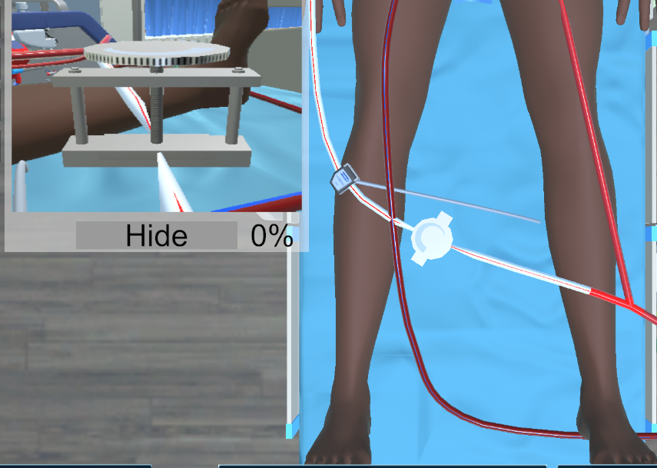

Figure 34 Flow Control and Measurement in Augmented Limb

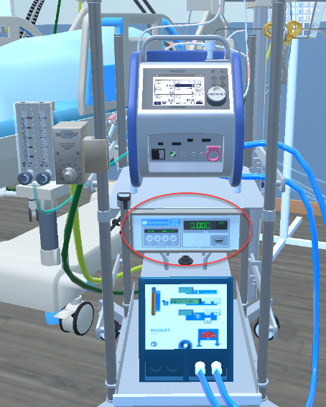

The flow reading can be found on the flow module located between the heat exchanger and the pump.

Figure 35 Flow module

    - Cannula Selection

Clicking on a cannula brings up three options

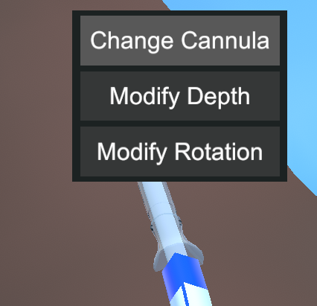

Figure 36 Cannula Options

Selecting “Change Cannula” brings up a separate window (See Figure 37) allowing different cannulas to be chosen. This will cause CALIFIA to make an immediate change in the fluid path resistance to match the resistance properties of the chosen cannula.

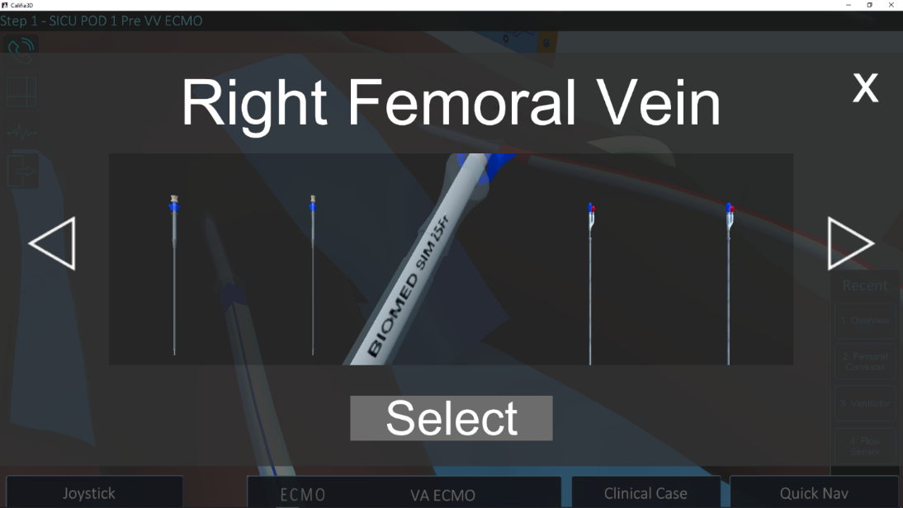

Figure 37 Selecting Different Cannulas

    - Clamps

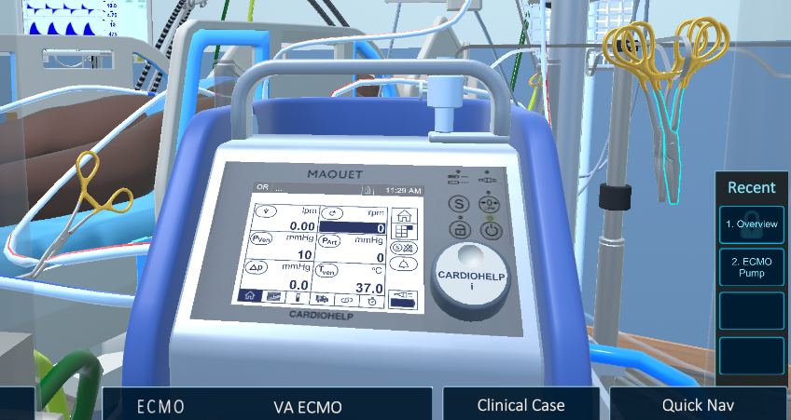

Figure 38 Clamp Targets

Clamps are targetable items (Figure 38) that when selected, will be removed (Figure 39).

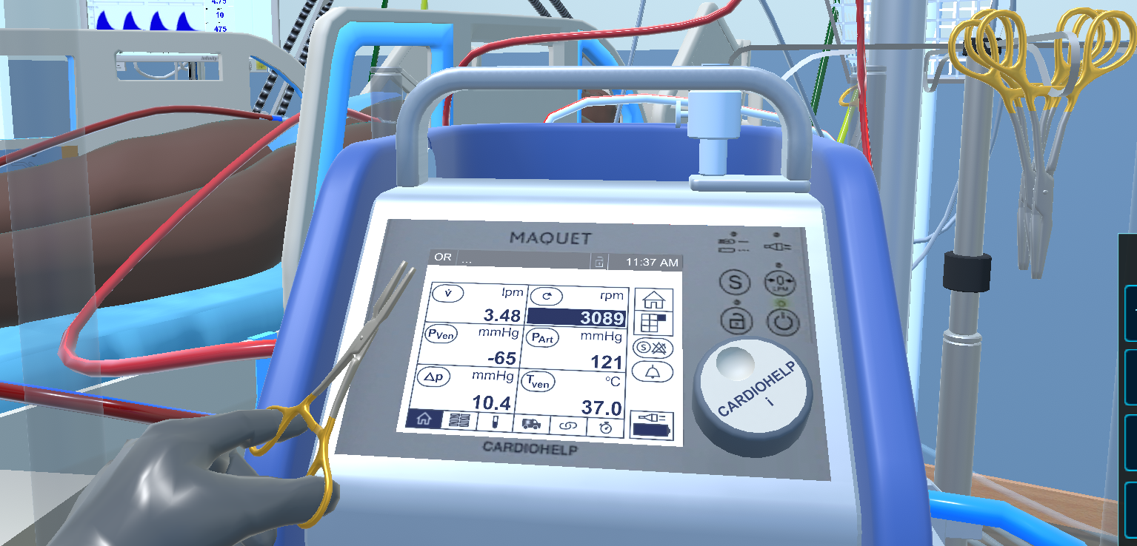

Figure 39 Clamp Removal

    - Call Button

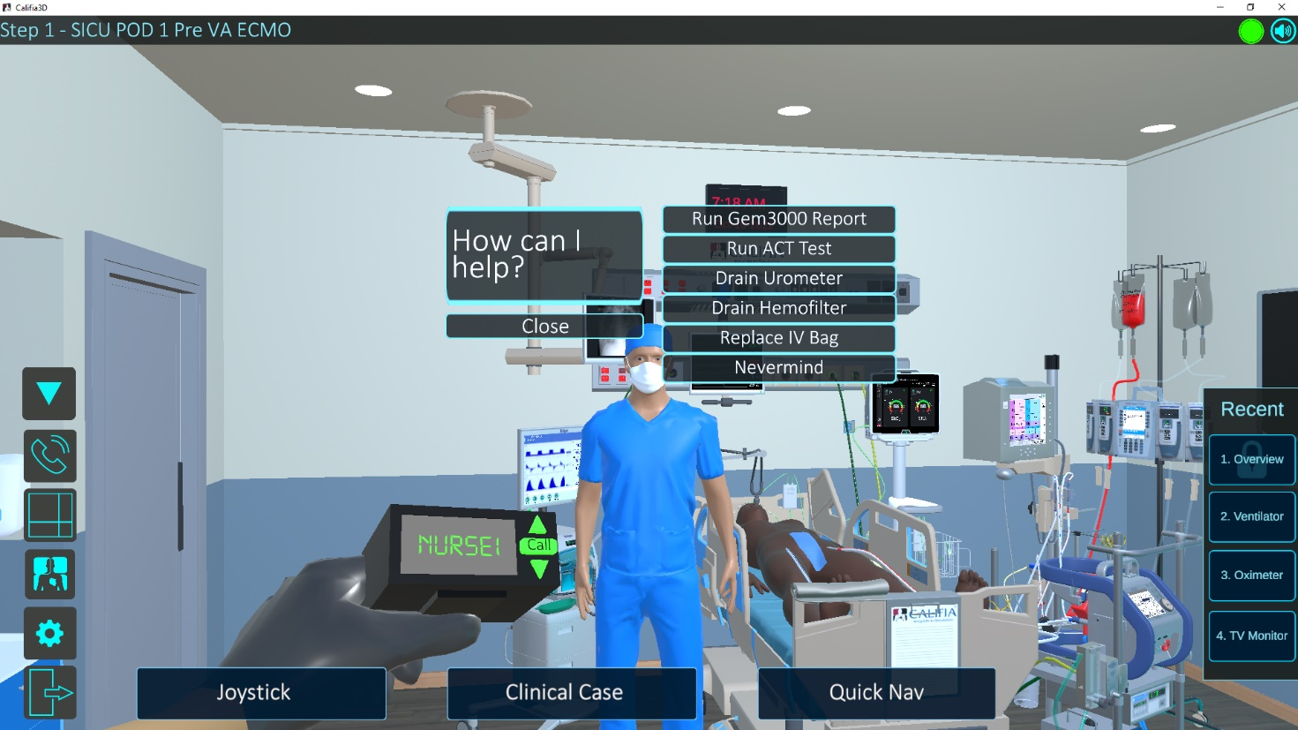

Figure 40 Call Button

Pressing the Up-Arrow (bottom left Figure 30) brings up five new icons along the left border. Pressing the Call button (Figure 40 first left icon) summons the Surgeon or the Nurse. Figure 40 shows the action options available calling the Nurse. If a blood gas is requested, the available sampling sites become visible (Figure 41).

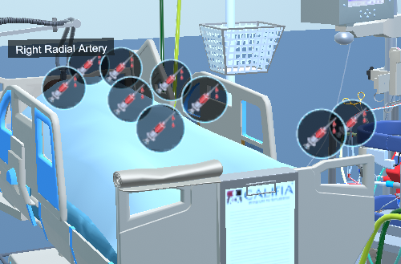

Figure 41 Available Blood Sampling Sites

Clicking on the roll at the top of the foot of the bed will remove (or replace) the sheet over the patient.

    - Cerebral Oximeter

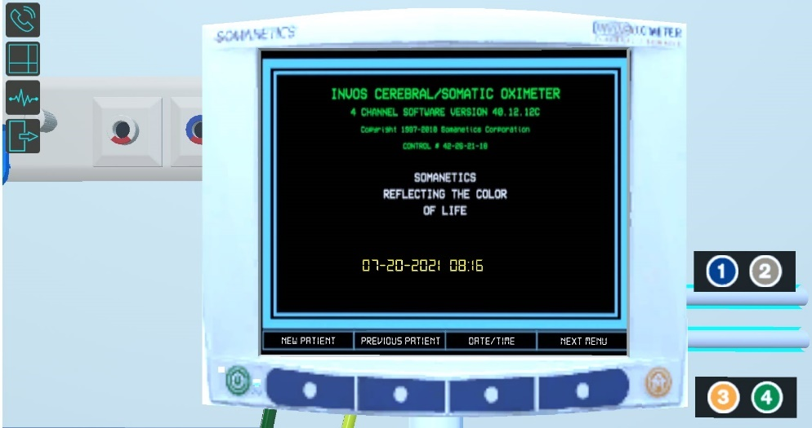

Figure 42 Cerebral Oxymetery Sensors

Turning the oximeter on (Green button lower left. Fig 42) brings up four sensors labeled 1-4. These sensors are links which when clicked immediately bring up a sensor selection option (Fig 43).

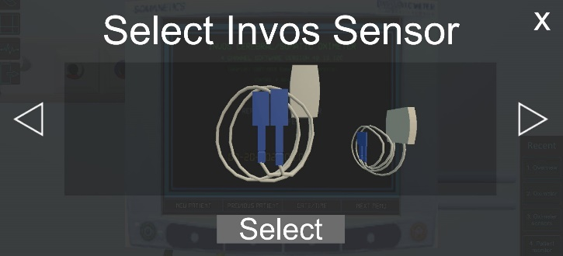

Figure 43 Sensor Selection

Pushing the Select button and selecting a sensor immediately shifts the operator’s perspective to the oxymeter’s sensors (Fig.44). Once all sensors have been selected, press the “Home” button (yellow button right bottom corner).

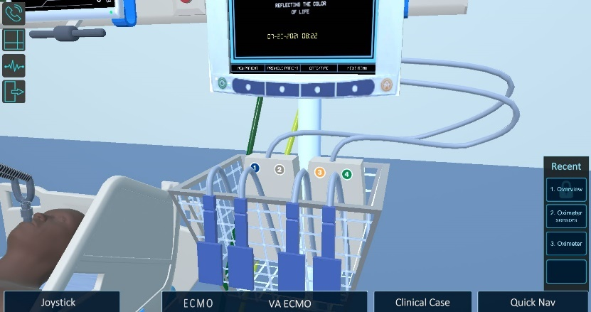

Figure 44 Cerebral Oxymetery Sensors

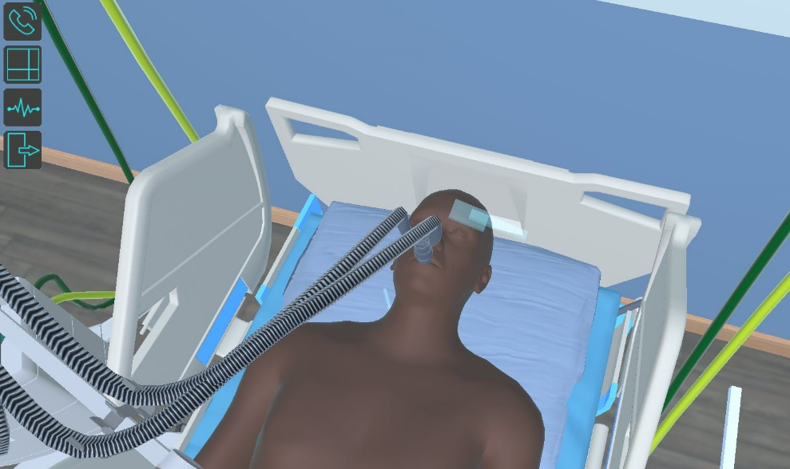

Figure 45 Cerebral Oxymetery Sensor Attachment

Each of these sensors are links that when clicked, shifts the camera’s eye toward the patient and indicating the attachments site for the sensor. In this example shown in Figure 45, sensor #1 was chosen and the attachment site is the left temple.

Clicking on that location automatically secures the sensor and shifts focus back to the sensor tray (Fig. 44). Once all sensors have been attached, the oximeter is ready to use.

    - Patient’s Chart

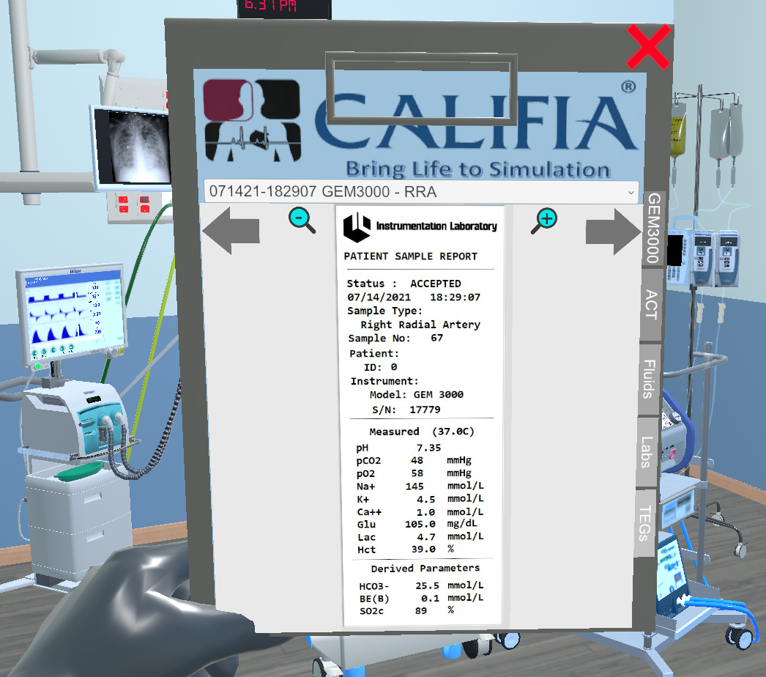

Figure 46 The Patient’s Chart

Clicking on the chart at the end of the bed brings it front and center as shown in Figure 46. Depending on the scenario, the chart may contain blood gas results, ACT, Fluid balance sheet, lab reports and Thromboeslastogram printouts. Clicking anywhere outside the chart places it back on the end of the bed.

    - Fluid Infusion

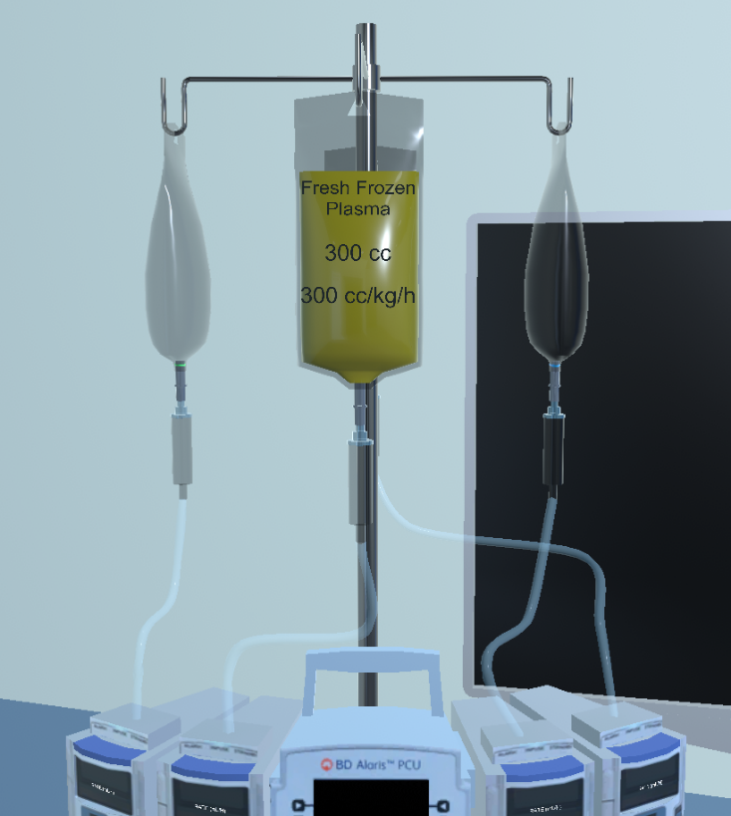

Clicking on the IV bag (Figure 43) brings up a separate window (Figure 48) to change the type of fluid to be infused.

Figure 47 IV Infusion Set-Up

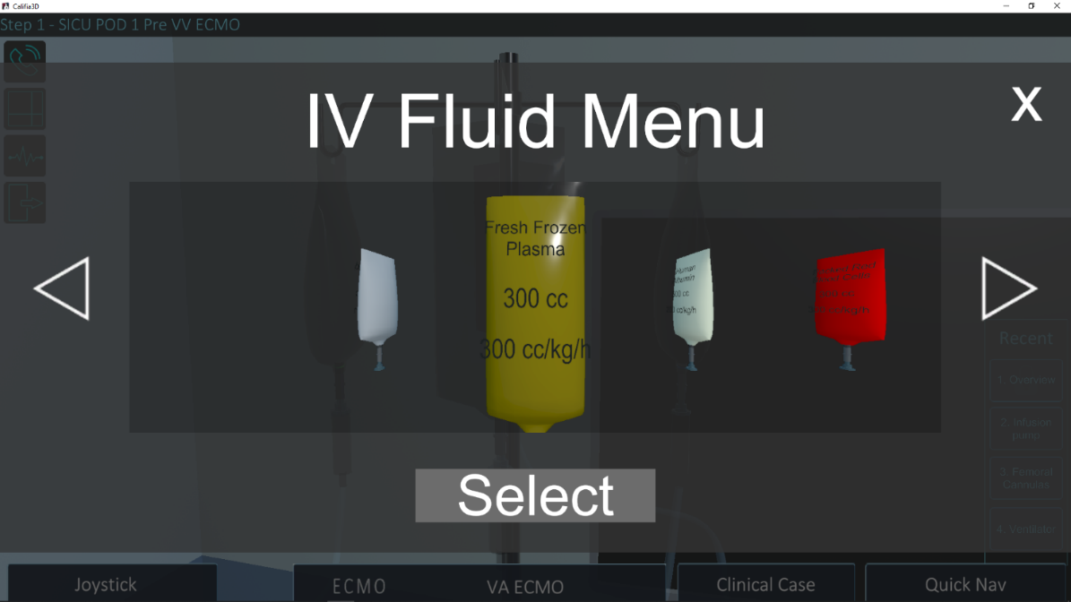

Figure 48 Selecting Different Infusion Solutions
    - Mosaic Mode
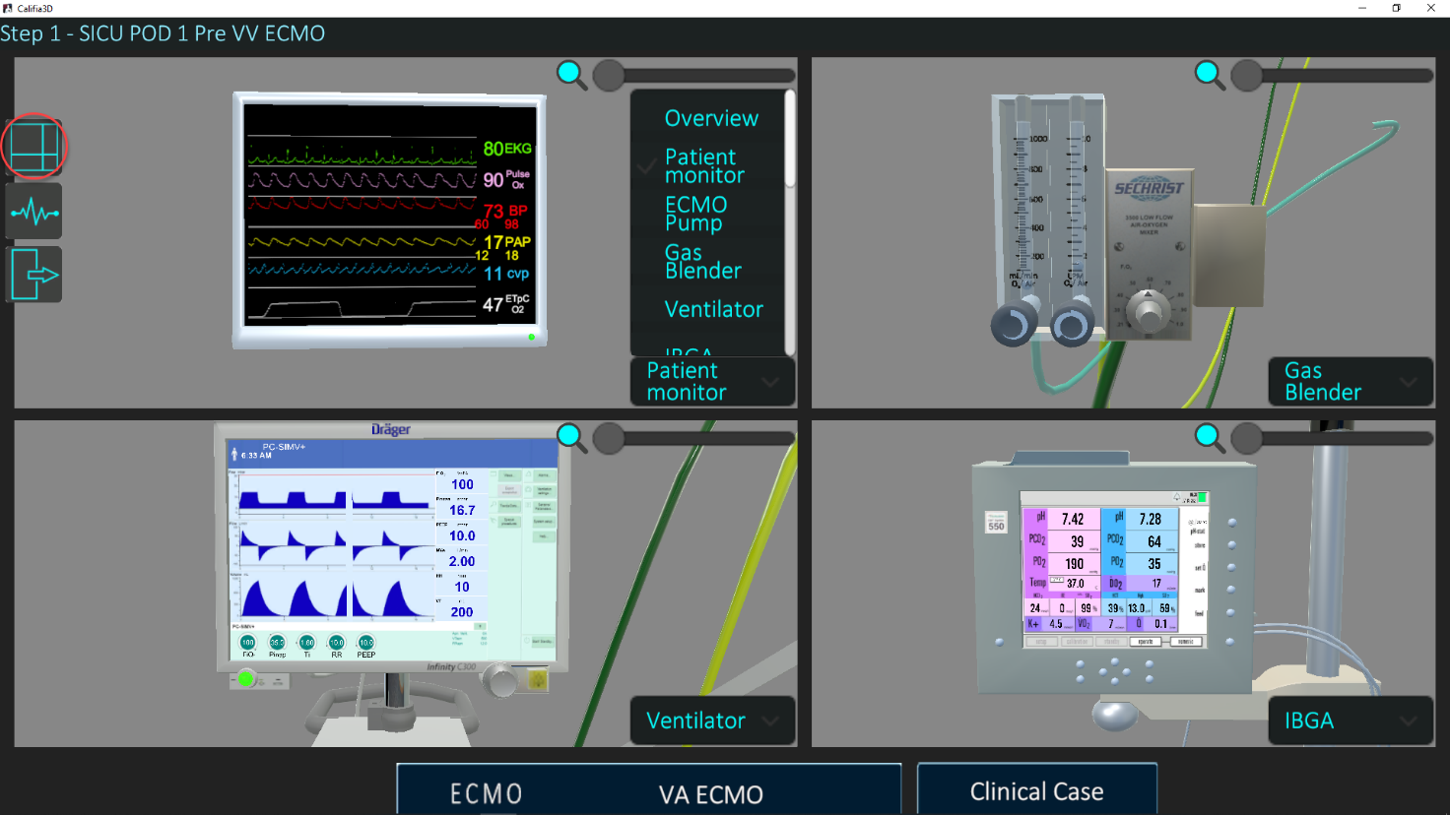

Figure 49 Mosaic Mode Instrument Layout

An alternate, “Mosaic” layout can be utilized by clicking the icon on the left margin (Figure 49). Any of the devices in the ICU can be chosen to occupy one of the windows by clicking on the label and choosing from the devices listed. Also, it is possible to zoom in and out of each window using the slider adjacent to the magnifying glass in the top right corner. It should be noted that each of the devices retain their functionality in this mode.
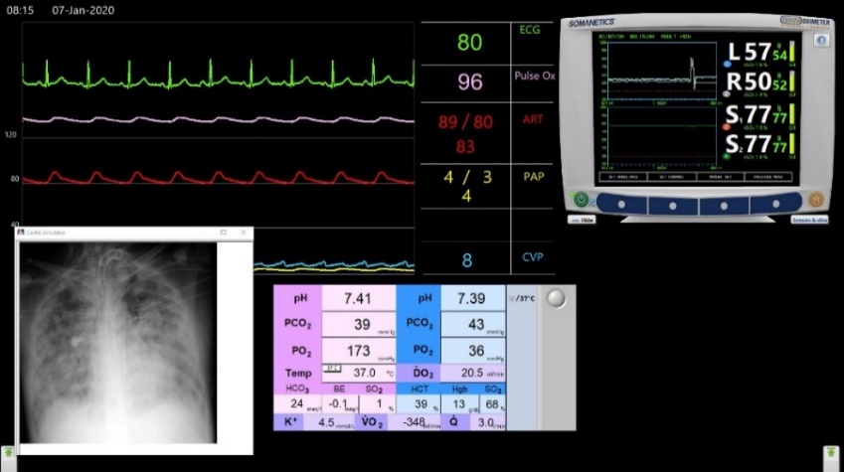

Figure 50 Legacy Learners Screen

It should be noted that the 3D environment window can be collapsed (or closed) revealing the legacy screen (Figure 50) which remains fully functional and will be described in later sections.

- Instructor’s Panel

Figure 51 Instructor’s Panel

The Instructor’s Panel contains the controls needed to manipulate patient variables, display specific monitors, and analyzers, and control the clinical scenario.

Near the top middle of the Instructor’s Panel is a cluster of indicators providing information about the patient including rate of oxygen consumption$\left({\dot{V}}_{O_{2}}\right)$, CO₂ production $\left({\dot{V}}_{{CO}_{2}}\right)$ oxygen delivery$\left({\dot{D}}_{O_{2}}\right)$. Also given is the native cardiac output (C.O.). A drop-down menu allows the use of different formulae for BSA calculations. These are described in Appendix G.
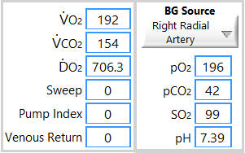

Figure 52 Patient Information Panel

The 8 Tabs in the lower right corner of the panel (Figure 52) will be described in the sections that follow. .

  - Patient Variables Tab

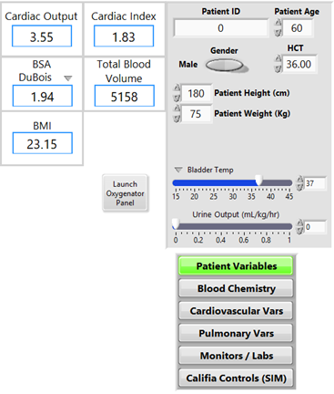

Figure 53 Patient Variables Panel

The “Patient Variables” tab brings up the panel used to change various patient parameters and the oxygenator parameters by clicking on “Launch Oxygenator Panel” button (see Figure 53). The temperature labels on the OR Monitor can be changed using the drop-down menu as shown in Figure 54.

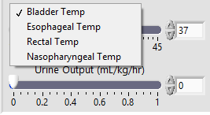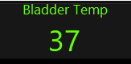

Figure 54 Patient Temperature Labels (Instructor’s Panel: Left, Legacy Panel: Right)

  - Blood Chemistry Tab
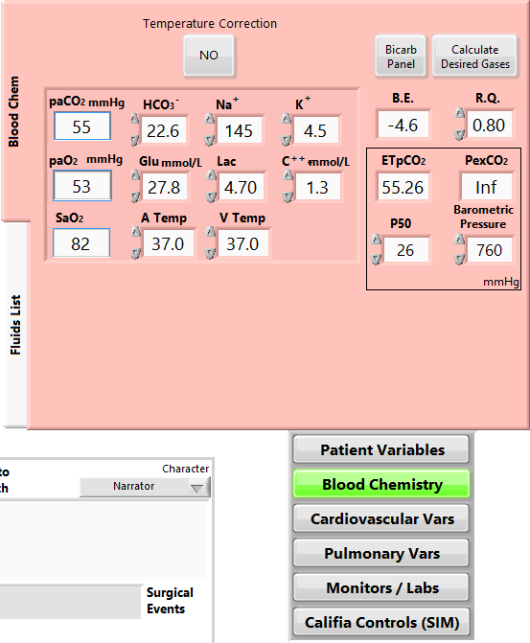
The “Blood Chemistry” tab reveals controls used to set electrolytes, arterial and venous blood gases and temperature (see Figure 55). In addition, whether the on-line monitor displays temperature corrected values or not can also be selected by button at the top of the panel. It should be noted that if the blood gases are being calculated
(see 8.1. Blood Gas Calculation ) entries for blood gases in this panel are indicators only and thus cannot be manually changed (as shown in Figure 41). Likewise, if the Patient’s temperature is being calculated
(see 8.2. Temperature Source), the A Temp and V Temp windows will become indicators only and thus cannot be manually changed.

Figure 55 Blood Chemistry Controls

      - Bicarbonate ion ( HCO₃⁻ )

Bicarbonate concentration can be manipulated by pressing the desired change (increasing or decreasing HCO₃⁻ concentration in mmol/L) Changes are made in one mmol/L increments.

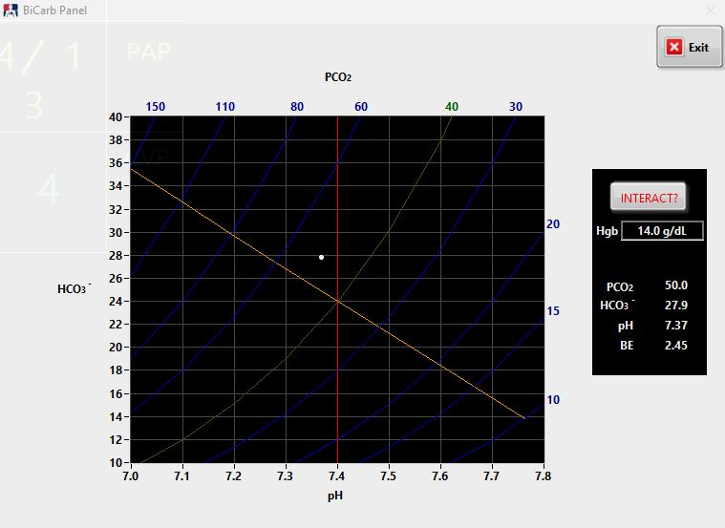
Pushing the “Bicarb Panel” button will bring up the Bicarb window as seen in Figure 56.

Figure 56 Bicarb Panel – “Display” mode

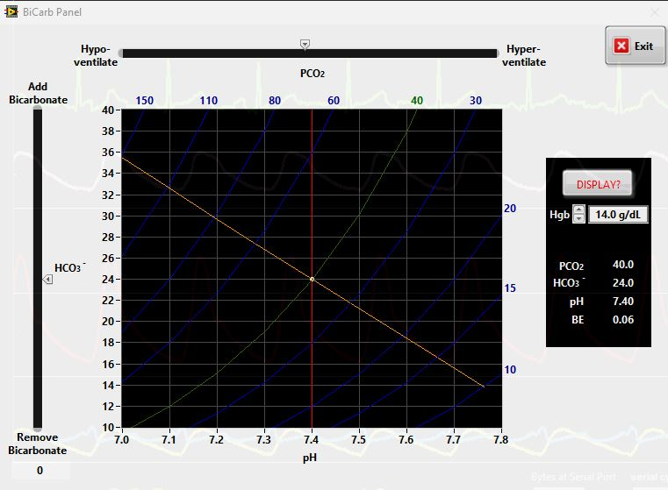
The “Bicarb Panel” can be moved anywhere between the Instructor’s panel and the OR screen and can function in two modes: “Display” and “Interactive”. In the Display mode (shown in Figure 52), the Bicarb window simply plots the status of the patient.

Figure 57 Bicarb Panel – “Interactive” mode

In the Interactive mode, the operator can make adjustments in the pCO₂ and add or remove HCO₃⁻ by way of two sliders as well as adjust Hgb (see Figure 57). These manipulations will NOT change the patient parameters but is intended for illustrative and educational purposes only.

      - Calculate Desired Gases
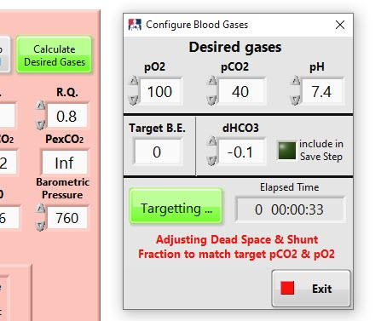

Figure 58 Bicarb Panel – “Interactive” mode

When the “Calculate Desired Gases” button is pressed a separate window opens as shown in Figure 58. This window allows the entry of pO₂, pCO₂ and pH. Pulmonary compliance, shunt fraction and dead space will be adjusted to give the target gases.
      - Heparin Dose Response

Controls for the HMS Heparin Dose Response analysis are found in the middle window near the middle of the Blood Chemistry tab (see Figure 55). Pushing the “Display Printout” button will make the HMS printout visible on the Legacy OR Monitor Display as shown in Figure 50. It can be closed by pushing the “X” in the upper right corner of the printout display.

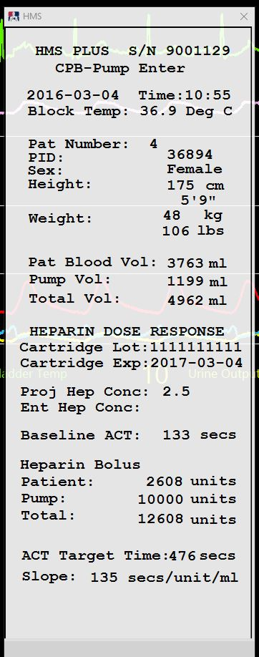

Figure 59 HMS “Virtual” Printout on Legacy Screen

An actual print-out can be obtained by pressing the button labeled “Call for HMS” found near the bottom - middle of the Legacy OR Monitor Menu Ribbon as seen in Figure 60

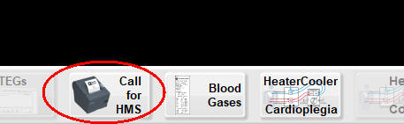

Figure 60 Call for HMS

  - Fluid Management
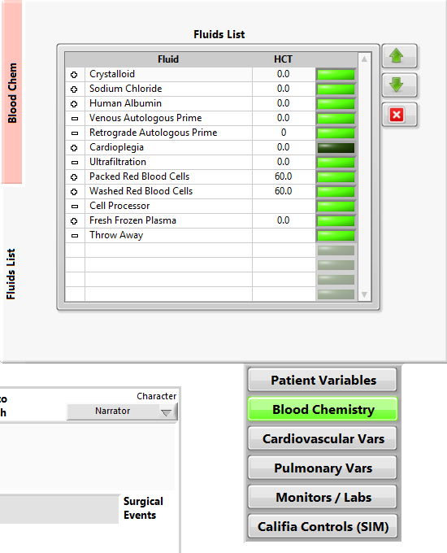
The Fluid Management Module offers the ability to manage the addition or removal of fluids from the patient’s total blood volume. This feature consists of the Fluid List on the Instructor Panel, and the Fluid Panel icon on the OR Monitor. The instructor uses the Fluid List to name and configure the list of fluids available to the learner during a clinical scenario. The learner opens the Fluid Panel, selects a fluid from the list and enters a volume to be administered or removed. Depending on the characteristics of the fluid entered by the instructor in the Fluid List, the learner’s actions will result in Total Blood Volume (TBV) and/or hematocrit (HCT) changes. The CALIFIA® program uses the updated TBV and HCT values to calculate SvO₂ and VO₂.

      - Defining the I-O Characteristics of Fluids in the Master List

The Fluid List on the Instructor Panel defines the fluids that can be accessed in the Fluid Panel on the OR Monitor. This list can be edited and added to.
Table E1a and Table E1b lists fluids preloaded into the software and accessible through the Fluid Panel, in the CPB and ECMO program, respectively.

Fluid | Effect on HCT | Effect on Total Blood Volume | Fluid HCT
Crystalloid | ↓ | ↑ | 0
Colloid | ↓ | ↑ | 0
Drugs | ↓ | ↑ | 0
Retrograde autologous prime | ↑ | ↓ | 0
Cardioplegia | ↓ | ↑ | 0
Ultrafiltration | ↑ | ↓ | 0
Packed Red Blood Cells | ↑ | ↑ | 60%
Washed Red blood cells | ↑ | ↑ | 55%
Cell processor | ↔ | ↓
Fresh Frozen Plasma | ↓ | ↑ | 0
Throw away | ↔ | ↓

Table E1a Preloaded CPB Fluid List

Fluid | Effect on HCT | Effect on Total Blood Volume | Fluid HCT
Crystalloid | ↓ | ↑ | 0
Colloid | ↓ | ↑ | 0
Drugs | ↓ | ↑ | 0
Retrograde autologous prime | ↑ | ↓ | 0
Ultrafiltration | ↑ | ↓ | 0
Packed Red Blood Cells | ↑ | ↑ | 60%
Washed Red Blood cells | ↑ | ↑ | 55%
Fresh Frozen Plasma | ↓ | ↑ | 0
Throw away | ↔ | ↓

Table E1b Preloaded ECMO Fluid List

The instructor can add fluids to the master list by naming the fluid and designating the effect on TBV and HCT. They can also edit the existing entries. For example, the PRBC and washed RBC’s assume a product with a 60% and 55% hematocrit, respectively. This can be changed by the instructor (see Editing Fluid List).

      - Initiating the Fluid Panel

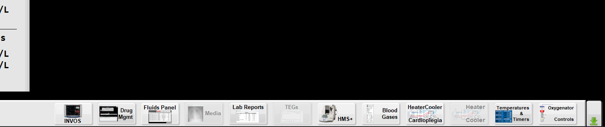
Press the Fluid Panel button on the OR Monitor menu ribbon (see Figures E1 and E2).

Figure E1 Accessing the Fluid Panel

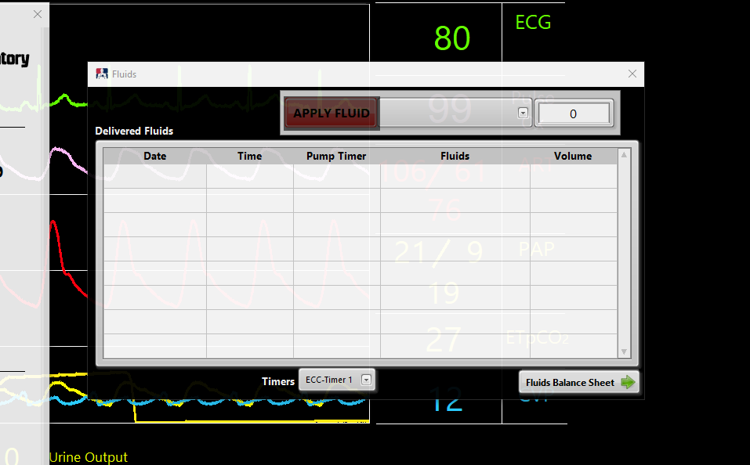

Figure E2 Fluid Panel When Initially Launched

      - Preparation of Priming Fluids (Pre-CPB or Pre-ECMO)

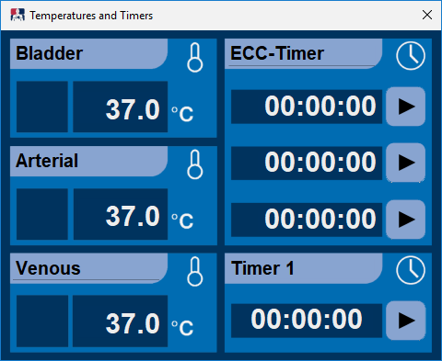
NOTE: The impact of the fluids entered in this table will only take effect when the simulated patient is on extracorporeal (ECC) support. The program recognizes that the patient is supported on ECC when the system detects blood flow in the arterial line AND the ECC-Timer is started (see Figure E3).

Figure E3 ECC-Timer.

Select one of the fluid options from the drop-down menu to add to the prime. For example, Crystalloid.
Press the volume to the right of the fluid selection and a number pad appears. Enter the volume of crystalloid in the prime (see Figure E4). Note: the program will ask for confirmation when the input exceeds 999-mL.
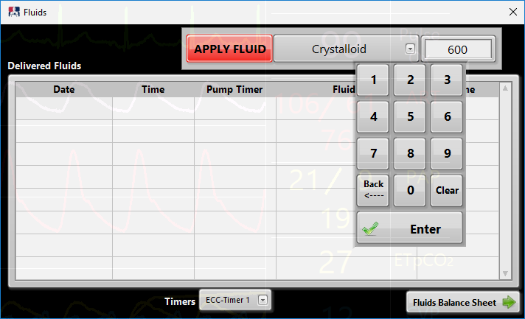
Figure E4 Enter Volume

Press APPLY FLUID to add the fluid to the list of Infused Fluids (see Figure E5).
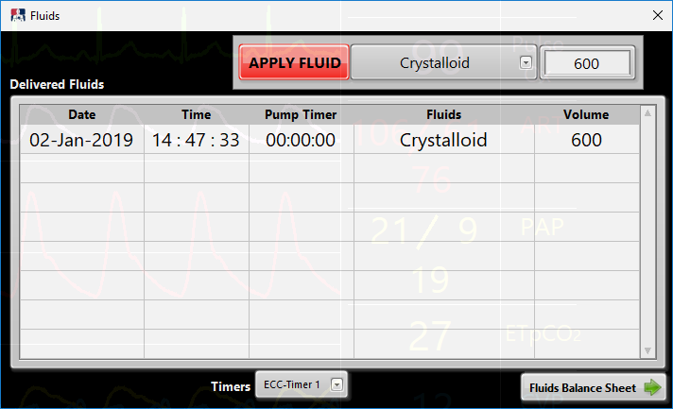

Figure E5 Apply Fluid to List of Infused Fluids

Repeat previous steps to add additional fluids to the prime (see Figure E6).

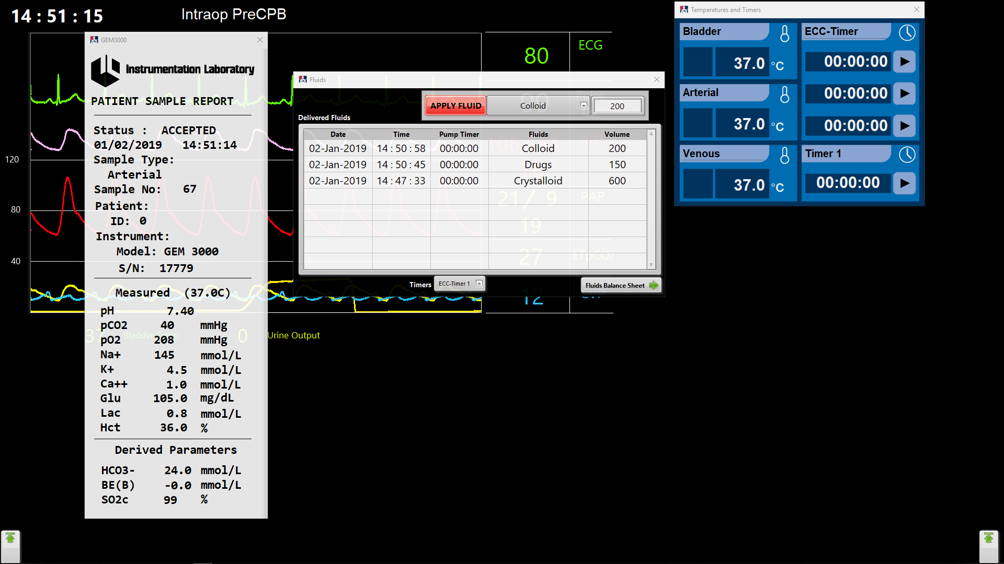
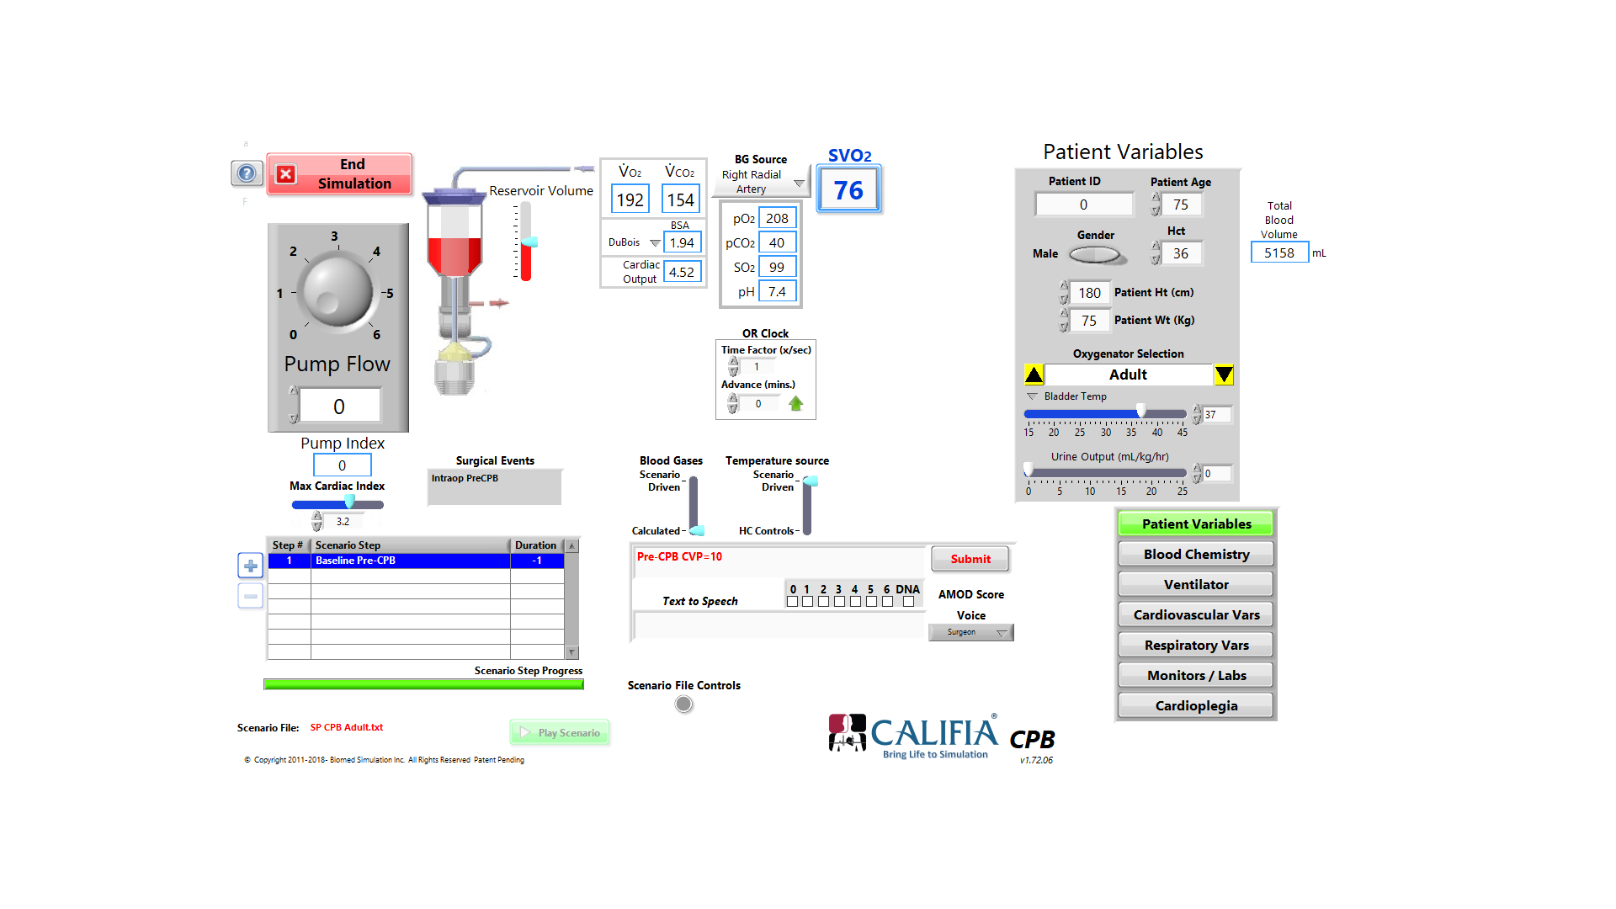

Figure E6 Entering Fluids Prior to Starting ECC-Timer AND Initiating Flow Through the Arterial Line

Note in Figure E6 the values under the Pump Timer column are all zero. Because the patient is not on ECC support, these entries have no affect on the TBV or HCT. The TBV on the Instructor’s Panel displays the patient’s initial blood volume.
Once CPB or ECMO flow is initiated and the ECC-Timer is started, the fluid entries will increase the TBV and decrease the HCT (see Figure E7).

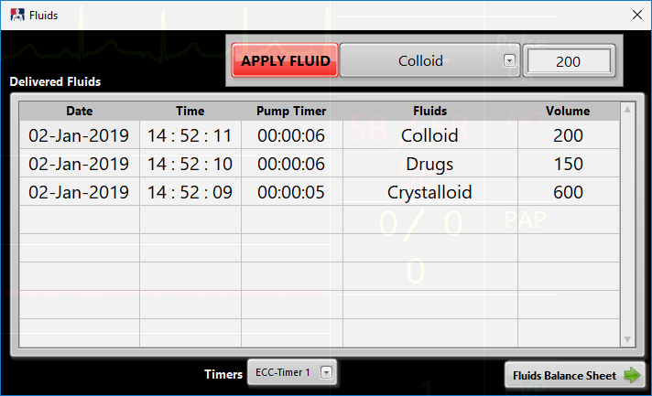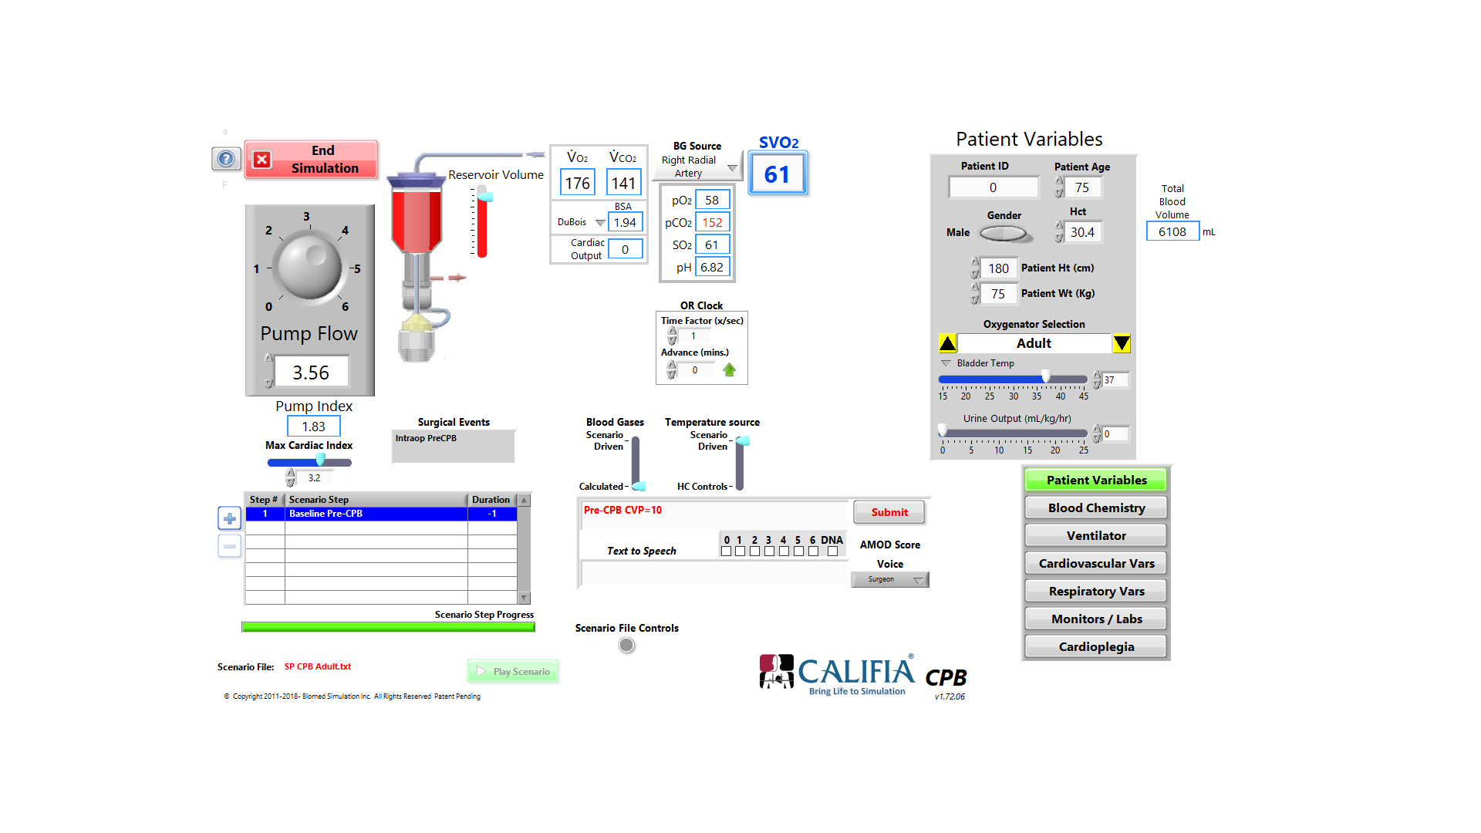

Figure E7 ECC-Timer Started and Forward Flow Detected Through the Arterial Line

Retrograde Autologous Prime and Antegrade Autologous Prime volumes can be entered in the Delivered Fluid list either before or after initiating ECC support. Either way the program uses the volume entered to reduce the hemodilution effect of the total prime. For example, if the total volume of the crystalloid prime is 950-mL and the RAP volume is 500-mL the dilutional effect of going on ECC support will be 950 – 500 = 450-mL.

      - Fluid Management on ECC Support

- Pressing APPLY FLUID immediately affects the TBV and HCT. These values cannot be edited once the APPLY FLUID button is pressed.
- The Fluid Panel in Figure E8 shows an 800-mL crystalloid cardioplegia entry. The result is an increase in TBV and a decrease in HCT.

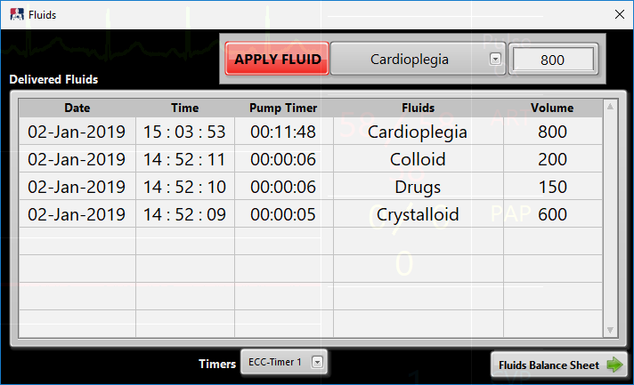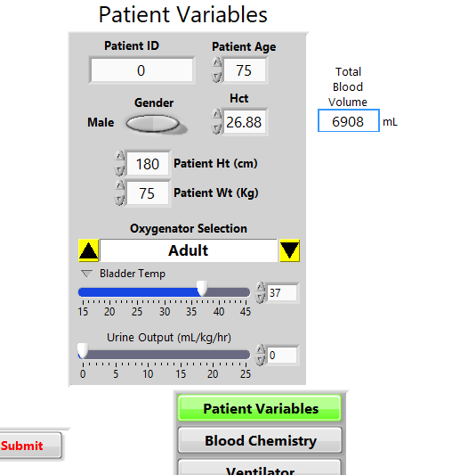

Figure E8 Cardioplegia Delivery

- Note in Figure E9 that by removing 800-mL of plasma water with Ultrafiltration the TBV and HCT returned to pre-Cardioplegia administration values

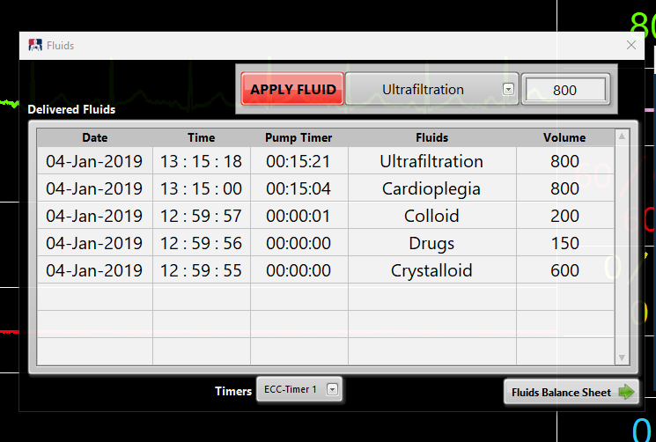

Figure E9 Removing Fluid via Ultrafiltration will Reverse Hemodilution Due Cardioplegia

      - Urine Output Management

- The Urine Output affects the patient’s TBV and HCT and is set on the Instructor’s Panel as a rate Urine Output (mL/kg/hr). If the urine output for a 75-kg patient is set at 5-mL/kg/hr, the patient will produce 375-mL of urine in one hour (60-minutes). The OR Clock > Time Factor (x/sec) can be used to speed up the effect of Urine Output. For instance, a Time Factor of 60 will display in one minute of actual time the results of one hour of urine output (see Figure E10).

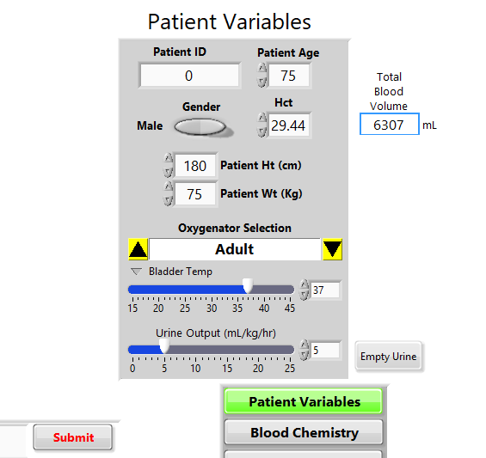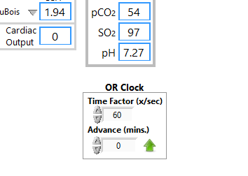

Figure E10 OR Clock Will Influence Urine Output Reported on the OR Monitor

The accumulated Urine Output, in mL, is displayed on the OR Monitor below the pressure waveforms (see Figure E11).

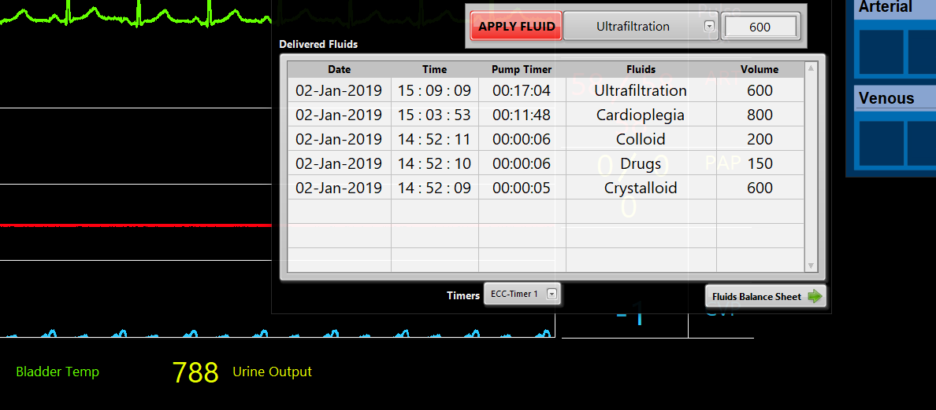

Figure E11 Urine Output Displayed on OR Monitor

The value displayed on the OR Monitor will reset to zero when the instructor presses the Empty Urine button on the Instructor’s Panel (see Figure E12).
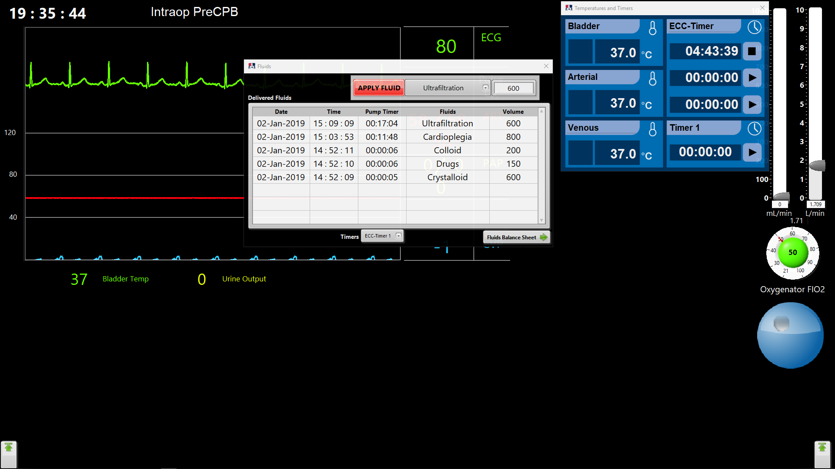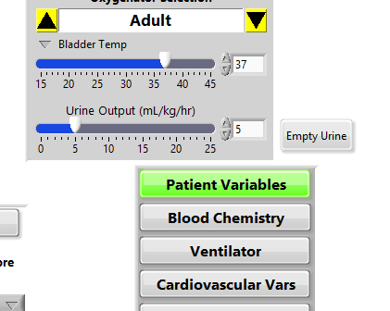

Figure E12 Pressing ”Empty Urine” on Instructor Screen Will Reset Urine Output on OR Monitor to Zero

      - Fluids Balance

Press Fluid Balance at the bottom of the Infused Fluid list (see Figure E13). The Fluid Balance table is a summary of input and output fluids during the case

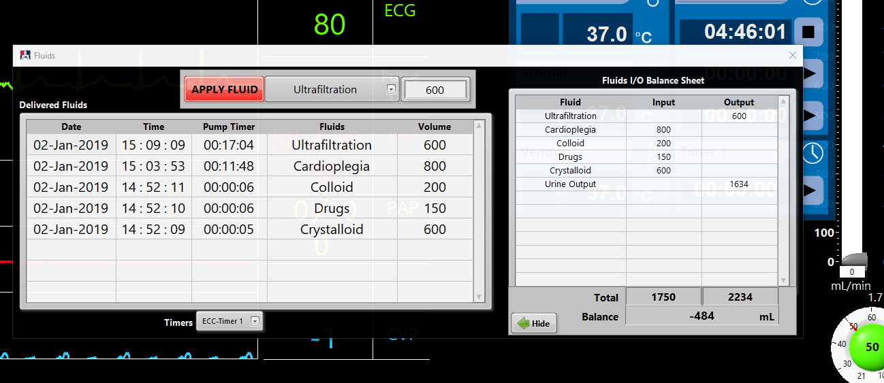
Figure E13 Fluid Balance Table

- Urine Output volume is added to the Fluid Balance table only when the operator presses Empty Urine.
- Once ECC support is terminated, TBV and HCT will no longer be affected by fluids entered in the Infused Fluid list.
- The instructor can edit TBV and HCT on the instructor panel both on and off ECC support. This can be useful, for example, if the instructor wishes to simulate interventions by the team when the patient is off ECC Support. Prior to reinitiating ECC support the instructor can create a patient profile that exhibits a low HCT and a high TBV.
- Urine Output (mL/kg/hr) will affect Total Blood Volume and HCT on and off ECC support.

      - Adding and Editing Fluids in the Master Fluid List

- Press Blood Chemistry > Fluid List on the Instructor’s Panel to access the Fluid List. Fluids in the lists have four attributes that determine how the fluid affects the TBV and HCT (see Figure E14).
- The first column determines if the fluid increases or decreases the TBV and can be assigned + or -. Values can be changed from + to – by pressing the sign.
- The Fluid column accepts any text input, and has no affect on how the fluid affects TBV and HCT.
- The HCT column indicates the hematocrit of the fluid. For example, a crystalloid solution HCT would be 0. The preloaded Packed Red Blood Cells have an HCT of 60%, but the instructor can change this value to accommodate clinical practice. If the field is left blank, the HCT of the fluid will be equal to the patient’s HCT at the time the fluid is infused. For example, Throw Away Blood might have the same HCT as the patient when the HCT field is left blank or it may have a considerable amount of crystalloid mixed in. In the latter case the instructor may wish to change the HCT value to 10 or 15.
- The last column determines if the learner will have access to this fluid in the Fluid Panel selection. 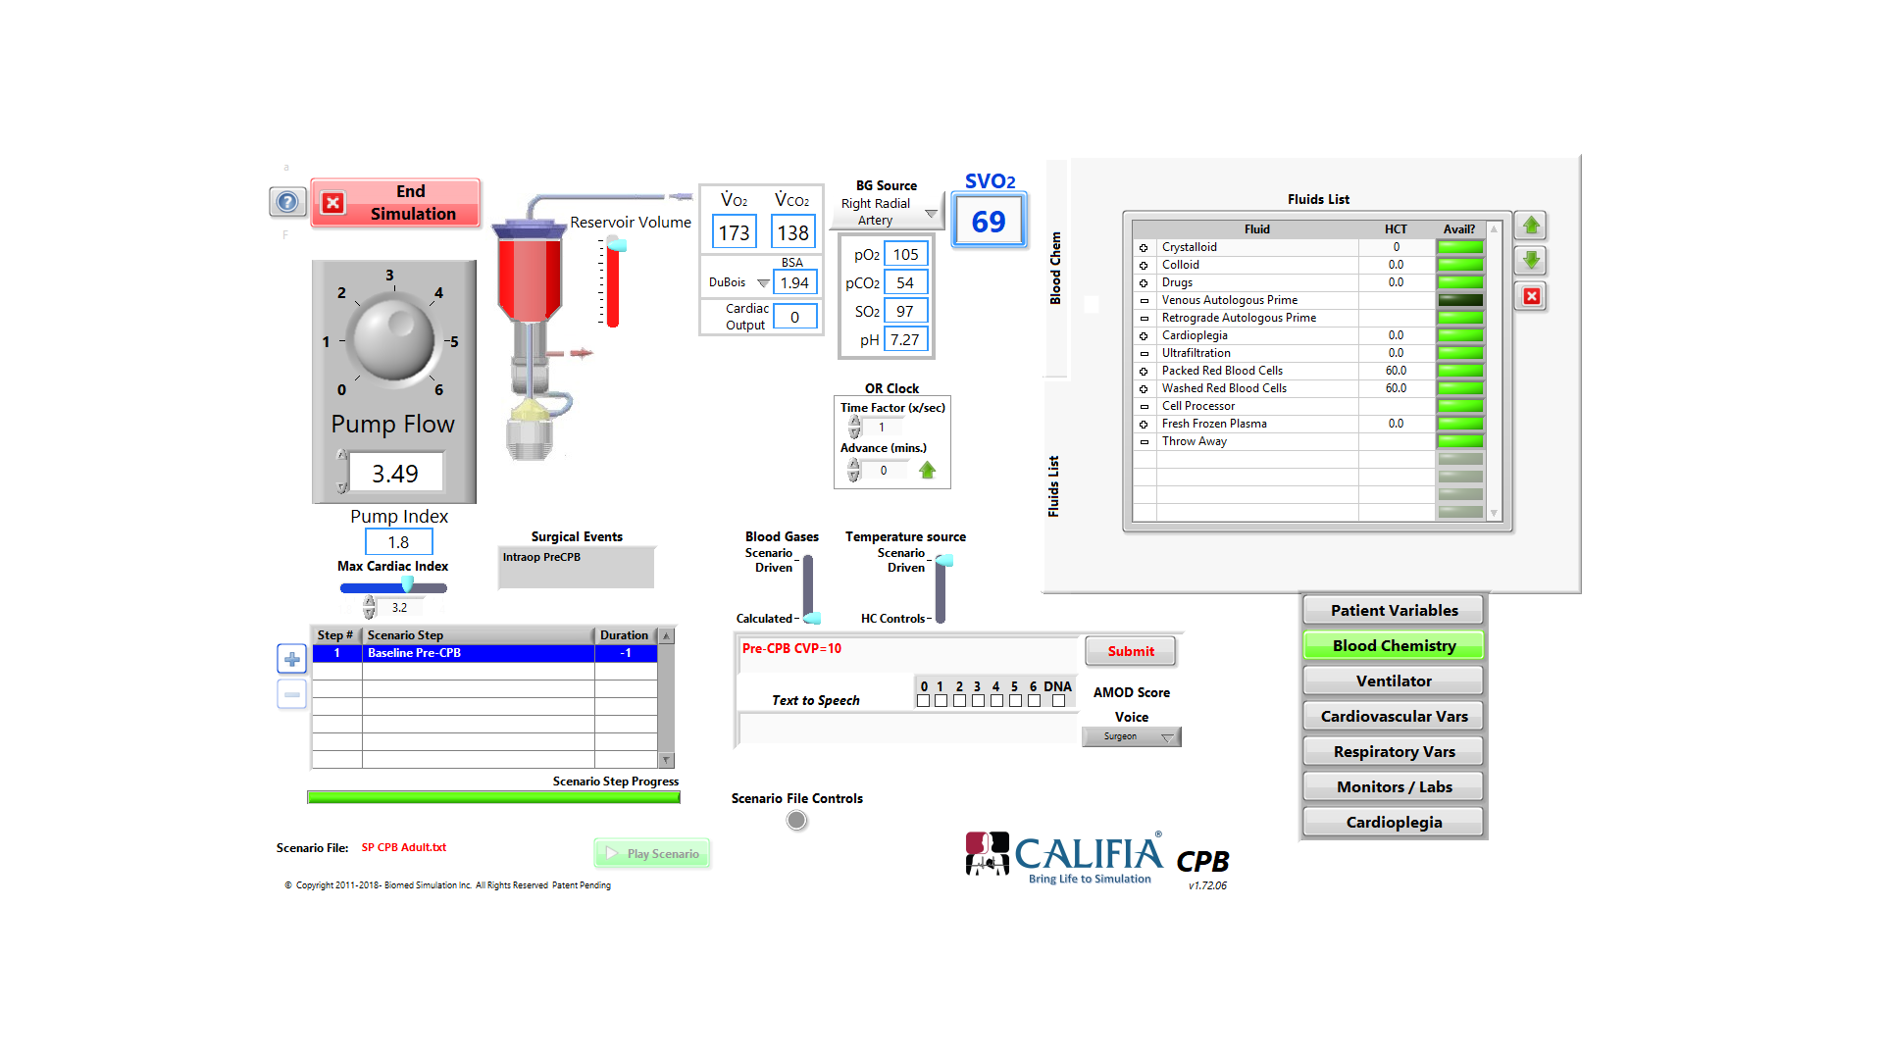indicates availability and indicates that it is not available.
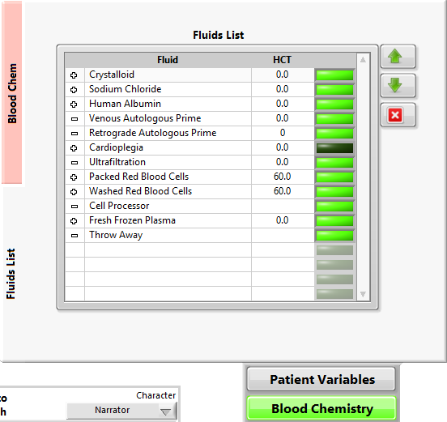

Figure E14 Editing the Master Fluid List

      - Fluid Management Module Data Captured in the Pump Record

Fluid Management Module data may be recorded on the Pump Record, when Fluids under the Parameters list is added to the Pump Record list. The Fluid name, and Volume will be recorded when infused and delivered to the patient. The Pump Record will also capture the Input Fluids, Output Fluids and Fluid Balance from the Fluid Balance. Although the continuous variables such as Flow, MAP etc. are recorded at the interval selected in the opening screen, the Fluid parameters are time stamped at the time they are administered.
See screen shot of pump record in Figure E15. In this example the interval selected was 5-seconds. However, the data for the fluid management is added at the time the fluid was administered.

Figure E15 Screenshot of Pump Record When Fluid is Selected as a Parameter
  - Electronic Gas Blender (EGB)

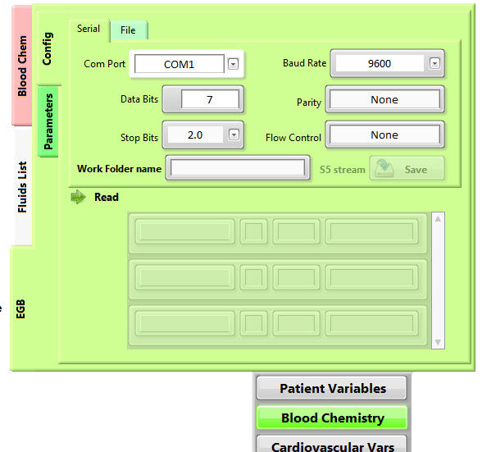
The “Electronic Gas Blender” (EGB) is an optional, add-on accessory which allows direct communication between CALIFIA and the Electronic Gas Blender from the Livanova S5 HLM. Once this connection is established, manipulations of the EGM controls will directly affect the CALIFIA Sweep and FiO₂

Figure 61 Electronic Gas Blender

  - Cardiovascular Variables Tab

Cardiovascular variables can be found under the “Cardiovascular Vars” tab (see Figure 48). Contractility is expressed as a percentage of maximum. The Metabolic factor adjusts for the effect of anesthesia on metabolism with 1.0 representing 100% of calculated basal metabolic rate for the patient. (Note: changes in the patient’s temperature will affect metabolism independently).

The “ECG Choices” buttons determine which ECG pattern is displayed on the Patient Monitor. There are six basic patterns that can be chosen by the top row of buttons; “SR” (sinus rhythm) “STel” ( ST-segment elevation), “Paced” (paced rhythm), “Vfib” (ventricular fibrillation) “Asystole” and “Vtach” (ventricular tachycardia). In addition there are 10 different patterns numbered one through 10 representing a continuous transition from normal sinus rhythm to asystole. During cardioplegia delivery, the simulator will automatically cycle through these 10 patterns at a rate dependent on the cardioplegia delivery flow rate and the “Flow Factor” (see 7.8. Cardioplegia Delivery Tab below).

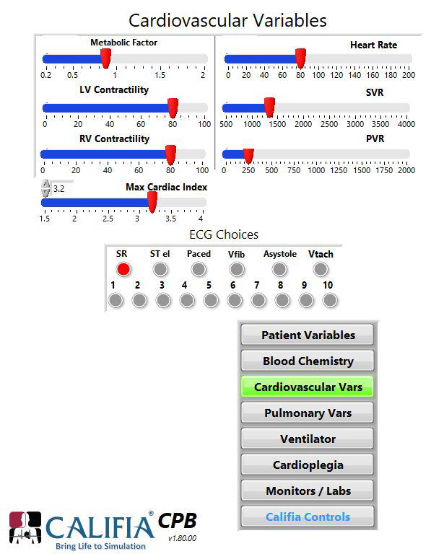

Figure 62 Cardiovascular Variables

Note that if you click just above the left end of each parameter's slider, it will reveal a box displaying its exact numerical value. Allowing for more precise and controlled adjustments. Additionally, please be aware that Heart Rate, LV contractility, SVR, Max Cardiac Index and Metabolic Factor are not limited by the slider range.

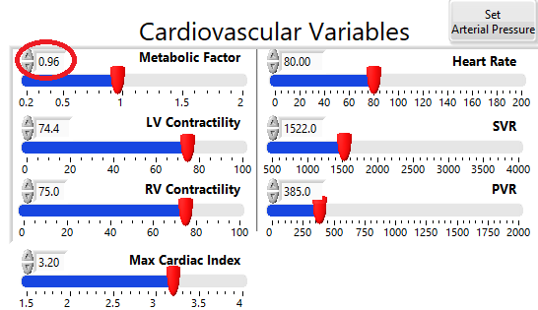

  - Pulmonary Variables Tab

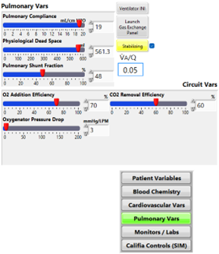
Figure 63 Pulmonary Variables Selection

The “Pulmonary Vars” Tab has four sliders that change Respiratory parameters (see Figure 63). “Pulmonary Compliance” changes the volume of gas ventilating the lungs with each inflation when the ventilator is in Pressure Mode. This predominately affects alveolar ventilation and thus P_{a}CO₂. “Pulmonary Shunt Fraction” affects the PO₂ of blood entering the pulmonary vein, and “Dead Space” alters the alveolar ventilation. “Oxygenator Shunt” affects the gas exchange effectiveness of the oxygenator affecting both O₂ and CO₂ transfer.

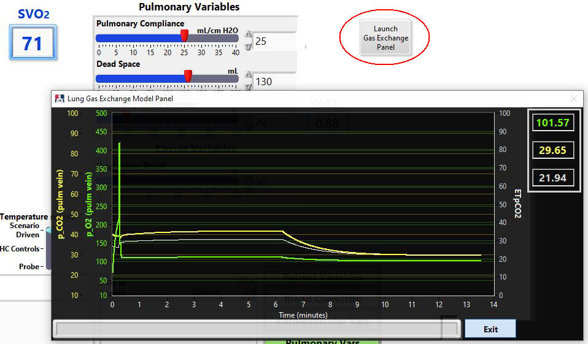

Figure 64 Gas Exchange Panel

  - Ventilator Tab (CPB Only)

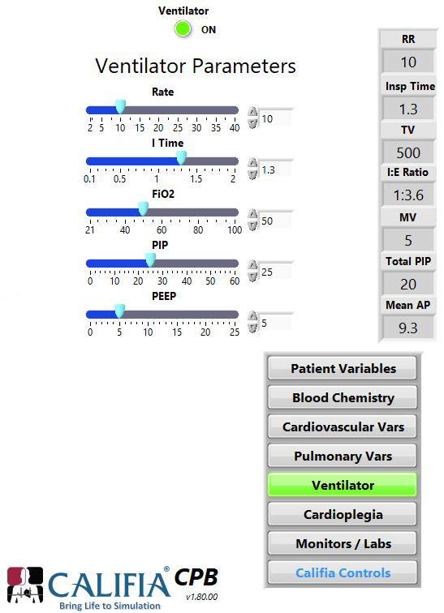
Figure 65 Ventilator Tab Selection

The ventilator is used to support the patient before and after cardiopulmonary bypass.

      - Ventilator.ini File

Along with a scenario file, a ventilator file (*.ini) is required before the simulator can be started (see Figure 8 page 3-1). A ventilator file is a text file which is used to establish the initial ventilator settings. An example of a typical ventilator.ini file is seen in Figure 66. New Ventilator files can be created using a text editor. However, in order for the system to recognize this file, it must be saved with the file extension “.ini”.

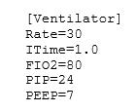

Figure 66 Ventilator ini file

  - Cardioplegia Delivery Tab (CPB Only)

The controls for cardioplegia delivery are found under the “Cardioplegia” tab as shown in Figure 67 below. Toward the top is the indicator showing the rate of “Cardioplegia Flow” in L/min. The three position slider bar allows the instructor to choose between cardioplegia off (“Off”) (see Figure 67A), antegrade (“Ante”) or retrograde (“Retro”) delivery. The cross-clamp button (“XClamp”) applies or removes the cross-clamp. If set to the antegrade or retrograde position and the cross-clamp is on, the simulator will integrate the cardioplegia flow and cycle through the individual ECG patterns depending on the amount of cardioplegia delivered. This process can be accelerated or slowed down by use of the “Rate of Change” control. Moving to a higher Rate of Change number will accelerate the progression through the ECG patterns as long as cardioplegia is being delivered and the cross-clamp is on.
Moving the slider to the Retro position (Figure 67B) does two additional things. First, it brings up another control labeled “Retrograde Resistance”. In addition, it changes the CVP tracing on the OR Monitor screen into a coronary sinus pressure trace. The pressure displayed on that trace will be a function of both the cardioplegia flow rate and the “Retrograde Resistance” value.
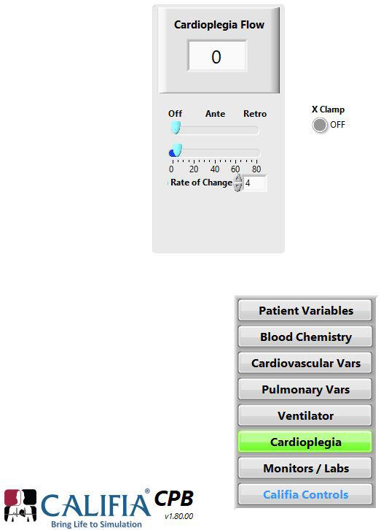
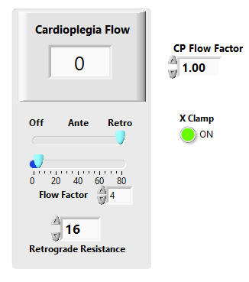

- B.

Figure 67 Cardioplegia Flow Indicator and Controls
  - Monitors / Labs Tab

Various in-line monitors and point-of-care analyzers can be chosen for display on the OR Monitor using the “Monitors/Labs” control panel (see Figure 70). The six in-line blood monitors listed under the top drop-down menu are illustrated in Figure 55
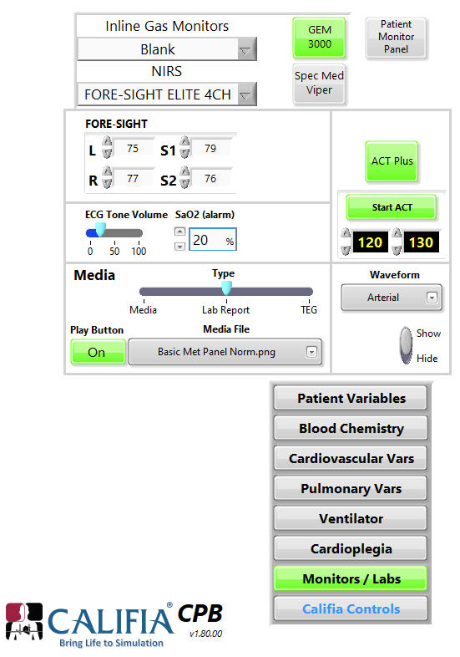
Figure 68 Monitors / Labs Selection

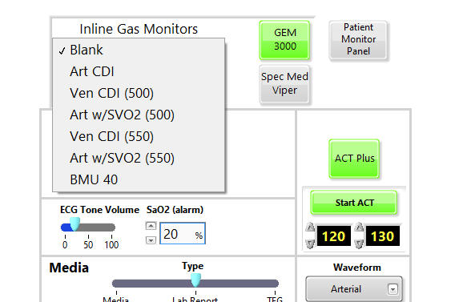

Figure 69 In-Line Gas Monitors

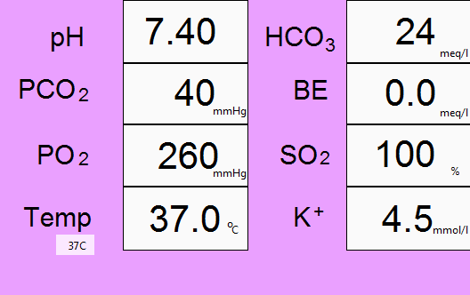

Art CDI

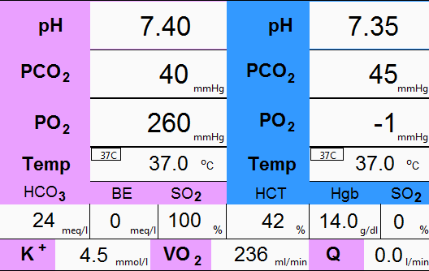

Ven CDI (500)

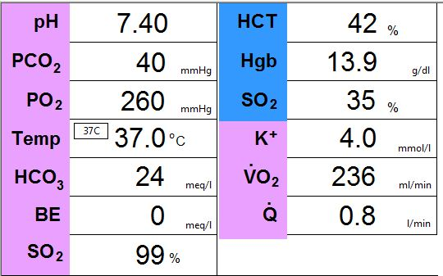

Art w/SVO₂ (500)

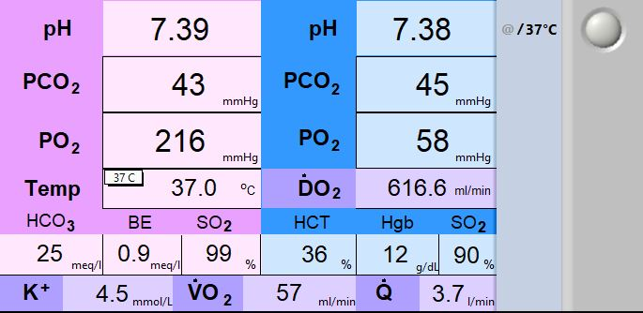

Art w/SVO₂ (550)

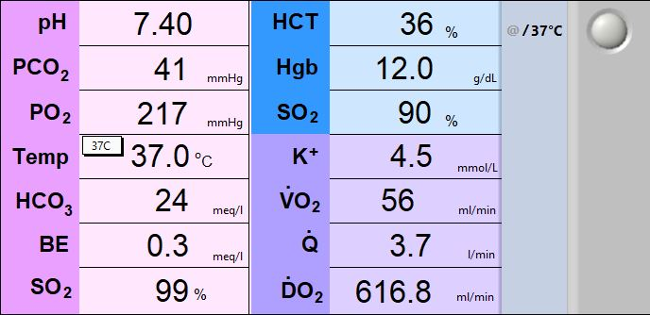

Ven CDI (550)

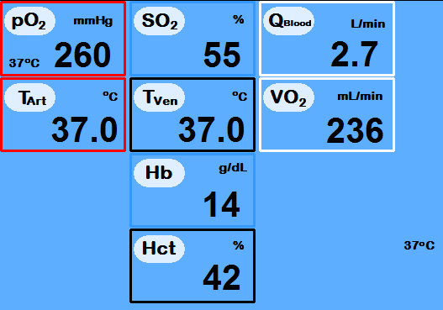

BMU 40

Figure 70 In-Line Gas Monitors Options (cont.)

      - ACT Plus

Pushing the red ACT Plus button (turning it green as shown in Figure 71) causes the ACT results screen to appear near the middle of the OR Monitor (see Figure 71). The ACT controls (Figure 68 above) allow entry for the ACT results, start the analysis, and reset (or start) the counter. The speed of the analysis can be manipulated by speeding up the OR clock by increasing the time factor (see 8.4. OR Clock ).

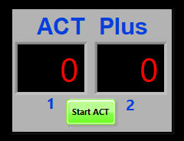

Figure 71 ACT Plus

      - Spectrum Medical

Pushing the “Spec Med” button displays the panel shown in Figure 72 (below) in the lower left corner of the OR Monitor.

. 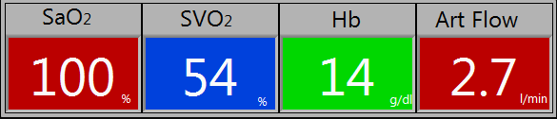

Figure 72 Spectrum Medical Panel

      - NIRS

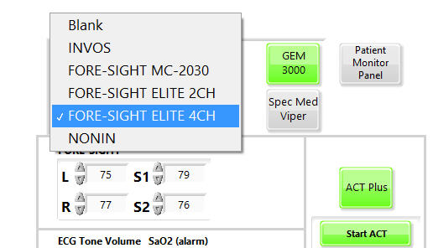

Figure 73 NIRS Drop-Down options

Selecting a NIRS monitor from the “NIRS” drop-down button on the Monitor Control panel (see Figure 73) will make the selected NIRS monitor visible in the upper right corner of the Legacy OR Monitor display (see Figure 59). Changing the values displayed on the NIRS monitor is accomplished with the controls found in the middle of the Monitors /Labs tab (see Figure 50). There are five different NIRS monitors that can be selected as shown in Figure 73.

      - GEM 3000

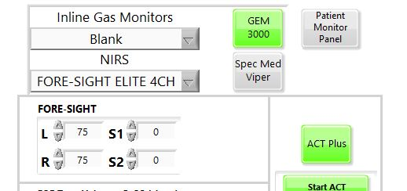
Selecting the “GEM 3000” button will make the results appear on the OR Monitor as seen below in figure 76.

Figure 74 GEM 3000 Controls

The source of the blood sample can be chosen using the drop-down menu under “BG Source”.
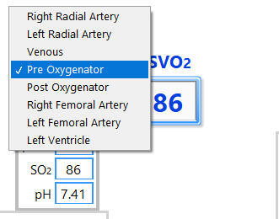
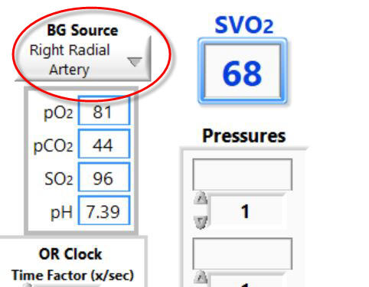

Figure 75 Blood Gas Selector on Instructors panel

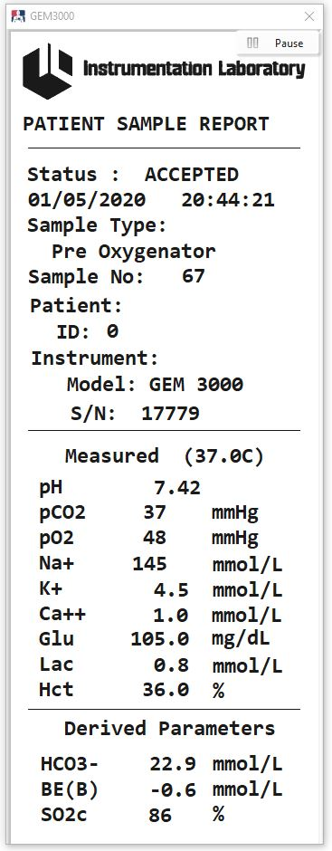

Figure 76 GEM 3000 Print-out

      - Media Files

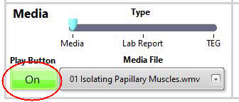
Pictures, videos (Media), lab reports or TEG traces can be displayed using the media controls which are located near the middle of the Monitors/Labs Display (see Figure 77). The three position slider selects the type of Media window to display.

Figure 77 Media Controls

Pushing the “Play Button” on the Controller Display (turning red to green) will activate the corresponding Media Type Icon on the bottom ribbon (see Figure 78 below).

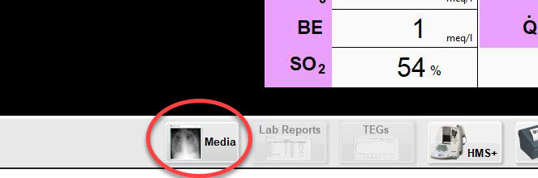

Figure 78 Media Button

The OR Monitor icon will change depending on the position of the “Type” slider (Figure 77) and alerts the learner to the type of file available (Media, Lab Report, or TEG).

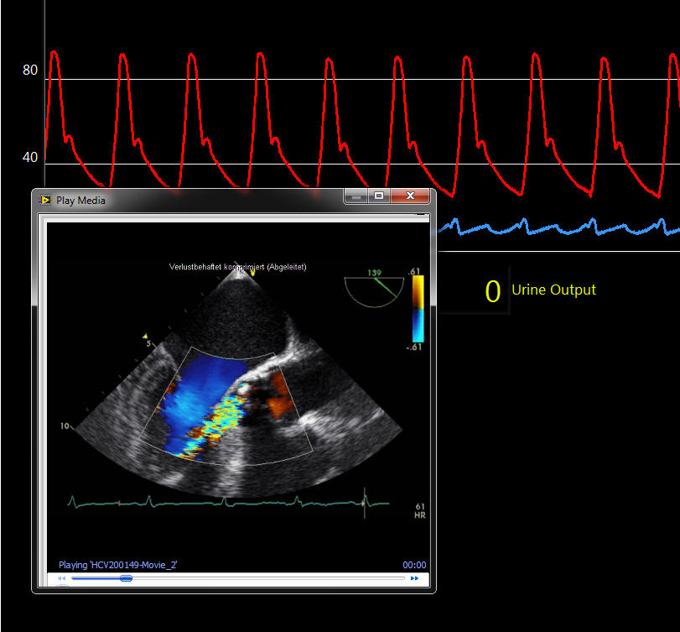
Pushing the “Media” Icon (Figure 78) on the OR Monitor Ribbon will make the corresponding window appear (see Figure 79). This window can be moved or resized. To close the window, push the same (now green) button again or push the red “X” in the upper right corner of the window. The program will remember the size and location of the window when it is closed so that it will reappear with the same characteristics the next time the button is pushed. Media files (.jpg, .avi, .wmv, .mp4, .mov) can be loaded into the simulator by placing them into the folder …\Simulator Files\media which is shown in Figure 18. Likewise, TEG images should be loaded into …\Simulator Files\TEG.
Figure 79 Media Window

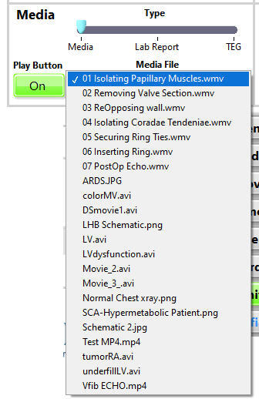
The media choices found in the Media Files drop-down menu on the Controller Display (see Figure 66) are automatically populated by the filenames in the media folder. Likewise, any TEG traces placed in the TEG folder (Figure 26) will be automatically placed in the TEG drop-down menu.

Any customized Lab Report generated and saved during the configuration process (see 4.1. Lab Reports ) will automatically be available in the drop-down menu for Lab Reports.

Figure 66 Media Files Drop-Down Menu

      - ECG Tone Volume

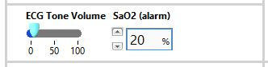
The volume of the ECG tone can be adjusted from zero (off) to 100% using the slider shown in Figure 80. It should be noted that the pitch (or frequency) of the ECG sound varies with the saturation reading of the Pulse Oximeter.
Figure 80 ECG Volume Control
and SaO2 Alarm Control

Also included is the SaO2 (alarm) setting. This determines the SaO₂ below which results in a steady tone (non-pulsatile)

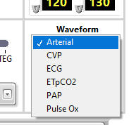
      - Waveform Show/Hide

It is possible to hide any of the waveforms displayed on the OR Monitor. This is accomplished by choosing the desired waveform from the dropdown menu shown in Figure 81. Once chosen the waveform can be hidden or made visible using the slider control.

Figure 81 Waveform Drop-down Menu
  - CALIFIA Controls Tab
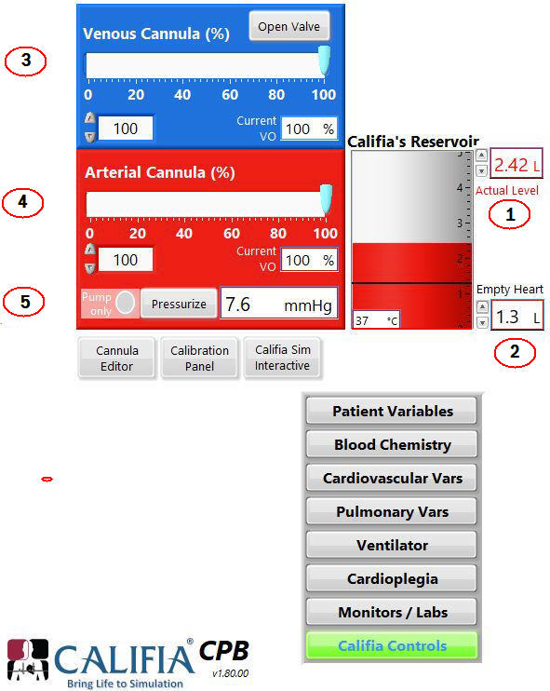

Figure 82 Califia Controls (CPB)

The “CALIFIA Controls” tab contains several controls and indicators that are described below.

The “Pressure” in the arterial line, and the “Temperature” of the fluid in the CALIFIA reservoir.

① The “Actual Level” is a digital indication of the blood volume inside CALIFIA. The Level indicator will start flashing red once the volume exceeds 3.2 L. The Tank indicator towards the middle of the figure shows the volume of blood in the CALIFIA reservoir

② “Empty Heart” determines the minimum (“empty heart”) fluid level in CALIFIA. Increasing the value for the Level Setpoint will cause CALIFIA to “hold-up” blood and reduce the volume available to the HLM reservoir. This is useful for simulating blood loss at the surgical field. Likewise, a return of blood from the surgical field (making more available to the HLM reservoir) can be simulated by reducing the level setpoint. If the level setpoint is suddenly set at a level below the volume in the reservoir a blue warning will appear as well as a switch labeled “Reset Level Setpoint”. These will remain visible until either the “Reset Level Setpoint” button is selected OR the level in the reservoir falls to the new Level Set point, which will automatically reset the empty heart level.

③ The Venous Cannula (%) slider control adjusts the maximum venous valve opening. 100% represents fully open to the specification of the cannula selected
(see 7.11 Cannula Editor). The “Open Valve” button simply opens the valve to the maximum, regardless of any cannula chosen.

④ The Arterial Cannula (%) slider control adjusts the maximum arterial valve opening. 100% represents fully open to the specification of the cannula selected (see 7.11 Cannula Editor). “Current VO” indicates the actual positions for the corresponding valve. For example, if a selected cannula calls for a valve opening (VO) of 48.5 moving the Arterial Cannula (%) slider to 50%, will result in the actual AV Opening indicator to read 24 (50% of 48.5).

⑤ The “Pump Only” switch turns on the heart pump. The heart pump is controlled to match ejections depicted on the OR Monitor. Please note that if the heart is empty and thus not ejecting, or if the heart is in asystole etc., the heart pump will not turn on.

“Pressurize” is only active when the heart pump has been activated. This control will turn on the pressure control feedback system that will maintain pressure in the arterial line equal to the patient’s mean blood pressure shown on the OR Monitor.

  - Cannula Editor

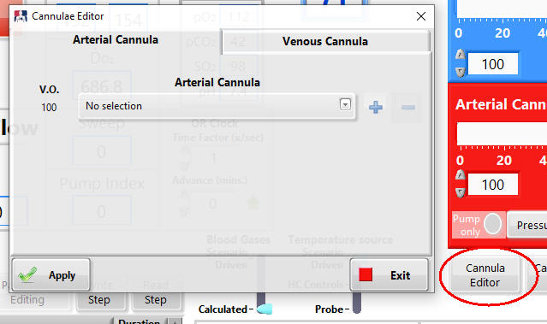

Figure 83a. Cannula Editor -Window

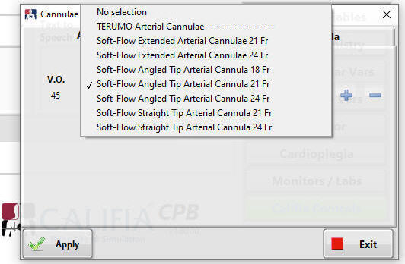

Figure 83b. Drop Down showing available cannulae

The cannula drop-down menu can be edited. Pushing the blue minus sign will remove a cannula from the list. To add a cannula to the drop-down list, push the blue plus symbol and two new fields will appear as seen in Figure 83c below.
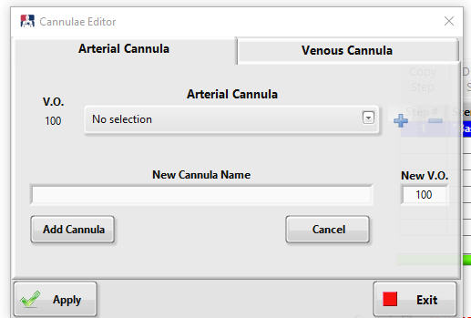

Figure 83c. Adding a Cannula Selection

Enter the name of the cannula in the “New Cannula Name” field and choose a valve opening percentage value from the pressure flow curves shown in Figure 84. Pushing the “Add Cannula” button will save the entry. The default is “No Selection” which will set the maximum valve opening at 100% (VO = 100).

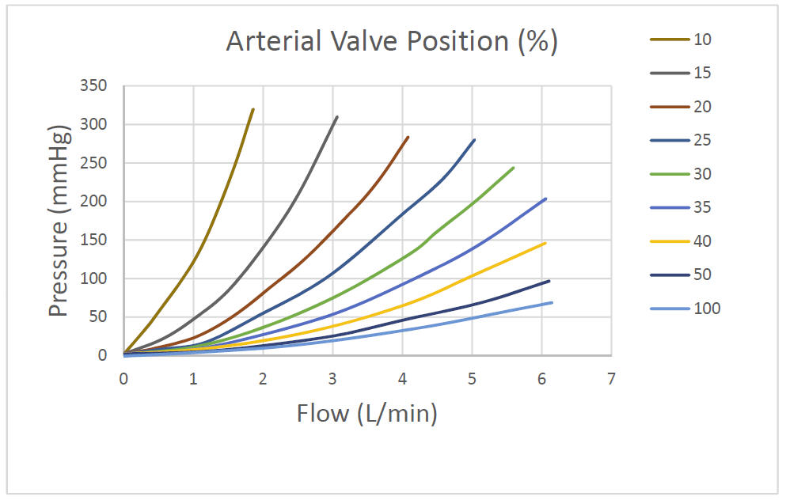

Figure 84. Arterial Valve Pressure-Flow Curves

  - Calibration Panel

To find the adjustments needed to calibrate CALIFIA, locate the Calibration Panel button located near the middle of the panel. Push this button to make the Calibration Controls visible as shown in Figure 85.

      - CVP Calibration

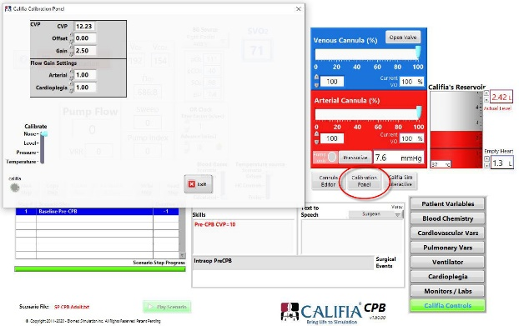
The "CVP Offset" control is used to make any fine adjustments up or down in the CVP.

The “CVP Gain” adjusts the amount that CVP changes when volume is shifted into or out of the patient from the circuit.

Figure 85. Calibration Controls

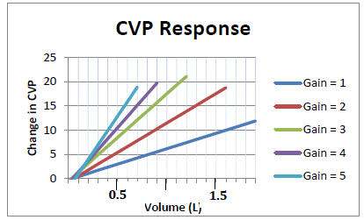
To calibrate the CVP system in CPB mode…

1) Select a “CVP Gain” value from the chart to the left (Figure 86). This graph represents the amount CVP will change for a given volume shifted to the patient. Smaller patients will require higher gain values.

2) Open the circuit and slowly turn the pump flow to approx. half flow (the actual flow rate will not matter).
Figure 86. Gain of CVP Response

Figure 69. Effect of “Gain” on CVP
response to volume

3) Once a steady state has been reached (on partial bypass with the heart empty), adjust the "CVP Offset" to set the CVP at -2. Any subsequent changes in “CVP Gain” may require adjustments in "CVP Offset". Once these values are set, they will not need to be adjusted again. The program will retain the values that are entered.

There are three calibrations or adjustments that should be made before the simulator can be used properly. The first two are the “CVP Offset” and "CVP Gain". These are used to adjust the level of CVP depending on the amount of water in the Patient Module reservoir. The “Flow Cal” is used to adjust the Pump Flow reading on the simulator to match a known flow.

In order to calibrate the system…

Fill the reservoir approximately ½ with water. The exact volume is not important.
There are three calibrations or adjustments that should be made before the simulator can be used properly. The first two are the “CVP Offset” and "CVP Gain". These are used to adjust the level of CVP depending on the amount of water in the Patient Module reservoir.
1) Set the “CVP Gain” to “2”

2) Adjust the “CVP Offset” value until the CVP is at the desired level on the ICU Monitor.

3) Add fluid to the reservoir to increase the CVP trace on the ICU Monitor. Adjust the CVP gain to create the desired increase in CVP based on the patient size and volume of fluid added. Figure 69 will help guide this adjustment.
After changing the gain you may need to readjust the “CVP Offset”, but once set, there should be no need for further adjustments. The program will retain the values that are entered (It may be a good idea to write the numbers down).

      - Flow Calibration

The “Art Flow” (Pump Flow) and “Cardioplegia Flow” calibration values are multiplication factors which can be used to adjust the flow readings of the Pump Flow indicator (Figure 51) and the Cardioplegia indicator (Figure 67). If the simulator is reading a value lower than desired, increase the current value in the appropriate flow calibration control.

      - Two Point Calibration (Level, Pressure, Temp)

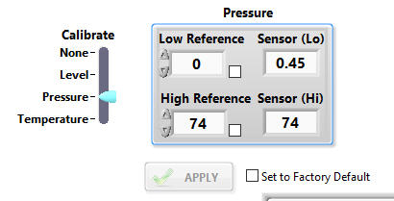
The built-in temperature, level and pressure sensors can be calibrated using a two-point calibration technique. Moving the “Calibrate” slider to one of three options “Level”, “Pressure”, or “Temperature”, will bring up the corresponding Two-Point Calibration Panel
(see Figure 87)

Figure 87 Two-Point Calibration Panel

In order to calibrate one of the three sensors, first move the slider to the sensor to be calibrated. The following describes the process for calibrating the pressure sensor.

1. Establish a steady reference (low level) pressure. One way to do this is to close the arterial valve (see Figure 82, ④) and apply the desired pressure into the arterial line. Enter that pressure in the “Low Reference” window.
2. Once Pressure Sensor reading has stabilized, check the box next to “Low Reference” (leave it checked) (see Figure 87).
3. Establish a high reference pressure and enter the value in “High Reference”.
4. Once Sensor reading has stabilized, check the box next to “High Reference”.
5. At this point the “Apply” button will become enabled; press it once to finish the calibration.

To reset calibrations to factory settings, check the box labeled “Set to Factory Default” and press the “Apply” button.

- Instructor’s Panel Common Elements

  - Blood Gas Calculation

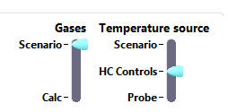

Figure 88 Blood Gas Calculation Switch

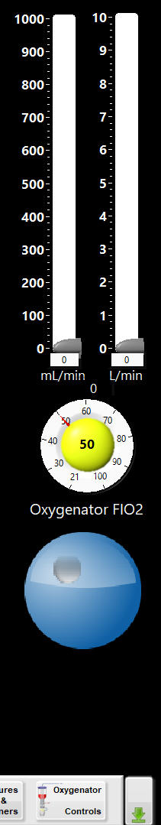
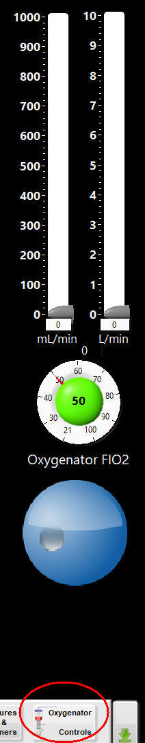
A slider switch (“Gases”) located near the middle of the Instructor’s Panel allows for the blood gases to be calculated when “Calc” is selected versus being dictated by the scenario file when “Scenario” is selected. (see Figures 88). When “Calc” is selected all blood gases will be calculated based on the physiological characteristics of the patient, the ventilator settings and the sweep and FiO₂ of the oxygenator gas.

Controls used to vary the sweep and FiO₂ are made visible by pressing the “Oxygenator Controls” button found to the far right of the OR Monitor menu ribbon (see Figure 89).

The oxygenatorFiO₂ is adjusted using the large blue thumbwheel located under the rotameter. To change the FiO₂, first activate the teal button (turning it yellow) and then use the large thumbwheel located in the bottom right corner of the OR Monitor. Once the desired FiO₂ is selected, deactivate the yellow button by pressing it again.

The sweep gas is adjusted by the two sliders located in the top right corner of the OR Monitor.

Figure 89 Oxygenator FiO₂ and Sweep Controls
  - Temperature Source

There are three positions of the “Temperature Source” slider, “Scenario”, “HC Controls” and “Probe”, (see Figure 75 above). If the Temperature Source slider is in the Scenario position, all patient temperatures will be dictated by the scenario. These include the A Temp and V Temp found under the Blood Chemistry tab
(7.2 Blood Chemistry Tab) and the Patient Temperature found under the Patient Variables tab (7.1 Patient Variables Tab).

If the Temperature Source slider is moved to the “HC Controls” position, an additional button will become active in the menu ribbon at the bottom of the OR Monitor labelled “Heater Cooler” (see Figure 90). Pushing this button will cause a set of Heater/Cooler controls to become visible on the left half of the OR Monitor (Figure 90). Using these controls to change the water temperature and turning the Pump on will cause a corresponding change in the patient’s body temperature (as long as the patient is on bypass) according to the patient’s size, flow rate, temperature gradient etc.
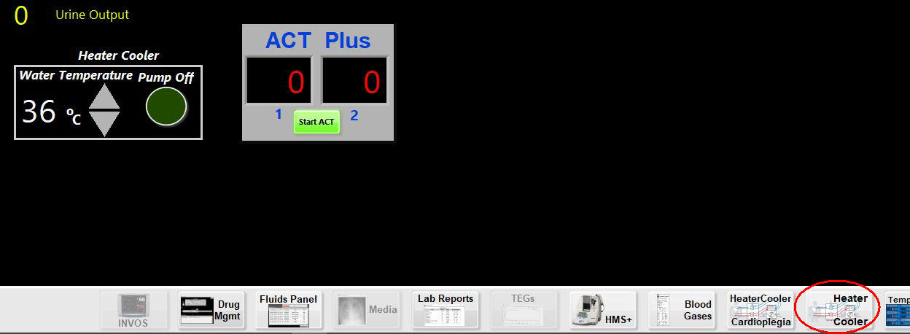

Figure 90 Heater Cooler Controls

If the “Temperature Source” slider is moved all the way down to the “Probe” position and the patient is on bypass the patient’s temperature will be influenced by the water temperature perfusing the CALIFIA Patient Module. In this case, the temperature probe inside CALIFIA will measure the water temperature being delivered and record it as the arterial temperature. All of the other temperatures (venous, bladder, etc.) will be calculated according to the patient’s size, pump flow rate etc.
  - Evaluation Controls
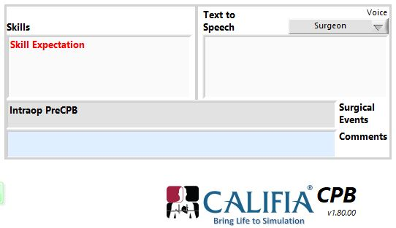
Two text fields located near the middle of the Instructor’s Panel are used as part of the simulation evaluation process (see Figure 91). The “Skills” field reflects entries (in red font) intended to alert the instructor to skills to be evaluated at that step. The “Comments” field accepts entries that will be annotated within the Pump Record. The Comments field is only visible if there is a Pump Record being kept (see 4.1.2 Pump Record ).

Figure 91 Evaluation Skills-Comments

      - Text to Speech

Entries in the “Text to Speech” text box will be read out loud by the simulator. For those computers having more than one voice, a drop-down menu will allow different voices to read the text. Which of the computer voices is assigned to each actor is chosen in the opening screen configuration ( see 4.1.4. Characters )

      - Surgical Events

Specific surgical events can be displayed across the top of the OR Monitor (see Figure 79). This is accomplished by typing entries into the grey Surgical Events box located near the middle of the Instructor’s Panel (see Figure 91 above).

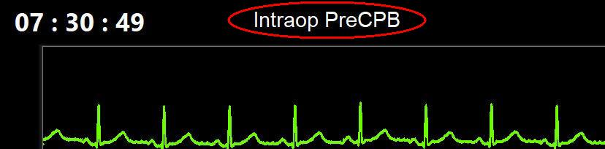

Figure 92 Surgical Events

  - OR Clock

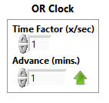
The controls used to manipulate the OR Monitor Clock can be found near the top middle of the Instructor’s Panel (see Figure 93). The “Time Factor (x/sec)” controls the speed of the OR Clock by the factor entered. For example, an entry of zero will stop the clock whereas and entry of 60 will advance the clock one minute every second. The “Advance (mins.)” entry will force the clock to jump ahead by the number of minutes entered. After entering a value, the green up arrow must be pushed to initiate the change.
Figure 93 Time Factor / Advance

It should be noted that speeding up the OR clock will influence the ACT Plus, HMS+, rate of Heater-Cooler temperature responses, and the INVOS cerebral oximeter.

  - Virtual Pressure Displays (ECMO Only)

The ECMO programs provide the ability to display “Virtual” pressures (this feature can also be found in the VA-ECMO (Sim) and VV-ECMO (Sim) programs). This is accomplished using the controls shown in Figure 93 which are found near the top middle of the Instructor’s Panel. The titles and values of these displays can be manipulated by the instructor. The pressures will be displayed at the bottom of the OR Monitor. (Figure 95). Erasing all three titles will cause the entire display to disappear. None of these functions can be controlled by the Scenario file.

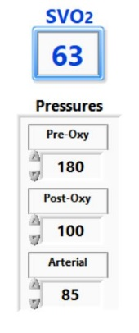
Figure 94 Virtual Pressure Controls)

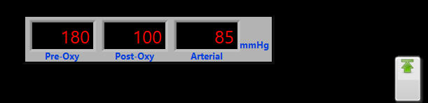

Figure 95 Virtual Pressure Displays (Legacy Screen

- CPB (Sim) Legacy Screen

The major difference between the CPB (Sim) program and the CPB program is that the CPB (SIM) does not require the CALIFIA Patient Module or a heart-lung machine to run. Instead, controls can be found by pressing the “HLM Controls” button found to the far left of the menu ribbon beneath the Patient Monitor screen. (See Figure 96)

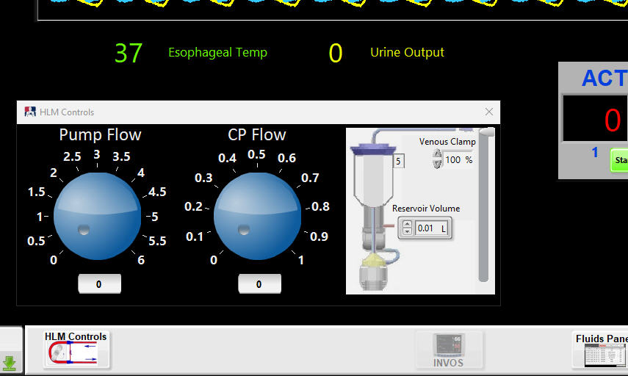

Figure 96 HLM Controls in SIM Mode

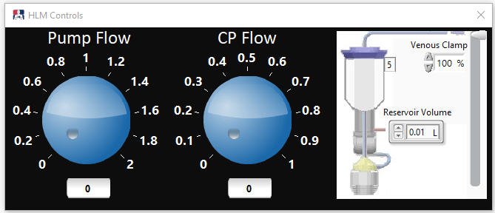

Figure 97. Changes in Pump Flow Scale for Smaller Patients

- Clinical Scenarios

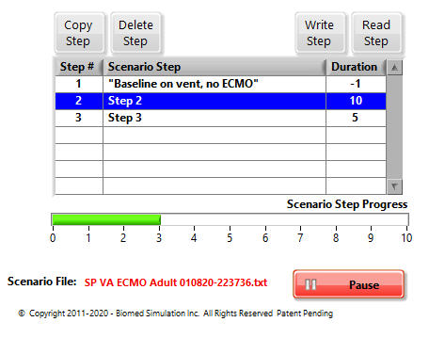
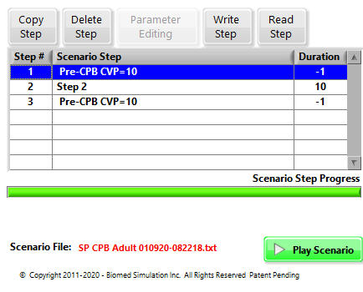
  - Scenario Controls

Figure 98 Scenario Controls (Play) Figure 99 Scenario Controls (Pause)

Each step of the loaded scenario is shown in the drop-down table which gives the Step #, the Scenario Step or action, and the Duration of the step in seconds (see Figure 98). This information is loaded from the scenario file when the simulator is started. The Scenario Step and Duration can be edited directly within the table by clicking on the entry and entering a new value. By highlighting a particular step and pressing the Play Scenario button (green button in Figure 98), the control values corresponding to that step will be read and the automatic sequencing through the scenario will begin. The green progress bar shows the time elapsed in seconds. This will continue until the Pause button is pushed (Figure 99) or the end of the scenario is reached.

The four buttons, “Copy Step”, “Delete Step”, Write Step”, and “Read Step” (Figure 98) control the creation of new scenario steps or load an existing scenario step. “Read Step” will load the corresponding control values from the “Step #” highlighted in the drop-down table. Pushing “Write Step” will bring up the Confirm Scenario File write dialog window. Pressing the Confirm button in this dialog box automatically updates all the values in the row of the scenario file corresponding to the step highlighted in the Scenario Controls table (see Figure 100) based on all the control settings at the time. The same dialog box allows the user to select any parameters currently with a value of “-1” to be updated with that parameter’s actual value. -1 is a special value that ignores the write command for that particular parameter and step. Parameters with a value of “-1” are shown with their label in red color; Figure 101 shows three parameters in the Patient Variables cluster whose scenario file values for that particular step are set to “-1”.

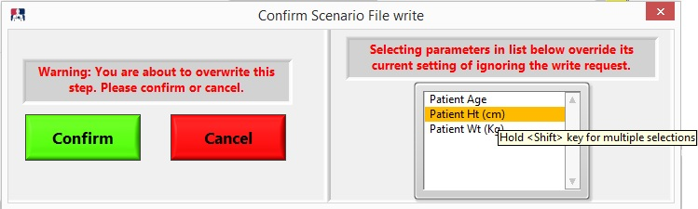
Figure 100. Confirm Scenario File Write Dialog Window

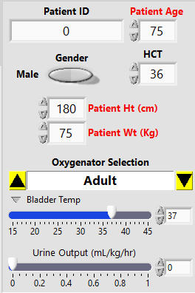

Figure 101. Parameters with red labels indicating they’re set to value of “-1” in the scenario file.

  - Scenario Files

Scenario files are tab-delimited text files (*.txt) that are used to control the simulator and manipulate patient variables. Scenario files are composed of a series of steps (Scenario Steps) that dictate all of the settings and variables that define the patient and the patient monitoring choices. Each of these steps is represented by a row in the scenario. The columns represent nearly all of the controls found on the Instructor’s panel and are defined below.

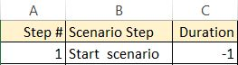

The first three columns provide the details of the specific step displayed on the scroll-down Scenario Control Table (see Figure 98). Column A specifies the step number which must be sequential and cannot be changed. It will show up in the scenario table as “Step #”. Column B is the name of the step and Column C dictates the duration of the step. This is the length of time in seconds that the simulator will remain at that step before proceeding to the next step and is displayed in the scenario table under “Duration”. The Duration column can also accept a “-1” which instructs the simulator to read the step and pause.

The next nine columns in the scenario file define the patient characteristics. Entries in these rows control the values found in the Patient Variables panel
(see section 7.1. Patient Variables Tab). Column J is used to determine which oxygenator is used in the bypass simulation. The choices are Adult or Pediatric. Entries under Patient Temp and Urine Output (mL) are visible on the OR Monitor just below the pressure traces.

The next fifteen columns in the scenario spreadsheet define the blood chemistry. Entries in these rows control the values found in the Blood Chemistry panel (see section 7.2. Blood Chemistry Tab). The patient’s arterial and venous blood temperatures are controlled by columns V and W and are displayed on the Blood Chemistry panel. When the temperature selection is switched to “Calc” or “Probe (see 8.2. Temperature Source), entries in this column will be ignored.

The patient Heparin Dose Response (HDR Slope) and various parameters required for the HMS calculations are entered under the HMS Parameters section. These six variables are visible toward the bottom of the Blood Chemistry panel (see Figure 55 and section 7.2. Blood Chemistry Tab ).

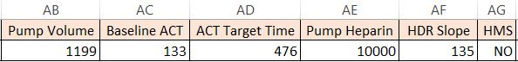

The next three columns correspond to the controls found under the tab CALIFIA Controls Tab (see section 7.10. CALIFIA Controls Tab) above). The first two columns control the Valve position dictating the percent of valve opening. The “Level” column controls the empty heart level in the CALIFIA Reservoir by setting the value in the “Level Setpoint” field.

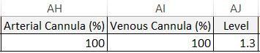

The next seven columns control the variables represented in the Cardiovascular Variables panel (see section 7.5. Cardiovascular Variables Tab. above). In addition, ECG choices are made in the column labeled “CPB ECG Choices”. Valid entries are described above in section 7.5. Cardiovascular Variables Tab.

The next 14 columns in the scenario file control various monitors that can be shown on the OR Monitor and correspond to the controls found under the Monitors/Labs Tab (see 7.9. Monitors / Labs Tab ). Information placed in the “Monitors” column must correspond to the 7 items in the drop down of the Monitors Panel (see Figure 69) which will result in one of the four monitors being visible on the OR Monitor. The “Spec Med” column controls whether data from the Spectrum Medical in-line monitor is visible on the OR Monitor (see Figure 72 above). The “NIRS” column controls visibility of the Cerebral Oximeter while the next four columns set values for the left (NIRS L), right (NIRS R) cerebral sensors as well as two somatic sensors (NIRS S1 & NIRS S2) respectively. A “Yes” entry in the “GEM 3000” column will force the blood gas analysis print-out to become visible on the OR Monitor. The “BG Source” column specifies the sample site to display for blood gas analysis (see section 7.9.4. GEM 3000 above). Control of the ACT analyzer is affected by the next four columns. Placing “Yes” in the “ACT Plus” column will make the ACT analyzer visible on the OR Monitor (see Figure 71 above). A “Yes” entry in the “ACT Start” column will cause the ACT analyzer to begin counting. Values placed in the next two columns will determine the final results displayed in ACT channels 1 and 2 respectively.

Column “Media Type” determines the type of media (equivalent to the slider in Figure 77). The “Play Button” column will control visibility of the media Play Button (see Figure 77) while the “Media File” column dictates the name of the media file that will be loaded (see section 7.9.5. Media Files above).

The next four columns control cardioplegia. Under “CP Delivery”, the three choices are “Off”, “Ante”, or “Retro”. Flow Factor changes the rate of progression of the ECG pattern toward arrest. Values placed under Retrograde Resistance will affect the sinus pressure displayed on the OR Monitor. For further explanation see 7.8. Cardioplegia Delivery Tab. The Cross Clamp is applied by placing YES in the “Cross Clamp” column.

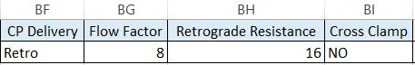

The “Max Cardiac Index” column sets the Max Cardiac Index (see section 7.5. Cardiovascular Variables Tab). “Surgical Events” entries will be displayed at the top of the OR Monitor (see Figure 92). The next two columns control the OR Monitor clock
(see section 8.4. OR Clock). The “Skills” column specifies the skill expectation corresponding to that particular step in the scenario. This entry will be displayed in red letters in the Skills field located in the Evaluation Controls (see 8.3. Evaluation Controls). The “Text to Speech” column provides the text that will be read by the simulator (see section 8.3.1. Text to Speech). For those systems having more than one voice, the “Voice” column will accept any of the following three choices Surgeon, Anesthesiologist, or Resident. Oxygenator performance is controlled by the last column which controls the shunt fraction (100%) of blood through the oxygenator.

- Switching Modes of Operation in CALIFIA Simulator Software

Modes of operation in the CALIFIA Simulator software refer to the various perfusion therapies offered in the software such as CPB or VA ECMO and whether these are software-only (Sim) or use the CALIFIA Patient Module. The ability to change the mode of operation while the clinical scenario is running preserves scenario fidelity and continuity. For example, after initializing a scenario in CPB (Sim), a step in the scenario file describes a transition to VA ECMO (Sim). The procedure to transition from one mode of operation to another during a clinical scenario without exiting to the Opening Screen is described next.
Select the next mode of operation using the Circuit selector below the VA and VV flow indicators as illustrated in Figure 102.

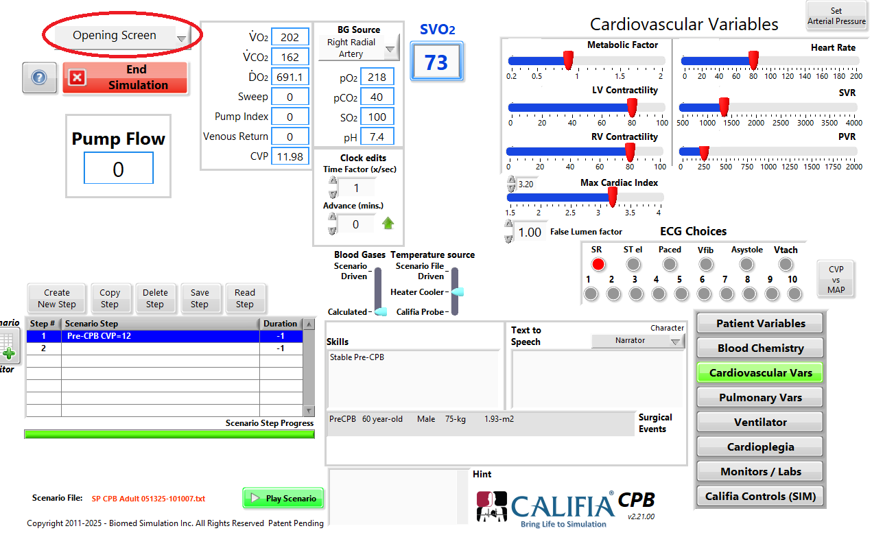

Figure 102. Mode Transition Selector Placement (top left)
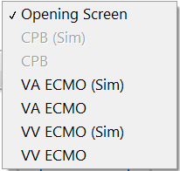

Figure 103 shows VA ECMO (Fem-Fem) selected. Notice the red button changed from End Simulation to Transition to VA ECMO (Sim)

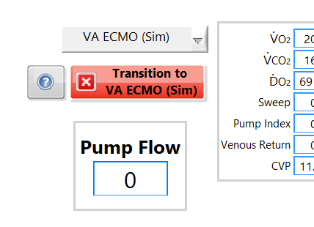

Figure 103. VA ECMO (Sim) selected

- Technical Assistance / Service

For technical assistance or service requests, please contact:

Biomed Simulation Inc.
9939 Via Pasar
San Diego, California,
92126

614-378-0895

service@biomedsimulation.com

Appendix A Beating Heart Attachment

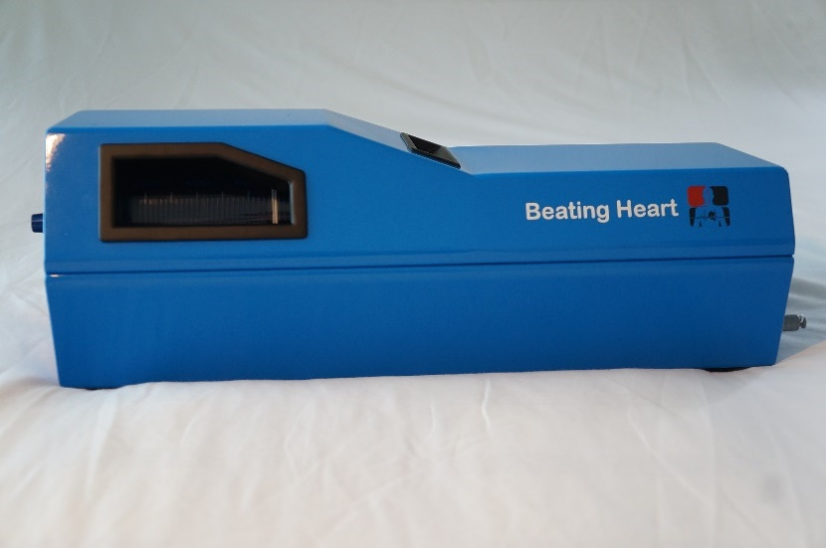

Figure A1 CALIFIA’s Beating Heart

CALIFIA’s Beating Heart connects via a single cable to CALIFIA at the connector ④ labeled “Beating Heart”.

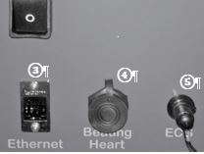

Figure A2 Beating Heart Cable Connection (From Figure 4)

A.1. Beating Heart Tabs

The Beating Heart attachment is connected to the CALIFIA Patient Module using a single cable (see Figure A2). Once this connection has been made and CALIFIA turned on, The “CALIFIA Controls” tab changes as shown below in Figure A1 (compare to Figure 49). Two new tabs will become visible at the left margin of the panel circled in red below. It should be noted that this applies only to the CPB module and not ECMO.

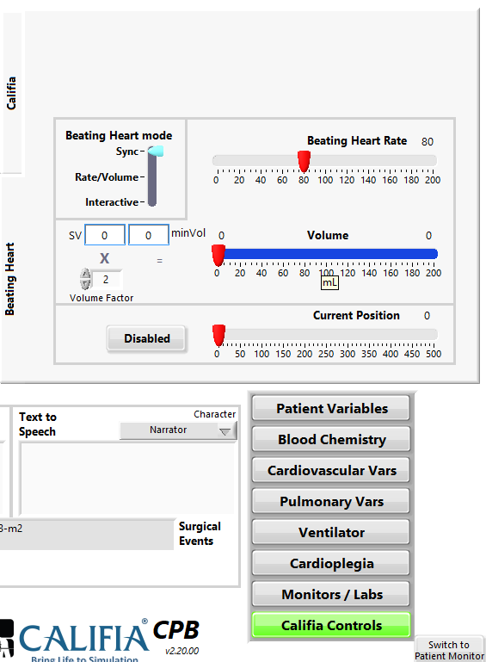

Figure A1 Beating Heart Tabs

The “CALIFIA” tab contains all the controls and indicators exactly as described above in 7.1.3. CALIFIA Controls (CPB).

The “Beating Heart” tab contains all the controls and indicators necessary to control and monitor the function of the beating heart
A.2. Beating Heart “Sync” Mode

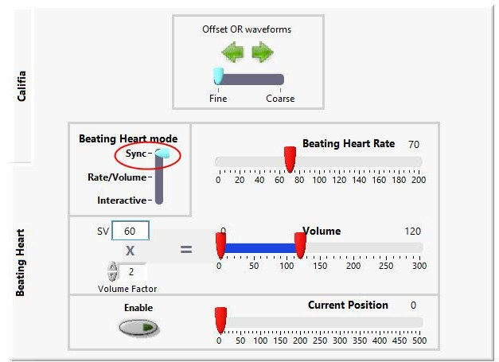

Figure A2 Beating Heart - Sync Mode

Selecting the “Beating Heart” tab reveals the controls and indicators shown above in Figure A2. There are three Beating Heart Modes: “Sync”, “Rate/Volume” and “Interactive”. Figure A2 shows the controls visible when the Mode switch is in the “Sync” position (circled in red above). With this selection, the action of the beating heart is determined by the patient. The “Beating Heart Rate” and the Stroke Volume (“SV”) follow the patient’s cardiac activity. The “Volume Factor” allows the operator to amplify the volume if desired. The “Enable” switch will turn the beating heart on and off. The “Current Position” indicator tells the position of the inflator. Zero is the home position when the heart is completely empty.

A.3. Beating Heart “Rate/Volume” Mode

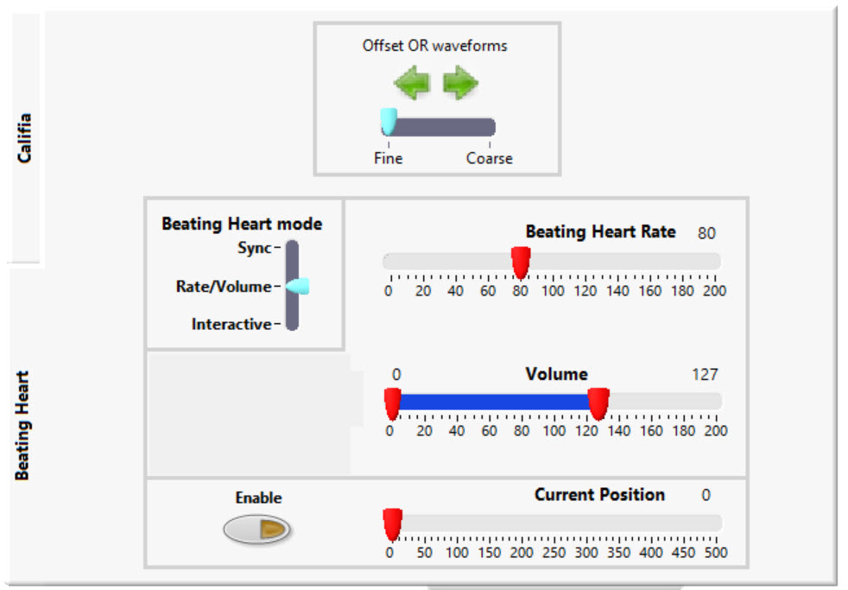

Figure A3 Beating Heart – Rate/Volume Mode

Figure A3 shows the Beating Heart controls in the “Rate/Volume” mode. In this position the rate and volume of the beating heart can be manually controlled using the “Beating Heart Rate” control and the “Volume” control. Note that both the lower volume value (End Systolic Volume) and the upper volume (End Diastolic Volume) can be independently manipulated. The remaining items on the tab are as described for the “Sync” mode above.
A.4. Beating Heart “Interactive” Mode

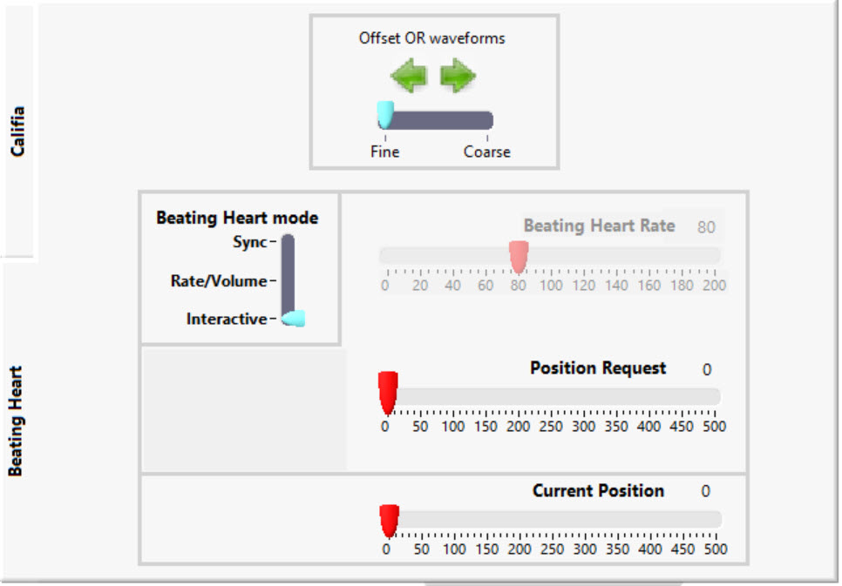

Figure A4 Beating Heart – Interactive Mode

In the “Interactive” mode, only the position of the inflator can be manipulated. This is accomplished using the “Position Request” slider shown in Figure A4. The “Current Position” indicator simply reports back the position of the inflator.

Appendix B CALIFIA’s Lung

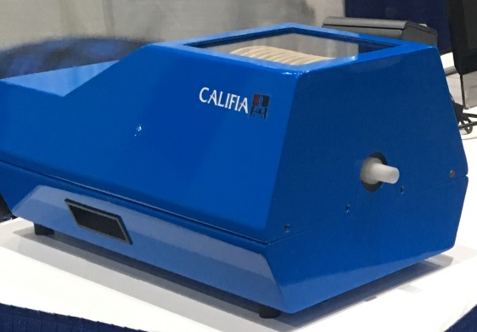

Figure B1 CALIFIA’s Lung Module

The CALIFIA® Lung is a standalone product of Biomed Simulation, Inc. that can model the behavior of a human lung. It is a programmable, high fidelity simulator system designed to be used independently or connect it to any ventilator or CALIFIA® Patient Module (CPM). It is intended both as a teaching tool, and as a tool for evaluating the performance of a clinician in the conduct of a simulated clinical case.
This appendix describes its integration with the CALIFIA® Simulator during ECMO or CPB. Refer to the CALIFIA® Lung User Manual for more information.
CALIFIACALIFIACALIFIACALIFIACALIFIA

B.1. Use of CALIFIA Simulator and Lung Together

Figure 1 in section 1.2 of this Operator’s Manual is modified as shown in Figure B2 to support the integration of CALIFIA’s Lung with the CALIFIA Simulator.
Califia Patient
Module
ECMO/Heart Lung Machine
Clinician
Instructor
Instructor’s Panel
Laptop
OR Monitor
LAN Switch
Lung
Module
Positive Air Pressure Device/Ventilator
Clinician
Figure B2 CALIFIA and Lung Simulator Components

The first column in Table B1 lists the IP addresses for all components connected to the LAN Switch.

 | IP address | Software Version
Laptop | 100.100.100.25 | 1.80.00 or newer
CALIFIA Patient Module | 100.100.100.13 | 2.80 (firmware)
Lung Module | 100.100.100.17 | 1.00 (firmware)

Table B1 Fixed IP addresses & minimum software versions required

The last column in Table B1 lists the minimum versions of the CALIFIA Simulator software and firmware required to support both of these devices. Please contact Biomed Simulation, Inc. for the latest software or assistance completing software updates.
B.2. External Connections

B.2.1. Data and Power Connections

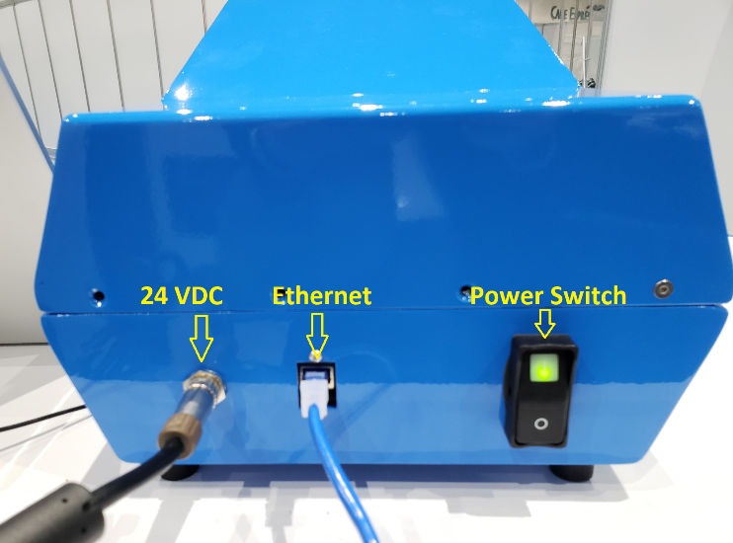

Figure B3 Lung Simulator Module Connectivity

Connect the power adapter to the connector labeled 24 VDC. The Ethernet cable attaches to the Ethernet terminal on your laptop or docking station. The Power Switch lights up green when the unit is powered on as shown in Figure B3.

B.2.2. Connection to Ventilator

The Lung Module is equipped with a 15 mm connector. To connect it to a mechanical ventilator, use standard ventilator tubing, Figure B4.
Review section B3 in this appendix to learn how to operate the Lung and determine when to connect the ventilator and initiate ventilation.

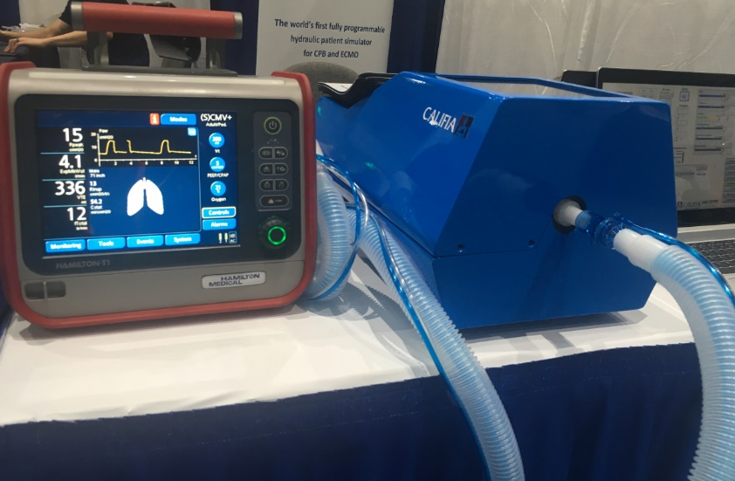

Figure B4 CALIFIA’s Lung Connected to Hamilton Medical®’s T1 ventilator

B.3. Operation

Table B2 shows the Lung Module supported in all the CALIFIA Simulator therapies.

 | CPB | CPB (Sim) | VA ECMO | VA ECMO (Sim) | VV ECMO | VV ECMO (Sim) | LHB | LHB (Sim)
CPM+LM | ü |  | ü |  | ü |  | ü
LM only | ü | ü | ü | ü | ü | ü | ü | ü
CPM: CALIFIA Patient Module
LM: Lung Module

Table B2 Lung Simulator Support with CALIFIA Simulator Therapies

The best training experience is achieved when both the Lung Module and the CALIFIA Patient Module are made part of the simulated clinical case.

In this appendix, the VA ECMO therapy is used to describe the operation of CALIFIA’s Lung.

B.3.1. CALIFIA’s Lung Section in Instructor’s Panel

The button CALIFIA’s Lung and corresponding section, red boxes in Figure B5, are available when the Lung Module is recognized by the CALIFIA Simulator software. The elements in this section are dictated by the Lung Mode.

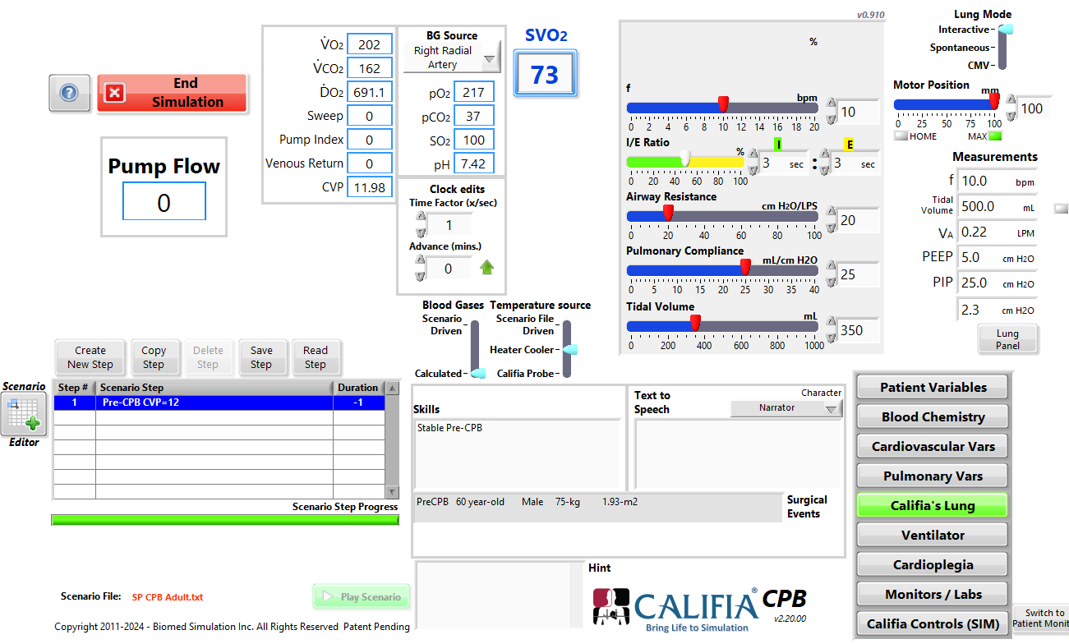

Figure B5 VA ECMO – CALIFIA’s Lung Section

B.3.2. “Interactive” Mode

The Lung Module defaults to Interactive mode.
This mode is not part of physiology, and its use is limited to testing the device, as it allows to control and modify all the parameters. In this way, the Motor Position (mm) slider can be used to place the motor at an exact position.

- Position 0 (zero) is the linear motor fully retracted representing the maximum lung volume allowed.
- Position 100 mm is the linear motor fully extended therefore the smallest lung volume possible

B.3.3. “Spontaneous” Mode

In this mode, the Lung Module spontaneously breathes and can be assisted with a Ventilator. Since a real ventilation device is used, the CALIFIA® Simulator virtual Ventilator, as described in section 8.2, disables and disappears.

The following parameters will affect the breathing quality:
- FiO2 (%) slider is used to match the Ventilator’s FiO₂ setting.
- Frequency (bpm) slider dictates breath rate in breaths per minute.
- I/E Ratio specifies the complementary inspire and expire fractions. These can either be set using the slider or numerically entered.
- Airway Resistance (cmH2O/LPS) specifies resistance to flow in the respiratory tract in cmH2O over Liters per Second.
- Pulmonary Compliance (mL/cmH2O) – when the Lung Module is present and detected, this parameter is also available under Pulmonary Vars.

- Tidal Volume (mL) is the target volume displacement; used as the amplitude driving the Lung Module’s spontaneous breathing cycle.

B.3.4. CMV Mode

CMV is Controlled Mandatory Ventilation. In this mode, CALIFIA® Lung is fully controlled by a ventilator.
The I/E Ratio turns into an indicator, reporting inspiration and expiration fractions as measured. Both Frequency and Tidal Volume sliders are hidden, since these parameters are dictated by the ventilator.
To adjust the breathing quality of CALIFIA Lung, the Airway Resistance and Pulmonary Compliance parameters are available for customization.

B.3.5. Measurements

When the Lung Module is either spontaneously breathing or controlled with a ventilator; the following measurements are carried out and displayed as follows:

- f is the measured breathing rate, expressed in breaths per minute (bpm).
- Tidal Volume is the volume of air, measured in mL, inhaled or exhaled in each breath cycle.
- Alveolar Ventilation (LPM) is the difference between Tidal Volume and Dead Space over a minute
- PEEP and PIP correspond to the minimum and maximum pressures measured during a breath cycle
- The last pressure indicator is the instantaneous pressure reported by the Lung Module.

Note: When Lung Mode is Interactive, these measurements display values corresponding to the virtual ventilator.

B.3.6. Lung Simulator Module Parameters Available via the Scenario File are Listed in Table B3

 | Units | Range
 | Units | Min | Max
Pulmonary Compliance | mL/cmH₂O | 5 | 200
FiO₂ | % | 21 | 100
Breath Frequency | bpm | 0 | 250
Airway Resistance | cmH₂O/LPS | 10 | 200
Pleural Pressure | cmH₂O | 0 | 30

Table B3 Scenario File Parameters Relevant to the Lung Simulator Module

The ranges in Table 1 are an estimate of what the device would support. It may be changing according to the ventilator settings and other external factors.

B.3.7. The Lung Panel

The Lung Panel button launches CALIFIA® Lung Panel.
It has three tabs:
- Displays: it displays various relevant lung traces.
- Calibrations: for calibrating the different sensors available within the Lung Module. More deeply explained in the CALIFIA® Lung User Manual.
- Remote Panel: placeholder tab reserved for future development.

B.3.8. Lung Panel Displays tab
The Displays tab presents two types of traces:
- Time-series for Volume, Pressure & Flow.
- Cyclical relations between Volume Flow as well as Volume – Pressure.
The PV Loops field specifies the number of breath cycles to display in both time-series and cyclical plots, with a default setting of 5 loops.
The ActiveExp (%) is a miscellaneous parameter specifying the portion of the expiration time the stepper motor is moving. This is used to allow for a rest period while CALIFIA® Lung is operating in Spontaneous mode.
Finally, the image and the indicator in bottom right of panel animate the process of inspiring and expiring.

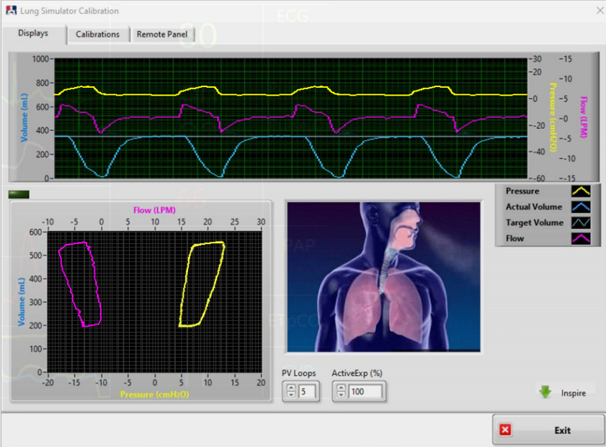

Appendix C HMS+ Option (Legacy Screen)

If the HMS+ option has been purchased and activated, an extra icon will appear in the OR Screen menu ribbon labelled “HMS+”. This button will replace the “Call for HMS” button shown in Figure 46. Pushing the “HMS+” button will result in the appearance of a virtual HMS+ machine. (see Figure C1 below).

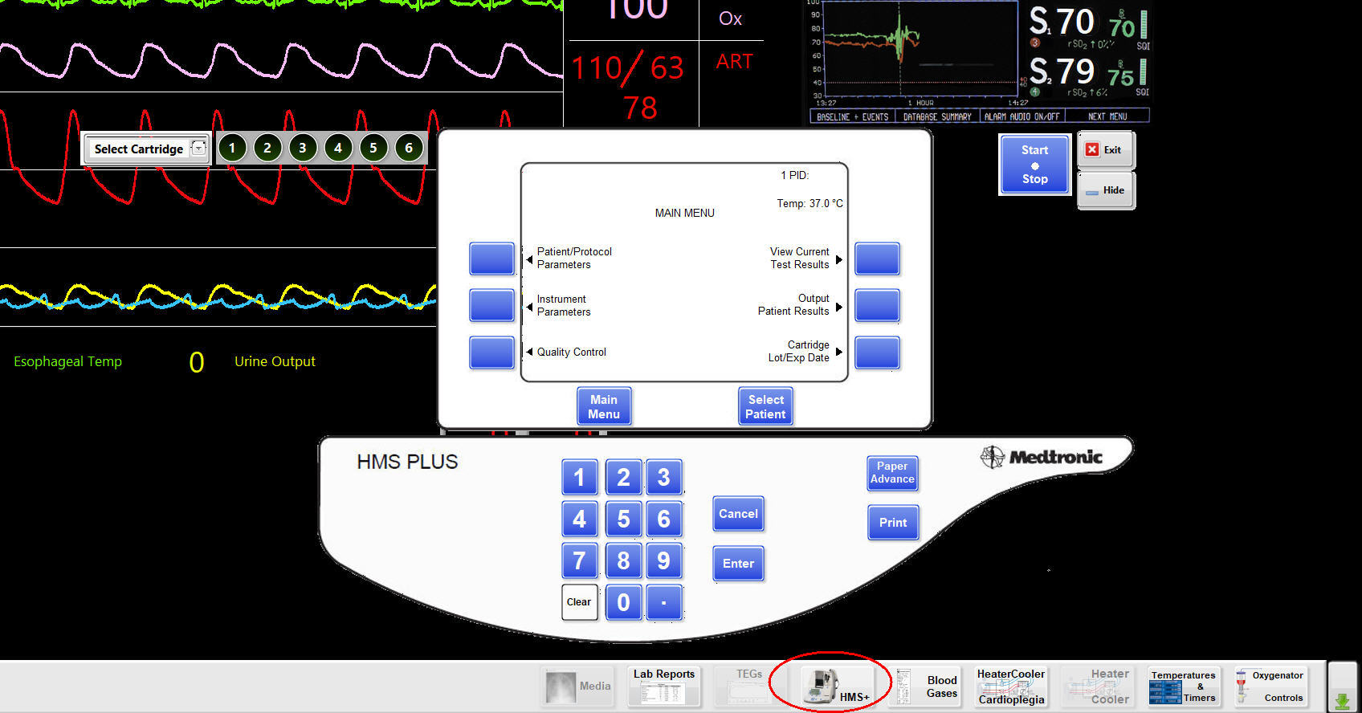

Figure C1 Virtual HMS+ Analyzer

A selection of cartridges can be found by pushing the down arrow next to the “Select Cartridge” window (see Figure C2).

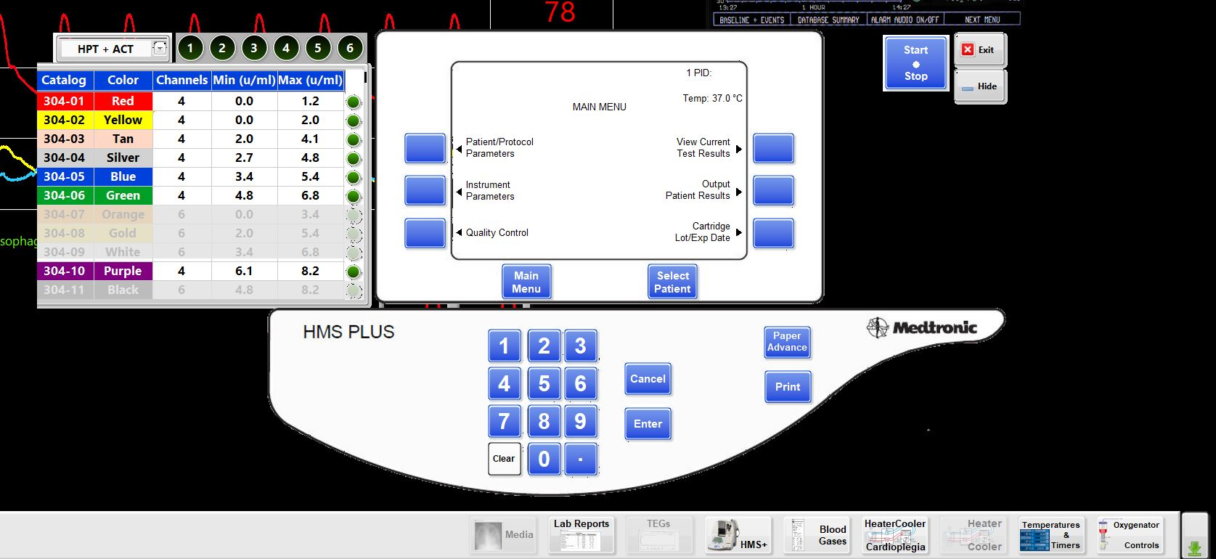

Figure C2 Cartridge Selection Panel

Appendix D INVOS Option

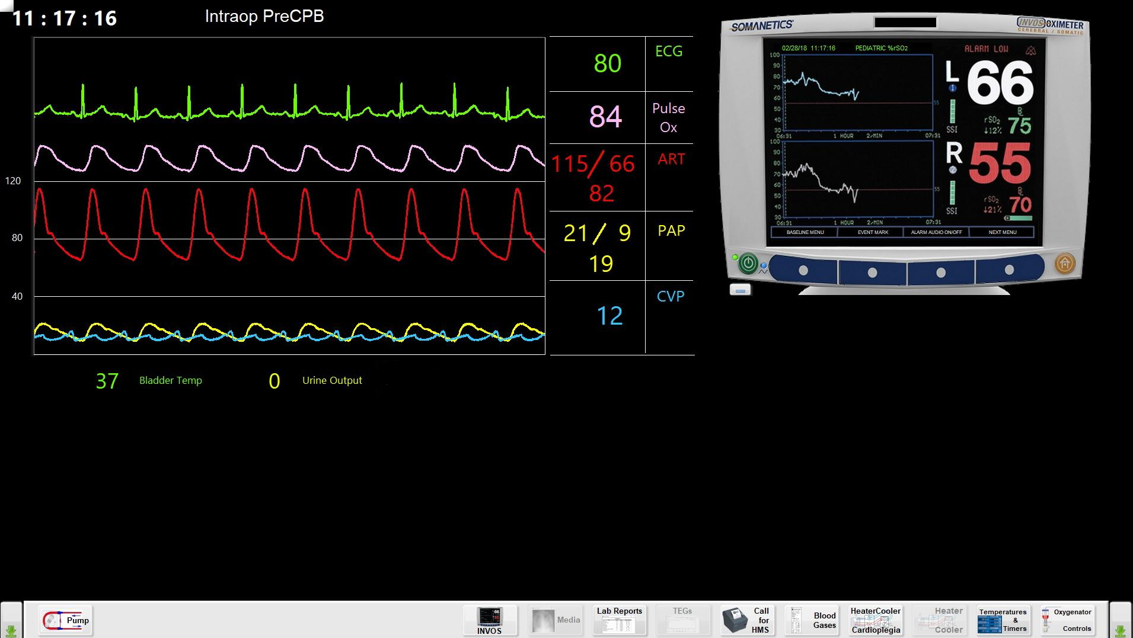

Figure D1 Virtual Invos Monitor

Principle of Operation

CALIFIA® simulation software predicts the INVOS™ NIRS values during cardiopulmonary bypass (CPB) and during veno-venous or veno-arterial extracorporeal life support (ECLS, ECMO). CALIFIA® uses cerebral and organ autoregulation to predict organ blood flow, oxygen consumption, blood and tissue oxygen levels and other physiologic variables change. Instructors can alter cerebral, organ and limb blood flow to probe learner control of NIRS values. CALIFIA® predicts cerebral and tissue oxygen levels for different CPB and ECLS cannulation schemes. Instructors may simulate obstruction of blood flow to a cerebral hemisphere, organ, or limb to probe learner knowledge and skills.
Glossary of terms
- NIRS – Near infra-red spectrometry
- INVOS™ – Medtronic’s regional oximetry measurement instrument
- VMD – Virtual Medical Device
- SrO2 – Regional or tissue HB %O2 saturation measured by the INVOS™ device
- Channel Site – NIRS device monitoring channel assigned to probe placement
- Scenario File – CALIFIA® program created by instructor or educator
- Noise Level – Set the random variability in the NIRS display value
- Weight Factor g/Kg – the grams of tissue for the organ as a fraction of the total body weight
- Metabolic Rate % (Cerebral) - The percent of the total body VO2 consumed by the brain hemisphere
- Metabolic Rate % (Limb) – Oxygen consumption rate by limb mass (ml O2/10g/min)
- Resistance % - The percent mechanical obstruction of the arterial flow to the organ or limb
- Total body VO2 – The patient’s total body oxygen consumption in ml O2/min
- Total body weight – The patient’s total body weight in Kg
- NIRS Sensor – The transducer placed on the patient to measure tissue HB oxygen levels
- OR Clock Time Factor x/sec – The instructor may speed up the OR Clock to compress time

- Instructor sets NIRS selector to INVOS (Monitors / Labs tab) as in Figure D2

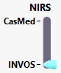

Figure D2 NIRS Selector

- Instructor sets INVOS Source selector to Calculated (Monitors / Labs >> INVOS) as in Figure D3

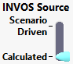

Figure D3 INVOS Source Selector

- On the INVOS™ VMD
  - Learner presses
Select Sensor for each of the four channels
Select Site for each of the four channels, see Figure D4

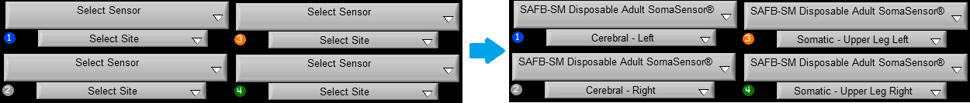

Figure D4 Select Sensor and Site

- As sites are selected, the corresponding control elements cluster is enabled in the Instructor’s Panel, see Figure D5. Please note that these parameters are not saved in the scenario text file, i.e. weight factor, noise level, metabolic rate, resistance and CBF-MAP panel range.

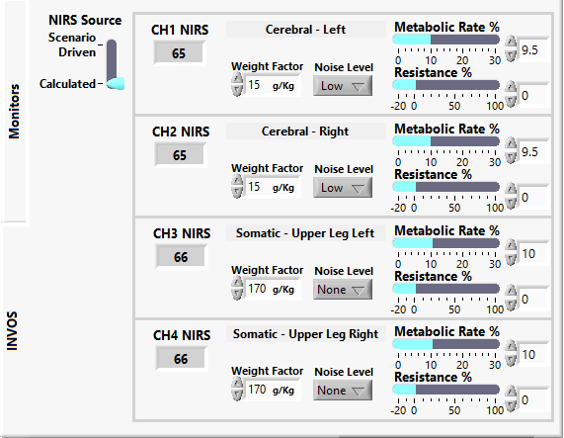

Figure D5 NIRS Control Elements

- Set-up NIRS Source variables for each simulated NIRS Channel (CH1-CH4) as in Figure D5.
  - Set Noise Level
  - Select Channel Site
  - Set Weight Factor g/Kg
  - Set Metabolic Rate %
  - Set Resistance %
  - Repeat 5.1 – 5.5 for each of four NIRS channels

Recommended Limits for Setting Weight Factor and Metabolic Rate
NIRS Site | Weight Factor | Metabolic Rate %
Cerebral | 12-18 g/Kg | 9.0 – 11 mlO2/100g/min
Leg | 140-180 g/Kg | 6.0-15.0 mlO2/10g/min

Note: g is grams of tissue; g/Kg is percent of total body weight

- Learner may press Home button on INVOS™ to land in its Main Screen and begin graphic display of SrO2 values

- Instructor may alter OR Clock Time Factor (x/sec) to speed up INVOS™ Monitor display

Reference
- Wong JK, et al. Cerebral and lower limb NIRS in adults on ECMO. Artificial Organs. 2012;36:659.
- Benni PB, et al. A validation method for NIRS based tissue oximeters for cerebral and somatic tissue oxygen saturation measurements. J Clin Monit Comput. 2018;32:269.
- Mariappan R. et al. Cerebrovascular reactivity to carbon dioxide under anesthesia: A qualitative systemic review. J Neurosurg Anesthesiol. 2015;27:123.
- Stevens MC, et al. Flow mixing during peripheral veno-arterial ECMO – A simulation study. J Biomechanics. 2017;55:64.
- Alwardt CM, et al. Regional perfusion during V-A ECMO: A case report and educational modules on the concept of dual circulations. J Extracorpor Technol. 2013;45:187.
- Choi JH, Kim SW, Kim YU, et al. Application of veno-arterial-venous extracorporeal membrane oxygenation in differential hypoxia. Multidisciplinary Respiratory Medicine. 2014;9:55.
- Lucero AA, Addae G, Lawrence W, et al. Reliability of muscle blood flow and oxygen consumption response from exercise using near-infrared spectroscopy. Exp Physiol. 2018; 103:90.
- Ex.Rx.net. Mean Segment Weights; Body Segment Data. Downloaded May 9, 2018 from https://www.exrx.net/Kinesiology/Segments
- Casavola C, Paunescu LA, et al. Blood flow and oxygen consumption with near-infrared spectroscopy and venous occlusion: spatial maps and the effect of time and pressure of inflation. J Biomed Optics. 2000; 5:269.
- Willie CK, Tzeng Y-C, et al. Integrative regulation of human brain blood flow. J Phyisol. 2014;592:841.
- Radegran G, Blomstrand E, Saltin B. Peak muscle perfusion and oxygen uptake in humans: importance of precise estimates of muscle mass. E. Appl. Physiol. 1999;87:2375.
- Ratanakorn D, Keandaoungchan E. Volume flow rate. Perspectives in Medicine. 2012;1:203.

Version 1.4

Appendix E Data Streaming

If the Data Streaming option is available, an additional tab will be present to the right of the “Work Directory” tab labeled “Data Comm” (see Figure E1a and E1b below).

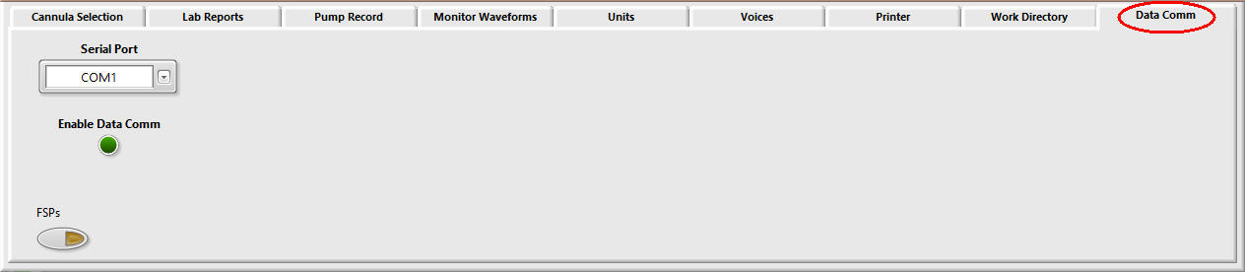

Figure E1a Serial Port Enable Button

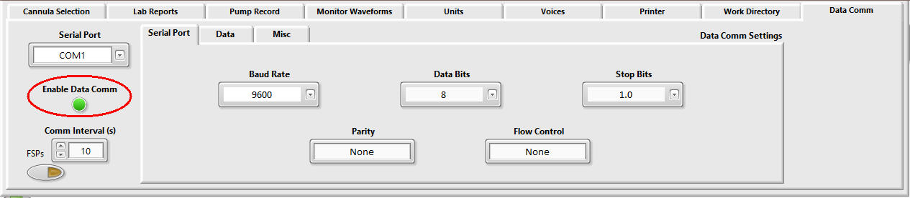

Figure E1b Enabled Serial Port Option Showing Set-up Tabs

E.1. CALIFIA Simulator Serial Communication Protocol Definition

E.1.1 Hardware

Requires a computer with a serial communication port, RS-232. A USB-to-RS232 adapter should work.

RS-232 configuration settings:
    - Baud rate: 9600 Baud
    - Data bits: 8
    - Stop bits: 1
    - Parity: None
    - No hardware handshake

Null modem RS232 cable

E.1.2 Data Packet Format

Simplex Communication. Currently, the simulator software is designed to send out data periodically provided a serial port is configured and external transmission activated. No need for any handshaking mechanism or data request commands from the receiver.

The data update rate is set by the simulator user. Default value is 10 seconds; minimum is 5 seconds
.
Simulator can be configured to send all parameters on every period or send only those parameters with changed values (local caching).

Packet format:
Start Packet | Packet ID | DATA | CRC | End Packet

No data is sent between End Packet and next Start Packet

The following control characters are defined for packet transfer:
- Start Packet: ASCII_SOH = 0x01
- End Packet: ASCII_EOT = 0x04
- Escape Character: ASCII_DLE = 0x07

ASCII_SOH and ASCII_EOT are used to uniquely demarcate the start and end of packets. Bytes sent between the ASCII_SOH and ASCII_EOT characters are part of the packet. No bytes are sent between the ASCII_EOT and the next ASCII_SOH. There is no length field, as this is inferred by the occurrence of the ASCII_EOT.

ASCII_DLE is used as an escape character to allow the values represented by ASCII_SOH and ASCII_EOT to be transmitted. Whenever any of these control characters is to be transmitted, it is replaced by the two-byte sequence ASCII_DLE followed by the required value + 0x80.

- Start Packet becomes 0x0781 /* byte1: DLE, byte2: SOH + 0x80
- End Packet becomes 0x0784 /* byte1: DLE, byte2: EOT + 0x80

The ASCII_DLE expansion occurs to all bytes between the ASCII_SOH and ASCII_EOT, including the Packet ID and the CRC.

Whenever multi byte integers are transmitted, they are transmitted low byte first (lbf). This includes the Packet ID and the CRC. The Packet ID is a 16-bit integer uniquely identifying the type of packet. See Table E1.

Packet ID
 | decimal | hex - 2 bytes | lbf | TX-ready (with DLE)
SIM_DATA | 21 | 0015 | 1500 | 0715 0700

Table E1 Packet ID Illustration

E.1.3 Packet Identifiers

Packets are sent at a user-defined frequency whenever the simulator software is running, and external transmission is successfully activated. There is no need to request data. Communication is simplex (one way only). See Table E2.

ID (decimal) | Description
21 | SIM_DATA
25 | SIM_INVALID_DATA
29 | SIM_NO_DATA
30 | SIM_ERROR

Table E2 Packet IDs

The CRC is the 32-bit CRC of all bytes between but not including ASCII_SOH and the CRC. The polynomial used for the CRC calculation is 0xEDB88320.

The CRC calculations are performed before ASCII_DLE characters are inserted on transmission, and after they are removed on reception.

E.1.4 Data

Table E3 shows the sub format

A | B | C |  |  |  | D |  |  |  | E |  |  |  | F | G

Table E3 Data Layout

Table E4 lists the data components

Segment | Bytes | Description
A | 1 | Parameter Enumeration (see Table 7 for complete list)
B | 1 | Status code (0x00: good reading 0x01: invalid reading)
C | 4 | Value^{1,4}
D | 4 | Upper Limit^{1,2,4}
E | 4 | Lower Limit^{1,3,4}
F | 1 | Units Enumeration (see Table 9 for complete list)
G | 7 | Timestamp (Year, Month, Day, Hour, Minutes, Seconds)⁵
¹ Value & both limits are represented as IEEE 754 single precision floating point numbers.
² +Infinity (0x7F800000) for Upper Limit indicates no upper limit.
³ -Infinity (0xFF800000) for Lower Limit indicates no lower limit.
⁴ If the Packet ID is not 0x0015 (SIM_DATA), these values should be ignored.
⁵ Timestamp format: 2 bytes: Year: MSB+LSB. 1 byte: Month, Day, Hour, Minutes, Seconds

Table E4 Data Components

Table E5 illustrates the timestamp function

Element (lbf) | Sample = Oct 21, 2017 10:45:28 AM | Hex | Actual output (lbf)
Seconds | 28 | 1C | 11140A150A2D1C
Minutes | 45 | 2D | 11140A150A2D1C
Hours | 10 | 0A | 11140A150A2D1C
Day | 21 | 15 | 11140A150A2D1C
Month | 10 | 0A | 11140A150A2D1C
Year MSB | 20 | 14 | 11140A150A2D1C
Year LSB | 17 | 11 | 11140A150A2D1C
Table E5. Timestamp Illustration
Lists in Table E6 & E7 are likely to expand as more capabilities are added to the CALIFIA Simulator software.

Enumeration (decimal) | Parameter | Unit Enums^{1,2}
1 | Urine Output (mL) | 7
2 | Bladder Temp | 1
3 | Esophageal Temp | 1
4 | Rectal Temp | 1
5 | Nasopharyngeal Temp | 1
6 | Arterial Temp | 1
7 | Venous Temp | 1
8 | MAP | 2
9 | Systolic Pressure | 2
10 | Diastolic Pressure | 2
11 | CVP | 2
12 | Gas Flow | 5
13 | HR | 17
14 | FIO2 | 4
15 | ACT sec | 8
16 | Hb | 20, 21, 22
17 | pHa | 0
18 | HCO3- | 21
19 | B.E. | 21
20 | Pump Flow | 5
21 | SaO2 | 4
22 | SvO2 | 4
23 | PaO2 | 2, 3
24 | PaCO2 | 2, 3
25 | GEM_PaO2 | 2, 3
26 | GEM_PvO2 | 2, 3
27 | GEM_PaCO2 | 2, 3
28 | GEM_PvCO2 | 2, 3
29 | GEM_pHa | 0
30 | GEM_pHv | 0
31 | GEM_HCO3-a | 21
32 | GEM_HCO3-v | 21
33 | GEM_Na+ | 21
34 | GEM_K+ | 21
35 | GEM_Ca++ | 15, 19, 21
36 | GEM_Glu | 19, 21
37 | GEM_Lac | 21
38 | CDI_PaO2 | 2, 3
39 | CDI_PvO2 | 2, 3
40 | CDI_PaCO2 | 2, 3
41 | CDI_PvCO2 | 2, 3
42 | CDI_pHa | 0
43 | CDI_pHv | 0
44 | CDI_HCO3-a | 21
45 | CDI_VO2 | 5
46 | PexCO2 | 2, 3
- Refer to Table E7 for Unit enumeration value
- Multiple entries mean software operator selects the units for these parameters

Table E6 Parameter Enumeration

enumeration (decimal) | Unit
0 | No unit
1 | degree Celsius
2 | mmHg
3 | kPa
4 | %
5 | litres per minute
6 | revolutions per minute
7 | mL
8 | Time in seconds
9 | Time in minutes
10 | degree Fahrenheit
11 | milli litres / litre
12 | centimeter
13 | kg
14 | lbs
15 | mEq / L
16 | Units per second
17 | beats per minute
18 | Time in Years
19 | mg / dL
20 | g / L
21 | mmol / L
22 | g / dL
23 | pH
24 | [H+]

Table E7 Units Enumeration
Sample packet build screenshot shown in Figure E2

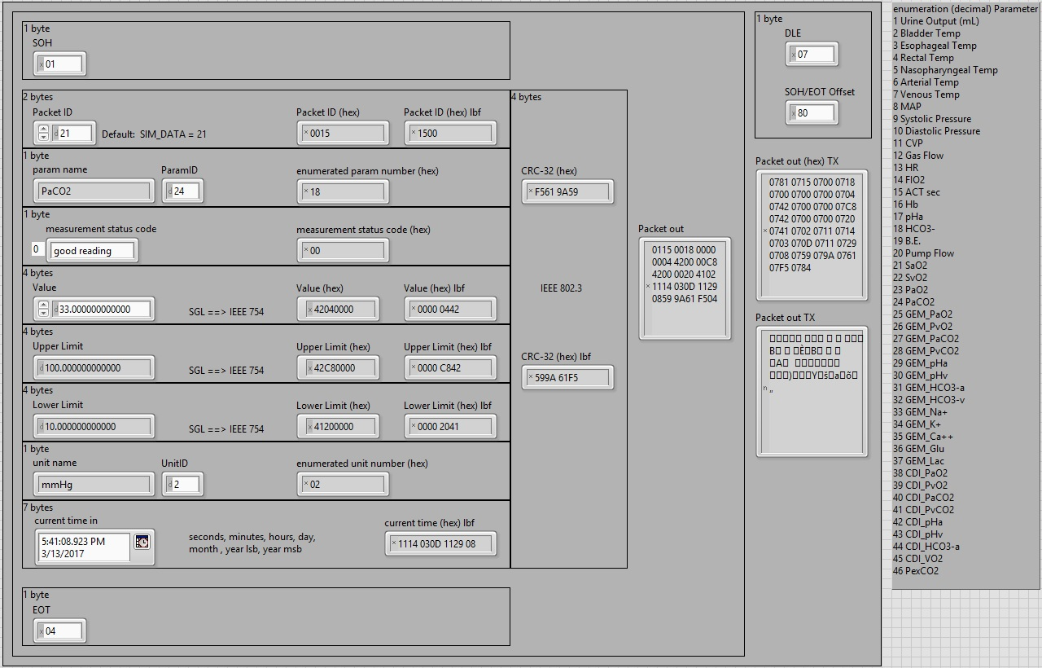

Figure E2. Sample Packet Build

E.1.5 Sample Data Capture

The following list of parameters (Table E8) was sequentially generated and then collected using a serial capture application similar to HyperTerminal (Table E9). Note the data has no significance or correlation with actual patient values or physiology.

Parameter | HI limit | LO limit | value | units
Urine Output (mL) | 2000 | 0 | 23 | 7 (ml)
Bladder Temp | 50 | 0 | 36.5 | 1 (deg C)
Arterial Temp | 50 | 0 | 35.3 | 1 (deg C)
Venous Temp | 50 | 0 | 33 | 1 (deg C)
MAP |  |  | 78 | 2 (mmHg)
Systolic Pressure |  |  | 93 | 2 (mmHg)
Diastolic Pressure |  |  | 61 | 2 (mmHg)
CVP |  | 0 | 5 | 2 (mmHg)
ACT sec |  | 0 | 110 | 8 (secs)
Pump Flow | 7 | 0 | 2.5 | 5 (lpm)

Table E8. Parameter List Sent Via Serial Port Sequentially
1: Read Operation
Return Count: 600 bytes
0781 0715 0700 0701 0700 0700 0700 07B8 0741 0700 0700 07FA 0744 0700 0700 0700 0700 0707 0711 0714 0703 070D 0712 0701 0735 0729 07AB 076A 0743 0784
0781 0715 0700 0702 0700 0700 0700 0712 0742 0700 0700 0748 0742 0700 0700 0700 0700 0701 0711 0714 0703 070D 0712 0701 0735 0772 077F 0761 0767 0784
0781 0715 0700 0706 0700 0733 0733 070D 0742 0700 0700 0748 0742 0700 0700 0700 0700 0701 0711 0714 0703 070D 0712 0701 0735 0751 0769 071F 0720 0784
0781 0715 0700 0707 0700 0700 0700 0704 0742 0700 0700 0748 0742 0700 0700 0700 0700 0701 0711 0714 0703 070D 0712 0701 0735 072F 0768 0737 070C 0784
0781 0715 0700 0708 0700 0700 0700 079C 0742 0700 0700 0780 077F 0700 0700 0780 07FF 0702 0711 0714 0703 070D 0712 0701 0735 0727 07ED 0737 07D7 0784
0781 0715 0700 0709 0700 0700 0700 07BA 0742 0700 0700 0780 077F 0700 0700 0780 07FF 0702 0711 0714 0703 070D 0712 0701 0735 0752 078D 0725 0793 0784
0781 0715 0700 070A 0700 0700 0700 0774 0742 0700 0700 0780 077F 0700 0700 0780 07FF 0702 0711 0714 0703 070D 0712 0701 0735 077A 07A4 0796 07A7 0784
0781 0715 0700 070B 0700 0700 0700 07A0 0740 0700 0700 0780 077F 0700 0700 0700 0700 0702 0711 0714 0703 070D 0712 0701 0735 07C8 0748 0725 07FA 0784
0781 0715 0700 070F 0700 0700 0700 07DC 0742 0700 0700 0780 077F 0700 0700 0780 07FF 0708 0711 0714 0703 070D 0712 0701 0735 07CF 07BF 07A3 0799 0784
0781 0715 0700 0714 0700 0700 0700 0720 0740 0700 0700 07E0 0740 0700 0700 0700 0700 0705 0711 0714 0703 070D 0712 0701 0735 0762 0742 0732 0787 0784

Table E9 Captured Data Via a Serial Interface – Hex Format (each packet is 60 bytes)

Appendix F Display Settings for OR Monitor

F1. Display Settings

The controls for changing the settings for the OR Monitor display can be found on the Windows Control Panel under “Display” (see Figure F1a).

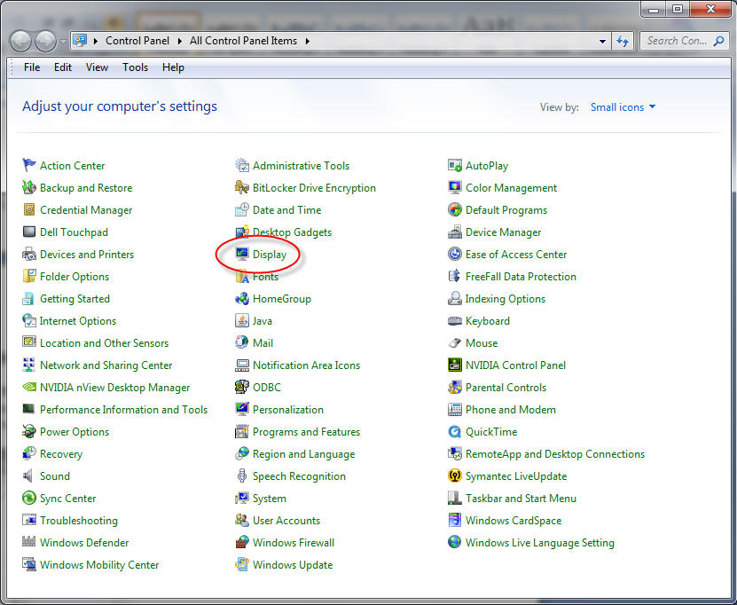

Figure F1a Display Option in Control Panel

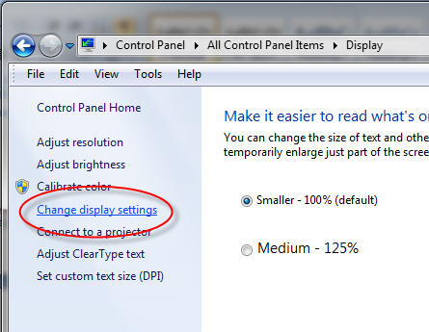
Clicking Display brings up the Change display settings option as shown in Figure F1b.

Figure F1b “Display” Option in Control Panel
Choosing Change display settings reveals a screenshot as seen in Figure F2. The laptop display must be the main display (1) with the OR Monitor set as an extension of the main display (2)

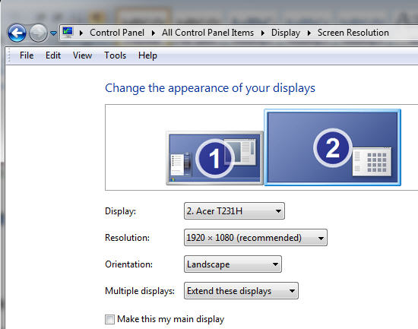

Figure F2 Change Screen Displays

F.2. Touch Screen Settings

Under the Windows Control Panel select Tablet PC Settings. See Figure F3.

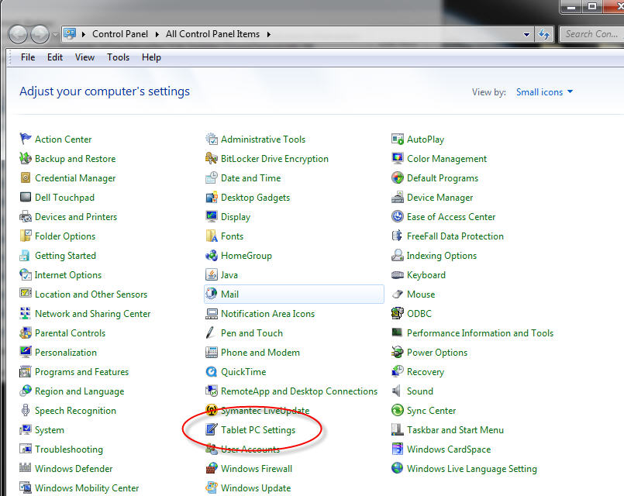
Figure F3 Accessing Touchscreen Options

When you click on the Tablet PC Settings icon the screen shot shown in Figure F4a will appear. Click on the Display drop-down to choose the second monitor as shown in Figure F4b.

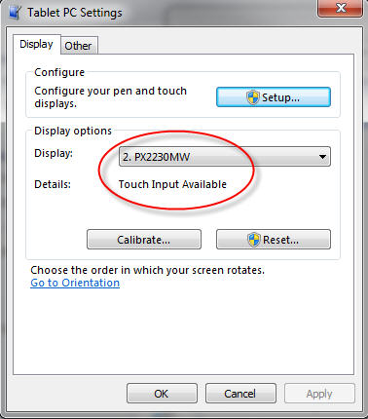
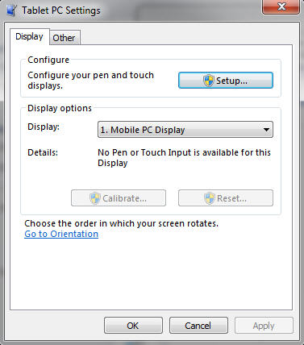

Figure F4a Tablet PC Settings Figure F4b Selecting the Second Monitor

If it does not say Touch Input Available next to Details as shown in Figure F4b click Setup shown in Figure F5

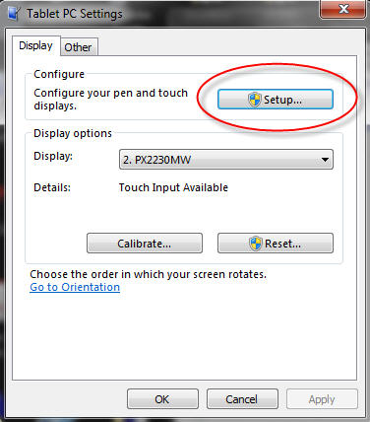

Figure F5 Touchscreen Set-up

Once selected, Figure F6 shows the screen that will appear first on the laptop screen. Follow the directions on the screen to choose the second monitor as having the Touch Input Available.

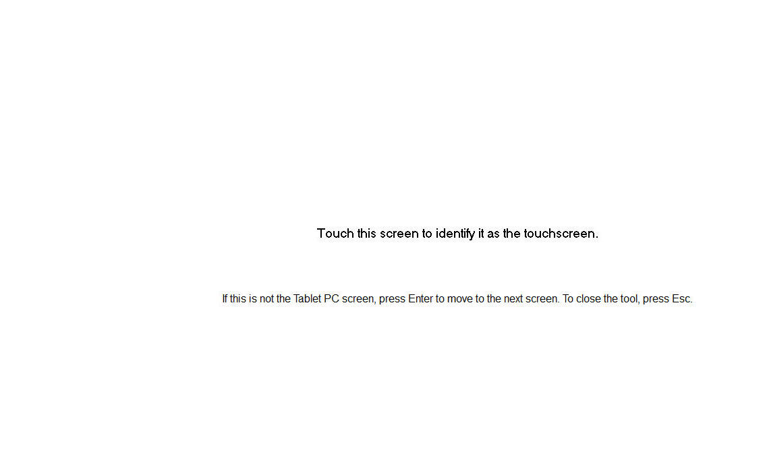

Figure F6 Laptop Screenshot

Once that is finished, you can choose “Calibration” and the screen shown in Figure F7 will appear on the Touch Monitor. Follow the instructions to finish the calibration



Figure F7 Calibration Screen
Appendix G Equations

- Body Surface Area Calculations

- DuBois & DuBois : $BSA (M^{2})$ = 0.20247 x height (m)^{0.725} x weight (kg)^{0.425}
DuBois D, DuBois EF. A formula to estimate the approximate surface area if height and weight be known. Arch Int Med 1916 17:863-71.
- Boyd : $BSA (M^{2})$ = 0.0003207 x height (cm)^{0.3} x weight (grams)0.7285 - (0.0188 x log(weight))
Boyd E. The growth of the surface area of the human body. Minneapolis: U of Minnesota Press, 1935.
- Haycock : $BSA (M^{2})$ = 0.024265 x height (cm)^{0.3964} x weight (kg)^{0.5378}
Haycock GB, Schwartz GJ, Wisotsky DH. Geometric method for measuring body surface area: A height weight formula validated in infants, children and adults. The Journal of Pediatrics 1978 (93):1:62-66.
- Mosteller: $BSA (M^{2})=\sqrt{\frac{height (cm) x weight (kg)}{3600}}$
Mosteller RD. Simplified Calculation of Body Surface Area. N Engl J Med. 1987 Oct 22;317(17):1098. (letter)
- Gehan & George : $BSA (M^{2})$ = 0.0235 x height (cm)^{0.42246} x weight (kg)^{0.51456}
Gehan EA, George SL. Estimation of human body surface area from height and weight.
Cancer Chemother Rep 1970 54:225-35.

- Base Excess

$$BE=\left(1-0.6206×Hgb×0.023\right)\left[\left(0.0301×PCO_{2}×{10}^{pH-6.1}-24.02\right)+\left(0.6206×Hgb×2.3+7.7\right)×\left(pH-7.40\right)\right]$$

Loeppky JA, Fletcher ER, Roach RC, Luft UC. Relationship between whole blood base excess and CO₂ content in vivo. Respiration Physiology 1993:(94):109-120

- Temperature Correction

pH(t) = pH(37) + 0.0149 (37 - t )

PCO₂(t) = PCO₂(37) 100.019(t - 37)

PO₂(t) = PO₂(37) 10[0.0052+0.0268( 1- e -0.3x)](t-37)
(where x = % Hgb desaturation)

Nunn JF, Bergman NA, Bunatyan A, Coleman AE. Temperature coefficients for PCO₂ and PO₂ of blood in vitro. J Appi Physiol 20, 23-26 (1965).

Appendix H Licensing Activation

CALIFIA Simulator installs in Evaluation mode by default. It lasts 30 days from the moment first launched. Once the 30 days of evaluation is reached, the application will prompt the user to either extend evaluation or activate the license. These require the user to contact Biomed Simulation (info@biomedsimulation.com) to obtain a License ID and password.
The License Activation dialog can be accessed from the Opening Screen, Figure H1. Press the 3-line button in the upper left (also referred to as the hamburger button) then Licensing.

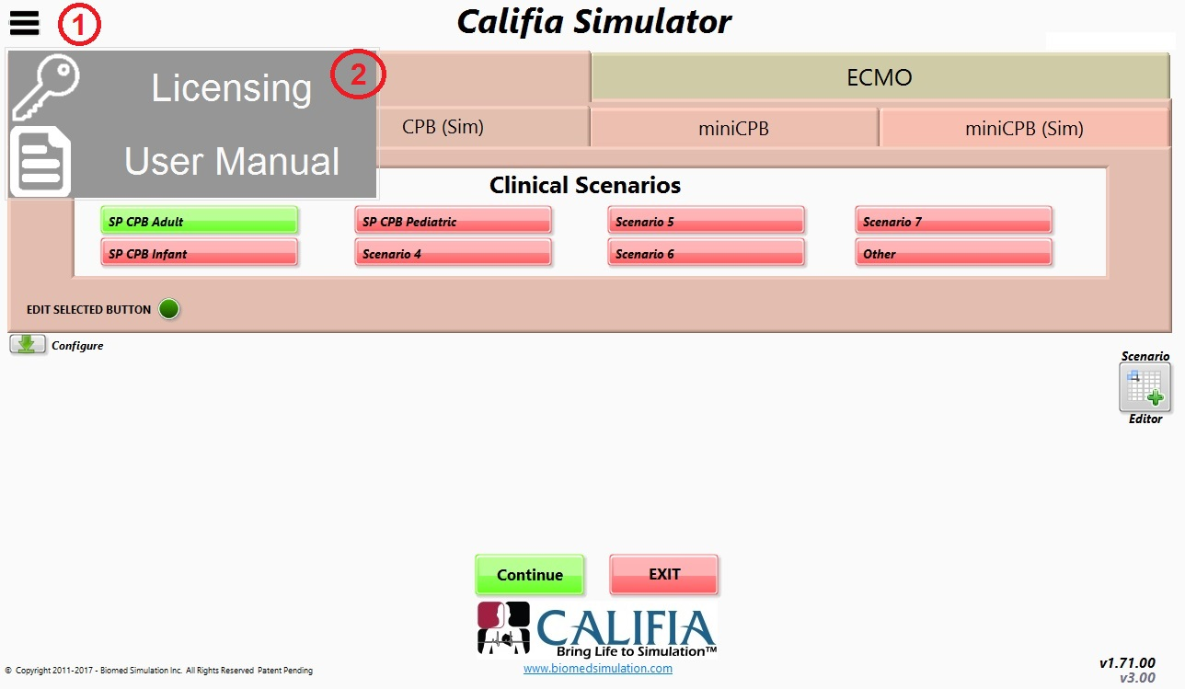

Figure H1 Licensing Access in Opening Screen
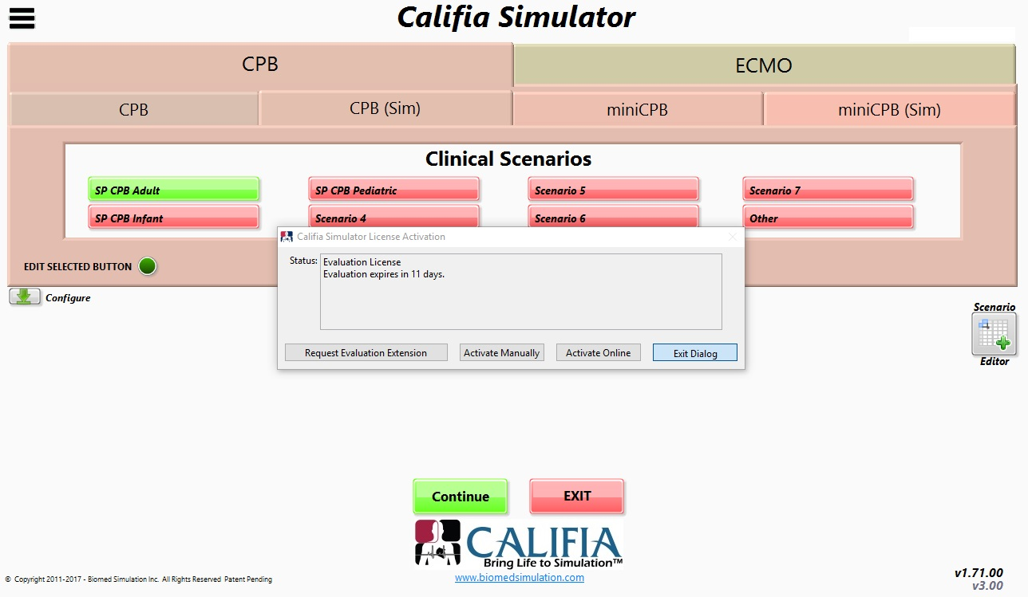

Figure H2 Licensing Activation Dialog

The dialog box in Figure H2 illustrates the case of an evaluation license; the options it offers are to either extend the evaluation or activate (manually or online). To activate the application, you will need a valid License ID and password. A single license ID can be activated in up to two computers.

Online Activation

Ensure the computer is online; press the Activate Online button in Figure H2. A new dialog box Activate Online will appear as shown in Figure H3. Enter the License ID and Password. The Installation Name is an optional entry to help manage multiple activations of your license. Press the Activate button, depending on internet speed, the exchange with the licensing server can be as fast as 3 seconds. An Activation Successful dialog displays when complete. Figure H4 shows the case of a successful activation of a Perpetual License. Press Continue to return to the Opening Screen.

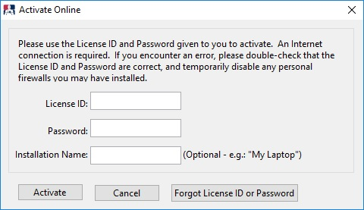

Figure H3. Activation Online Dialog

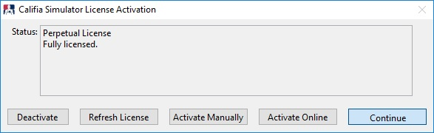

Figure H4. Perpetual License Activation Dialog

Manual Activation

If your computer is not online and you must activate the CALIFIA Simulator application, then you can step through the Manual Activation process.

Note: Biomed Simulation strongly recommends online activation; in cases where this is not possible.

Press the Activate Manually button, Figure H4 to land on the Manual License Activation Request shown in Figure H5.

Step 1. Enter your License ID and Password and press Generate Request button

Step 2. Press the Copy button to copy the Activation Request content to memory. Open Notepad and paste content. Save file to a USB drive or network drive then open from a computer with online access.

Step 3. Open an internet browser in the computer with online access and point it to: https://secure.softwarekey.com/solo/customers/ManualRequest.aspx; paste the contents from the Notepad file you created in Step 2, Figure H5, and press Submit. A new browser page, shown in Figure H6, will appear with the response. Press the Download button to save to a file you can access with the offline computer.

Step 4. Open the response file in offline computer, copy then paste its content in the Activate Manually Activation Code box, Figure H6, and press the Activate button. An Activation Successful dialog appears. Press Continue to return to the Opening Screen.

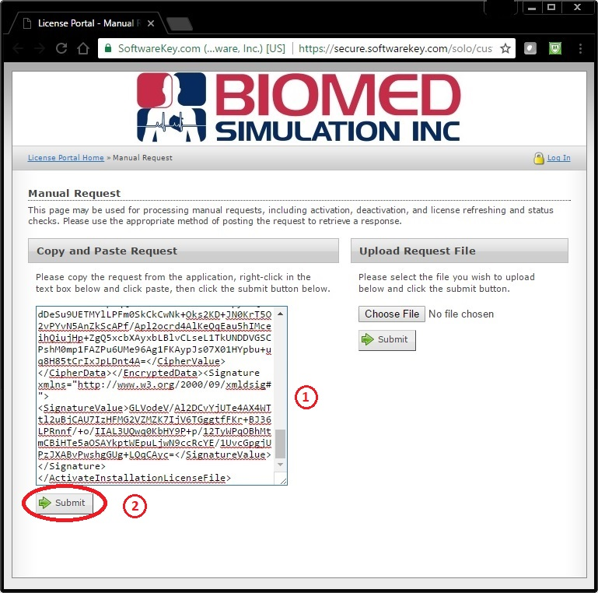

Figure H5. Manual License Activation Request (for demo purposes only)
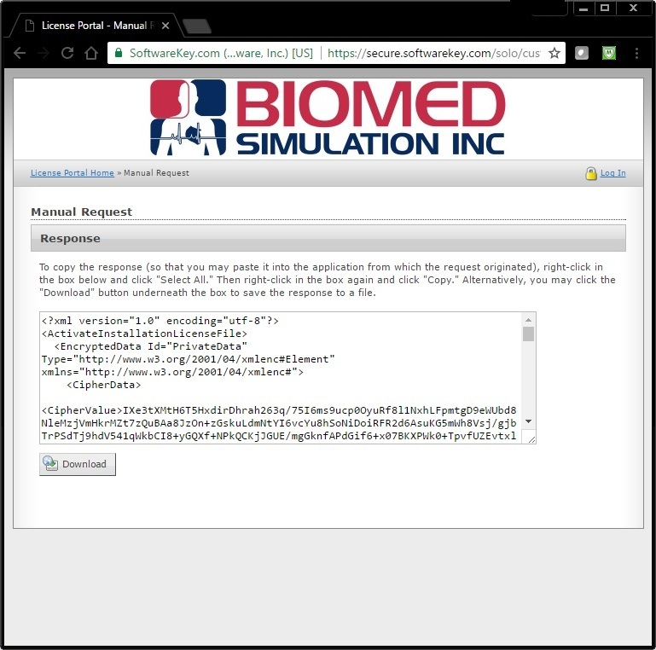

Figure H6. Manual Response (for demo purposes only)
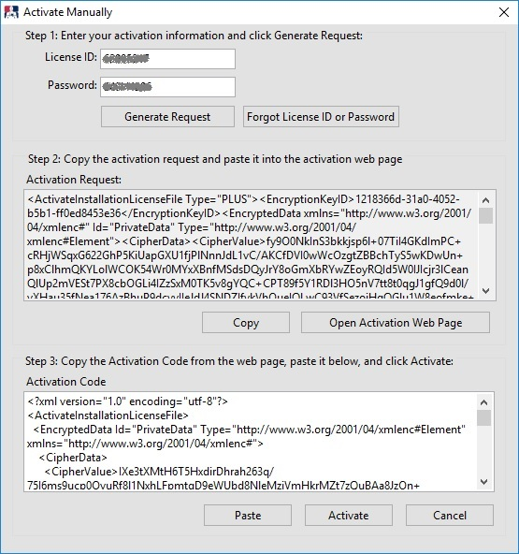

Figure H7 Manual Activation Code Box


